Challenges to Language Revitalisation: The Efut Perspective

¹Margaret M. Okon, ²Paulinus Noah
¹mmaokon@yahoo.com
https://orcid.org/0000-0003-4040-7123?lang=en
²seemaekediong@gmail.com

¹Department of Linguistics & Nigerian Languages, University of Calabar, Nigeria
²c/o Department of Linguistics and Communication Studies, University of Calabar, Nigeria

Abstract
Efut, a Bantoid language in the Niger-Congo Family, known as Balondo in its ancestral Cameroon homeland, seems to survive on the life support of cultural rituals and Ekpe (‘Leopard’) Society. There is no intergenerational transmission, as language shift is ubiquitous in almost all domains. As a corollary, except Okon & Noah (2021), most works underscore only its extinction rather than resuscitation and it is not listed in Ethnologue (2019); hence, part of the momentum for our revitalization effort. From our exploratory investigations, the major challenges to Efut include: aftermath of war, lack of documentation, poor language attitude, linguistic environment, leadership tussle, economic and technological factors. We discuss these issues and suggest stimulus packages towards revitalization. Some of these include proficiency in Efut as a positive reward system and prerequisite for ascendancy to the highest Efut traditional patriarchy (Muri Munene), chieftaincy title awards and free land allocation. The use of social media, optimizing the gains of cultural rituals and Ekpe would serve also as veritable revitalization tools. The paper challenges language enthusiasts and other stakeholders, especially Efut indigenes, to bring fresh perspectives towards revitalizing the language. No human language deserves to die!
Word Count: 191
Keywords: Efut Language, Challenges, Language Revitalisation, Language Endangerment, Cross River State, Prospects
INTRODUCTION
The profile of Efut is accessible in many documents relating to it (cf. Nakanda, 2010; Okon, 2003; Amaku, 2004; Efut Combined Assembly, 1996, 2003; Akak, 1998; Noah, 2004; Okon & Noah, 2021). However, according to Edet (2018),
The Efuts are descendants of the Balondo tribe who migrated from the Cameroons during the Batanga war of the 11th Century AD to this part of the world.”… They set forth with seven founding ancestors, namely: Nabonda, Na Ukem, Na Mkpara, Ebuka, Ato Iyoko, Ifakama and Ifundu. Each of them sailed out in a canoe, fully equipped and carrying separate royalty and Mkpe (Ekpe) insignia as symbols of their individual sovereignty or autonomy (p.59).
The significance of the Ekpe (‘Leopard’) Society in the socio-cultural life of the Efut is enormous, as will be highlighted later in our discussion.
The Efut language ‘spoken’ in Nigeria is, therefore, a variant of Londo spoken in Cameroon, which is a dialect of Oroko [bdu]. The Oroko people occupy a large part of Ndian (East of Ekondo-Titi and South of Kumba Subdivision) and Neme Divisions in the Southwest Province of Cameroon. They comprise the following ten clans, in alphabetical order, each with a distinct dialect, which we indicate in parenthesis:
- Bàkókó (Lòkókò)
- Bàkùndú (Lòkùndú)
- Bàlòndó ba Diko
- Bàlòndó ba Nanga (Londo) ~ Efut
- Bálùé (Lolue)
- Bàtángà (Lotanga)
- Bímá (Bima)
- Èkòmbè (Ekombe)
- Mbòngé (Mbonge) ^{I}
- Ngóló (Longoto)
The ten (10) Oroko Clans have an estimated population of 106,000 speakers (Lewis 2009:80). The language is classified as: Niger-Congo, Atlantic-Congo, Volta-Congo, Benue-Congo, Bantoid (Southern, Narrow Bantu). According to Kuperus (1985), “Londo is a Bantu language (A.11) of Cameroon spoken by about 7,000 people in 15 villages” (p.7) ². Londo speakers/people are called Balondo (~ Barondo) or Balondo ba Nanga, precisely to distinguish them from the nominally similar Balondo ba Diko (~Loko, Riko), which is linguistically closer to the Bima variety.
The Efut language began to wilt initially in the Cross River State of Nigeria for at least three reasons: the need to suppress Efut linguistic identity following the Batanga war, lure to be bilingual in Efik due to Efik perceived superior status, need to be bilingual in Efik which was the trade language (and Efik people were the sole intermediaries) with European merchants along the Cross River coast. Many other factors have along the line conspired to inhibit the use, growth, viability and resuscitation of the Efut language. These include: limited use, linguistic environment, lack of documentation, intermarriage, poor economy, globalization, social media, political factor, lack of government support, unbalanced bilingualism, youth attitude and intergenerational disruption. These then are the real challenges to revitalizing Efut.⁴
The importance of descent language is enormous for both the indigenous people and balancing the global linguistic ecosystem. Language revitalisation efforts have been ongoing in many parts of the globe for some decades. Not much effort or success towards this has been recorded in the Nigerian context. Neither the Nigerian Geological Language Survey (NGLS) project nor Nigerian Languages Project (NLP) is focused majorly on revitalization. This is not for lack of endangered languages in the country. Conversely, Nigeria is inundated with a plethora of sick, dying and dead languages, including Efut. The (Nigerian) Centre for Endangered Languages (CEL) has, however, been one of the few voices calling for urgent revitalisation steps for Nigeria’s dying voices. According to the CEL, as reported in Okwudishu (1997), “… all the languages in Nigeria have less than 50% of their original speakers, in fact, in most cases, only few elderly people speak or remember their languages. Almost, the only languages remaining are the dead and dying. The people are merely survivors, they are not inheritors” (p.126). Despite the zest and righteous purpose of language revitalists, endangered languages hardly relent in dying apace. Many minority languages are facing extinction threat in Nigeria, and that of Efut is extremely dire.

The Language Situation in the Cross River South Senatorial District
The Cross River South Senatorial District comprises the following Local Government Areas (LGAs): Akamkpa, Akpabuyo, Bakassi, Biase, Calabar Municipality, Calabar South and Odukpani. Efut people inhabit all these LGAs, except Akamkpa, Biase and Calabar Municipality. Efut is helmed in by Qua (~ Ejagham or Ekin), Efik and Ibibio – the last two exerting maximum sociolinguistic influence. In fact, the Efut Combined Assembly (2003) itself, among other sources, attests to the Ibibio linguistic influence on both Efut and Efik: “the Ibibios are still where they were and it is the Efiks who moved on carrying along with them a language based on Ibibio. When the Efiks were received by the Efut people of Creek Town, this Ibibio language became a common language of communication”. (p. 49)⁵. Today, almost no Efut indigene in the Cross River South Senatorial District speaks functional Efut. This may have largely impelled most sources (for example, Mensah & Offiong, 2004; Ndimele 2014) to aver that the language is extinct.

Map I Efut Speaking Local Government Areas in Cross River State, (CRS), Nigeria.

Map II Map of Calabar Demarcating Efut Territory from Efik and Qua in Cross River State.

Efut Moribund or Extinct?
According to Wikipedia (2019), “an endangered language or moribund language is a language that is at risk of falling out of use as its speakers die out or shift to speaking another language. Language loss occurs when the language has no more L1 users and becomes a ‘dead language’. For now we align with Noah (1990, 2004), to describe Efut as ‘mortally’ moribund. We do not subscribe to Mensah and Offiong (2004), that “Efut language is extinct. The last speaker of Usakedet (the language of the Efut people) died in 2001” (p.9). Okon & Noah (2021) also paint a grim picture: “finding a fluent indigenous Nigerian speaker of Efut Calabar is like finding a needle in a haystack” (p.143). The extreme difficulty in finding fluent Efut L1 user signposts the extent of the language’s endangerment. Efut is used occasionally for rituals and incantations, other than in Ekpe (‘Leopard’) Society songs. Ekpe play, one of the surviving aspects of the Efut people is, however, very vibrant and ubiquitous during (official and) cultural ceremonies and is proudly showcased to the international audience in the Calabar Annual Carnival, especially.
Efut names (personal and place) are another surviving legacy of the people. Even though some of these names have lost their original meanings synchronically, they are widely borne by the people. Consider the following, for example;
- Asikpo personal and place name
- Mesembe (from Mosembe ) ‘a female cultural play’
- Ukpa (~ Mbukpa in Efik): ‘breadth’
- Ebuka: ‘outside, playground (child of suspicious paternity’)
- Nakanda: ‘bully’
- Dibonda (~ Ibonda in Efik)
- Eyamba: an ‘ekpe title’
- Ambo (place name)
- Nyambi Personal name
- Ito: ‘wealth’
Cultural influence from their Efik, Qua and Ibibio neighbours, other than anglicisation, has helped to vitiate Efut onomastics.

Existing Works on Efut
Koelle’s 1963 (1854) wordlist on Londo, which he calls ‘Mūrūndo or Bárūndo” (1854:19) is the earliest linguistic record available to us. Though Johnston’s (1919, 1922) data are gotten primarily from Koelle’s work, Kuperus (1985) remarks of discrepancies between them, “though Johnston claims to have studied the same language as Koelle and has used Koelle’s Polyglotta list as a source for some of the items presented in the Comparative Study of Bantu and Semi-Bantu languages, there are discrepancies between the two authors” (p.19). Both authors admit seven vowels for Londo, unlike Johnston (1919). Fr. Bruens’ work on Londo culminated in his “A grammar of Lundu” (1937ms), which formed the data base for Guthrie’s (1953, 1957) analysis. Bruens’ work (1937) had sections on noun, adjectives, adverbs, numerals, kinship terms, etc, aspects of syntax and analysis of Londo stories. Kuperus (1985) elaborates the morphological and phonological structure of “Londo words”, with attention to verb paradigms, “within the wider context of the generativist notion of a word grammar” (p.24). There is also an undated 20 page “Balondo pocket dictionary”, typeset by Ndena Paul Ndena with ‘Our Father’, ‘Hail Mary’ and ‘Glory be to the Father’ included. This is an amateur work with an unreliable transcription, as useful as it may be. Okon (2003) compares the Nigerian (Efut) and the Camerounian (Londo) varieties in a BA (Hons) Degree Research Project. Noah (2004) sketches aspects of the phonological system of Efut and notes the absence of consonant cluster in the language, a feature that inundates most Cross River languages. A case for the resuscitation of Efut is also made as part of language engineering in this study.
In their 2004, “Socio-linguistic profile of the Calabar Urban,” Mensah & Offiong summarily dismisses Efut as extinct, with the last speaker of Usakedet dead, far back in 2001. Ndimele (2012) similarly does not include Efut as a living language in Cross River State. In recent times, it seems only Okon & Noah (2021) has given the rare hope that Efut may not be extinct, after all. This is a cautious optimism, nevertheless: “The prognosis for reviving Efut appears, realistically poor, at present. However, with appropriate input and pragmatic will from all stakeholders, it would be hasty, uncharitable, to consign the language to irreversible extinction. This optimism is sustainable only if…”(p.134). As almost no work exists on Efut revitalisation, the current effort is not only imperative but should also be replicated by other stakeholders.

Current Field Trip and Revitalisation Efforts
In addition to our earlier exploratory fieldwork effort in 2018 in the Calabar South LGA, we embarked on a five-day field trip to Bakassi LGA recently, where the Efut also occupy. Findings formed the major part for our Paper Presented at the ‘8th Cambridge Conference on Language Endangerment’, University of Cambridge (Oublished as Okon & Noah, 2021). Our current fieldwork started by a visit to No.1 Umon Street in the Calabar South LGA, which was pre-arranged courtesy of Muri Asuquo Nyong Ekpo. We were fortunate to meet for over an hour (on logistics) with Mr. Gabriel Etim, who piloted our inaugural field trip to Ikot Effiom in Bakassi LGA. Mr. Asuquo Etim of the Cross River State Deputy Governor’s Office and Chief Henry Usim were present also at Umon Street. But it was Mr. Gabriel Etim who later arranged our meeting with the main informant, Mr. Daniel Motiti Ukpa (65 years), a retired teacher from Illoh village in Balondo.

Pix II: Researchers with Main Informant and Chief Gabriel Etim (far left), who piloted the inaugural fieldtrip

Pix III: Main Informant (2nd from right) explains our Fieldtrip Mission to the Village Head of Ikot Effiom

Pix I: Researchers’ Arrival at the Residence of the Village Head of Ikot Effiom

Pix IV: Chief Ekpo Edet Effiom, Village Head of Ikot Effiom, makes an Illustration.

It was expedient for us to pay a courtesy visit to the Village Head of Ikot Effiom, where our two informants are hosted in order to allay suspicion of espionage or hostility, given their refugee status. The Village Head not only welcomed us warmly but was also excited at the prospects of revitalizing Efut; because according to him, his maternal grandparent was Efut. Data elicited from our informants, Mr. Daniel Ukpa (65years) and his sister, Mrs. Bridget Ekale Morasi (69years) included greetings, proverbs, a ballad and items based on the 400 Ibadan wordlist. Gaps in data were readily filled by the second informant, who also assisted to confirm data authenticity. We observed that though our informants are multilingual (in Londo, Efik, English and French), this had no apparent (negative) interference on the data quality as theoretically expected. Their competence in Efik and English proved an asset rather.
Prior to our fieldtrips (in 2018 and 2019), the Efut people, conscious of the need to rebirth the language, started language lessons under the inspiration of HRM, Muri (Munene) Effiong Mbukpa (who is not recognized by the Cross River State Government) but that programme ceased due to the monarchy tussle. As a prelude to the Thanksgiving Service of the (government officially recognized) Efut Monarch, HRM Muri Munene Prof. Itam Hogan Itam on December 15, 2018, our main informant was tasked with teaching Efut ballad to some female indigenes, here reproduced:
Efut Ballad
- Efut Ekora, Monyele mbora
Ekuri eso-ombe ware
Monyere Berehe (Response by all)
- Efut Basende, Monyere Monyere Mosobaka Dokpo
Owasu Yongha Banabana
Mofa Asakendeke
Monyere Berehe (Response by all)
- Efut Barondi Ngha Dironda
Efut Bakendeke Ngha Oboso
Monyere Berehe (Response by all)
- Atangari Ngonde Loba
Njuku Diongho Baseneke Mo
Monyere Berehe (Response by all)
- Muri Monene Professor Itam Hogan Itam
Nyam Nangho I
Nwana Nwa Efut Ukem Na Dibonda
Buri Wu Efut Bokani Owa
Ama Disoku Dikanani Mokongho
Monyere Berehe (Response by all)
- Efut Konja Efut
Ekumi Baroko Ekindaka
Ba Nja
Monyere Berehe (Response by all)
- Moki Iko, Moki Etrunyama
Moki Diari, Moki Beseme
Monyere Berehe (Response by all)
- Muri Asobaka Dibaku Dibe
Muri Asadaraka Nye-Nye
Adaraka Nga Menyoki-Menyoki
Monyere Berehe (Response by all)
- Muri Mato Ma Njoku
Muri Moangha Nwa Igingo
Monyere Berehe (Response by all)
- Mbo Osikpari Osiyuaka Mata
Osio Idiba Oka Nwaka Mbenghe
Monyere Berehe (Response by all)
- Onweri Mbenghe Oma
Onweri Bosoro
Bua Esasosoaka Matono Ma Ngho
Monyere Berehe (Response by all)

This Efut Ballad was taught to a group of 14 women during five language sessions, each of a two to three hour duration for two weeks. The ballot extolls the virtues of the new Muri Munene. The joy of Efut people on hearing and watching a live media broadcast in their native Efut language was as indescribable as it was incredible. For most Efut people, this was their first lifetime experience, apart from the usual use of Efut in libation and Ekpe rituals. With more commitment, enthusiasm and grit from Efut indigenous stakeholders especially, the effort to revitalize the Efut language will begin to yield lasting and palpable fruits.

Pix V: Main Informant (male sitting) confirms a point with the 2nd informant (female standing)

Pix VI: Researchers compare notes
(During data collection)

Pix VII: Lead Author reads Efut data for feedback,
Second Author makes notes

Pix VIII: Question and Answer session between Researchers and Informants

The Making of an Efut Monarch

History has it that one of the seven Efut founding fathers, Ifundu, severed ties with his Efut lineage and was incorporated into the Qua nations; hence the current six ancestral clans (and other subsidiaries) with their different Muri as clan heads. They make up the electoral college, with powers to select the Muri Munene.
There has been no succession dispute in recorded memory till 2009, after the demise of Muri Munene Ita Okokon Ekpenyong Ebuka Ebuka I. Two monarchs emerged after this: the incumbent Muri Munene and Muri Effiong Mbukpa (the latter was officially dethroned by the Cross River State Government in 2012). This made it possible for the State Government to recognize formally HRM Muri Munene Professor Itam Hogan Itam, whose pictures are displayed below:

Pix X: The Monarch of Efut, HRM Muri Munene,
Prof. Itam Hogan Itam

Pix IX: Ekpe Masquerade at Muri Munene
Inauguration

Pix XI : HRM Muri Munene, Prof. Itam Hogan Itam
and Wife, Prof (Mrs.) Edisua Hogan Itam

- Efforts by the Efut people to rebirth the language bore insignificant fruit due to the monarch tussle.
- In December 2018, a new monarch was officially recognized and crowned, and as a prelude to the Thanksgiving Service of the Monarch, HRM Muri Munene Prof. Itam Hogan Itam, an Efut ballad was taught to some female indigenes by our main informant
Challenges to Revitalizing the Efut Language
Revitalizing a critically moribund language is an uphill enterprise. Several factors have conspired, over the decades or perhaps centuries, to snuff life out of the Efut language. The factors which challenge revitalizing Efut include: lingering effect of the Batanga war, unidirectional bilingualism, neighbouring territorial assimilitist posture, deficit, poor language attitude, absence of orthography, globalization, intergenerational disruption and lack of government support. Okon and Noah (2021) highlight other debilitating factors, such as migration, inter-marriage, role of Efik as a trade language, code-mixing and skewed borrowing.

Aftermath of the Batanga War and Migration
One of the immediate effects of the Batanga war in the 11th Century (cf. Edet, 2018; though other sources date it 16th Century) that forced the Balondo (called Efut in Nigeria) from their descent Cameroon homeland is language diminution. It was natural for them to suppress their indigenous language for safety reasons. This had a telling effect on subsequent generations. In most cases, the immigrant population hardly maintained their ethnolinguistic, cultural habits after few generations due to socio-economic pressure from the host community. This is partly the pattern that is accelerating the unfortunate incorporation of Efut into the Efik/Ibibio, Qua ethnolinguistic identity.

Unidirectional Bilingualism
Monolingualism, and by extension monoculturalism, has very little contribution to the pristine continuity of global diversity. Bilingualism and multilingualism are to a large extent in concordance with nature and nurture. Bilinguals have a discernible edge in cognitive and metalinguistic tasks than monolinguals (Jessner 2006; cf. Edwards 2019). However, what is hurting the linguistic fortune of Efut most is unidirectional as opposed to balanced bilingualism. As natural as bilingualism is in language contact situation, some socio-economic and psychological factors ensure unequal consequences, such that Efut people, unconsciously (but perharps inevitably) abandon the Efut language for English or Efik or Ibibio.

Neighbourhood Assimilatory Posture
The inferior numerical status, cavalier language attitude and low socio-economic base of Efut make it susceptible for assimilation to her more powerful neighbours: Efik, Ibibio and Qua. Apart from these factors, sometimes also, there could be apparent prejudice and deliberate persecution of minority languages by the powerful, in order to appropriate the cultural and economic capital of minority groups (Ellis 1985). Akak’s (1998) view of Efut, for example, seems to lead this assimilitist ideology, “in the light of the foregoing exposition, we can all unanimously agree that the early Efut, by their natural policy of disintegration are now completely absorbed and assimilated through intermarriage and other forms of social interactions by the Efiks to become members of the various Efik families” (Preface).

Poor Language Attitude
Negative language attitude is not inherent in speakers. It is either acquired as a result of shame and feeling of inferiority complex or induced by government, colonial masters, by a dominant ethnoculture or even (in ignorance) by educationists (as when some schools ban the use of indigenous minority languages in the school premises). When the dominant culture devalues, demonises local languages as “backward”, “inadequate”, etc, feeling of shame and diffidence follow their users (cf. Noah, 1999, 2003). This induces negative attitude towards the use of descent languages, especially in public, thereby accelerating their course of extinction. Due largely to a constellation of language and socio psycho-cultural factors, Efut people (the youth in particular) have exhibited, for decades, a seemingly cold attitude towards the intergenerational continuity and retention of their language. This has made it easy for their gradual assimilation into the culture of the immediate neighbours.

Absence of Orthography
There are many advantages that a written language has over an oral language; even as we cannot deny the potency and impact of speech. In the societal hierarchy, a written language seems to be more prestigious than an unwritten one. We think, apart from its quintessence in record keeping, a written Efut would enhance a sense of ethnolinguistic pride in its users (though speech can also be preserved in electronic form) as well as its overall socio-economic importance. We therefore, appeal, advocate for all hands to be on deck in order to devise a practical orthography for Efut, which would serve as a catalyst for language documentation and development.

Globalisation
Globalisation can be beneficial, but in many cases its forces induce a death sentence in minority languages, culture and philosophy. The urge to conform to an integrated global economy, socio cultural and political values is perhaps the greatest threat to minority cultural mores. This can also happen at the local and state level, as manifested in the forces that conspire to induce Efut to abandon their language and adopt English and Efik. This globalised threat is greatly fostered by the new media that are typically available via the use of English and other major languages. Perhaps, the same social media could be used to decelerate Efut extinction, as done in other climes.

Intergenerational Disruption
It is not easy to find a proficient indigenous Efut speaker in Nigeria, at least within our current research domain, the Southern Cross River Senatorial District. If the adult population do not use the language, except occasionally during some traditional ceremonies and cultural events, how would Efut offspring learn the language? Since adult indigenes no longer use Efut at home, coupled with the current unprecedented urban mobility, which has pressured Efut youth, to migrate, transmitting the language to the present and future generations has now become rocket science. As no language can survive without inheritors and as the aged population base of speakers continues to ebb, so too would Efut die ineludibly by installment, if the critical stakeholders keep sitting on the fence.

Lack of Government Support
There is an incontestable weight and aura about government’s policy and practice on language use. An official recognition and support for Efut as a language of immediate environment in the Southern Cross River Senatorial District is sorely necessary as an anciliary measure to rejig it to vibrancy. The United Nations Draft Declaration on the Rights of a Child (1988) and the Nigerian National Policy on Education (2013) advocate strongly the rights of the child in mother tongue or the language of his immediate environment (cf. also UNESCO 1989). So far, there is no form of State Government recognition or support for Efut, despite the ostensible positive disposition of the Federal Government for indigenous languages.

Towards revitalizing Efut: Prospects and Strategies
The success stories of language revitalisation all over the world and the enthusiasm of Efut adult indigenes give us hope that adapting some of the strategies used elsewhere and devising new ones can put back zest in the life cycle of Efut language. Among the strategies to be adapted, some of those proposed by Fishman (2001) and Tsunoda (2006) seem quite germane for our present task. We will incorporate them into others that we have devised. Some revitalization strategies we suggest for Efut include:
Inclusive resolution of Efut Leadership Tussle
The succession tradition of the Efut monarchy was assaulted recently, after Muri Menene Ita Okokon Ekpenyong Ebuka V. joined his ancestors in 2009. The ensuring debacle led to the proclamation of two monarchs contemporaneously: Effiong Mbukpa and Itam Hogan Itam. The Efut language, regrettably, is the prime victim of the problem, as language does not thrive in a socio-political vacuum. For example, the Efut language tutorials that hitherto held in the Munene palace ceased. An all-inclusive resolution of the Efut leadership crisis, without a ‘victor-vanguished syndrome’ is urgent, critical. for result-oriented language revitalization activities.

Optimization of Efut Sociocultural Heritage Capital
The Efut nation is blessed with magnificent socio-cultural assets, which are in practical terms economic capital. Perhaps, the most prominent of these is the Ekpe (‘Leopard’) Masquerade. Other Niger-Delta groups, except Uruan in Akwa Ibom State, seem to have derived their inspiration, ideology and practice of the Ekpe Society from the Balondo (Efut). Since the late 1990s, the Ekpe play has become a major foreign exchange earner through tourism, festivals and carnivals in the State. The Efut should optimize not only the economic benefits of Ekpe, but also its potential for heritage cultural regeneration. Efut songs and ballads should also be re-invented to shore up its unique ethnic identity, survival and eventual transmission to the younger generation. Conscious effort should also be made for innovation, retention and expansion of Efut aboriginal names as a means of fencing off cultural erosion and assimilation. Heritage place and personal names are a depository of history, values, aspirations, philosophy and worldview of any descent population or nation, after all.

Efut Orthography
It is regrettable to note that even in its aboriginal Balondo homeland, Efut (Londo) has no writing system and is not taught at any level in the school system⁷. Apart from the uses, advantages of written records for legal, statistical, reference purposes, etc., a written language enhances greater logical thought, functional literacy, national development and higher participation in the contemporary global theatre. A written Efut would be a sturdy brake in its wheel of degeneration. The documentation and standardization of Efut would open new vistas to vast areas of its development, such as the production of literary materials and use in the digital media.

Reward system in Language Proficiency
The Efut stakeholders including the Munene Council and Efut Combined Assembly should devise and administer a sustainable reward system to encourage and reward proficiency in the use of the Efut language. This should reflect all genres of language use: poetry, prose, songs, ballad, drama and so on. Culture. Part of such positive language reward scheme could cover academic scholarship, award of honorary chieftaincy titles and considerations/advantage in land allocation, for example. Also, as Okon and Noah (2021) have muted, proficiency in Efut should be part of the eligibility criteria, henceforth, for ascendency to the Muri and Munene Stools.

Elaboration of Efut usage: Media and Public Ceremonies
There should be a dedicated effort to elaborate Efut code and also task it with multifarious functions in the media, meeting places and public ceremonies. The power of the electronic media would assist significantly in exposing the language and provoking interest. Such media programmes could include Efut musical request sessions, (anniversary) celebrations, talk shows and advertisements. One can reminisce the joy, enthusiasm and ethnic pride that the ballad broadcast stoked in Efut patriots during the Thanksgiving Service of HRM Muri Munene Prof. Itam H. Itam on December 15, 2018. The robust media publicity engineered by the current Muri Munene and Efut Youth Council is commendable and should be rumped up. Groups like the Mbono Efik, Efut ye Abakpa and Council of Efut Nation Facebook should blaze the trail in this respect.

Community Industrialization & Entrepreneurship Scheme
One cause of language shift is hinged on the socio-economic parameter. From a material perspective, there is very little need to ‘preach’ the use of heritage language to people whose socio-economic aspiration cannot be met within that ethnic society. As accented by Crystal (2000), “if food, welfare, and work are lacking, then it is only to be expected that they will direct their energies to ways of increasing resources and fostering economic growth” (p.24). In fact, issues of descent language revival could prove to be an unrealistic or irrelevant indulgence for indigenes on empty stomach. It is expedient, therefore, for able Efut indigenes and the Calabar South LGA authorities to establish cottage industries and other socio-economic projects within the Efut landscape. If more Efut youths reside in the Efut domain, the proposed language revitalization strategies would materialize more auspiciously.

Adult Learning Training Programme
The lofty programme of teaching Efut to adult indigenes, which was aborted with the lock down of the Munene’s Place, should be fine-tuned and resuscitated. An Efut Language Committee should devise a pragmatic language curriculum for teaching and learning, which could in the near future produce a new generation of Efut speakers in Nigeria.
SUMMARY AND CONCLUDING REMARKS
The Efut language is Bantoid and a variety of the Oroko language. It is spoken by the Balondo people and referred to as Londo in its aboriginal Southwestern Region of Cameroon. Efut is ‘spoken’ in parts of the Cross River South Senatorial District of Nigeria. It has no official status or recognition by the State Government and it is not manifestly used in the Calabar South L.G.A, which is its epicenter. It is fortuitous to find Efut a fluent speaker of Nigerian origin. Most linguistic data from our fieldwork come from Balondo immigrants in Nigeria. By most accounts, documented and experimental (cf. for example: Ugot & Ogar, 2014; 2004; Ndimele, 2012; Kuperus, 1985; Akak, 1998; Mensah & Offiong, 2004), Efut in the Cross River State is either nearly extinct in the opinion of Okon & Noah (2021) or atrophying at a mortally dangerous rate (CF. Noah 1990).
A constellation of hostile forces contrive to stoke this mortal trend and pose portent challenges to its revitalisation. Some of these challenges are: ethno linguistic apathy, Balondo war aftermath, socio-cultural pressure, neighbourhood assimilitist posture, leadership crisis, lack of orthography, intergenerational disruption, globalization and lack of government support. From our field trip experience and current trends in language revitalization, however, we are emboldened to believe that the Efut language can be reanimated from its comatose state, especially if patriotic and pragmatic strategies are put in place.
Among other measures to consider for its revitalization are: an all-inclusive resolution of the Efut leadership crisis, optimization of Efut sociocultural capital, reward system in Efut language proficiency, design of a practical orthography and elaborate use of Efut at home, media and public ceremonies. If the defenders of the almighty English in the US feel threatened by the Spanish language expansion; and, France is doing everything possible to resist the English pop-cultural and linguistic influence, then Efut should ‘fearfully’ adopt urgent, drastic measures for its survival. These should go beyond the occasional media-based intellectualism on Efut ethno-linguistic rebirth by its people. The ostensible picture that is palpable (perhaps, not accurate one) is that the Efut language has been abandoned and/or spurned largely by the government, its heritage people and other critical stakeolders.
Following from the above unhealthy scenario, we cannot be justifiably accused of gross exaggeration to conjecture that, except the critical stakeholders put all hands on deck and implement bullish revitalist strategies, Efut would go down the same painful, lonely path some extinct Nigerian languages have trodden already. The Cross River State Government, which is the biggest direct beneficiary of the indigenous Efut sociocultural capital via the Ekpe masquerade in her Calabar Annual Carnivals, cannot in good conscience, be the last player in the Efut revitalization effort.

ACKNOWLEDGEMENTS
The co-operation of informants and heritage people are critical for any field-based language research, especially if that language is unwritten and is hardly spoken. Therefore, our debt of gratitude goes to the following: Muri Asuquo Nyong who kindly introduced us to Mr. Gabriel Etim and his relatives: (Chief Henry Usim and Asuquo Etim). Mr. Gabriel Etim selflessly piloted our current inaugural field trip to Bakassi in May, June 2019. We thank Chief Ekpo Edet Effiom, the Village Head of Ikot Effiom, where our two informants (David and Mrs. Bridget Ekale Mosari) reside. The willingness of our main informant, Daniel Motiti Ukpa, in volunteering Efut information (and materials on Oroko) is exemplary. His dear wife never resented our interference in their family time and home. We say nyande, ‘thank you’. Our gratitude also goes to Dr. Ivor Miller of the Department of History & International Studies and Dr. Bassey Bassey of the Department of Geography & Environmental Science, both of the University of Calabar for Maps II and I, respectively. And, lastly, for emphasis, we are highly indebted to HRM, the Muri Munene of Efut and the Paramount Ruler of Calabar South L.G.A., Professor Itam Hogan Itam. His dear wife, HRM, Professor Edisua Hogan Itam, was very motherly to us on all our visits to their home. She was kind enough in giving us their royal pictures and introducing us to the third Efut informant who came to Nigeria because of the current hostility in Cameroun, Mrs. Augusta Orok Inyang (64 years). We add that, apart from providing us quality snacks on our visits, Prof Mrs. Itam, like the Munene, her husband, is very enthused with the prospects of revitalizing Efut.

Endnotes
- There seems to be no principled reason why Bima, Ekombe and Mbonge constitute an exception to adopting the Bantu class prefix, 10, for speech form. Observe also how Bima, Ekombe, Mbonge and Ngolo do not accept the Bantu class prefix, ba, which typifies ‘plural human nouns’.
- Chief Daniel Motiti Ukpa, an indigene of Iloh – a Balondo Village, gives the number of Balondo villages as 17 (Personal Communication). Kuperus’ estimate tallies with Friesen (2002) and Ndena (undated manuscript). A nominally similar variety, Balondo ba Diko, (spoken in three villages in the Bima territory), which very little is known of, is not dialectically close to Londo. It seems rather close to the Bima dialects, according to Bima and Balondo ba Nenga people. Kuperus (1985:17) makes neither a bifurcation of the Balondo Clan nor inclusion of the Bakoko (Lokolo) as a clan in the Oroko Group.
- We owe this narrative to our main informant, Chief Daniel Motiti Ukpa. The phonological processes yielding Efut from ‘a fool’ seem quite obvious. Lack of an opening diphthong in Efik simplifies it to a monophthong: [e], the absence of [s] leads to its approximate phonetic equivalent :/d/. And, though there is palpable lengthening of [u:], Efik does not indicate such feature in its orthography, possibly, due to its non-phonemic status.
- Usakedet, (~ Usanghade, Isangele (a Cameroon and Lower Cross language) does not seem to be genetically related directly to Efut (Londo), which is a Bantoid language.
- The Efut Combined Assembly is the second highest ranking traditional/leadership organ of government in Efut land, after the Muri Munene’s Council. The combined Assembly is made up of all Efut clans.
- Daniel Motiti Ukpa, our main informant, lives as a Cameroonian refugee in Nigeria with his wife and some of his extended family members. His enthusiastic involvement towards Efut rebirth partly got him to teach the Efut Ballad (reproduced earlier, 1.4) to Efut women as part of the activities for the thanksgiving service of the new Muri Munene.
- This information was volunteered independently to us by two of our Londo informants: Daniel Motiti Ukpa (from Illoh) and Augusta Orok Inyang (from Mosongisele in Ndian Division). Much of the data from the latter would be utilized in our subsequent work on Efut.
- The Efut Ballad in this paper is one positive step in the revitalization effort; at least, from the perspective of shoring up ethnocultural pride. This Ballad evinces part of the worldview, resilience and resourcefulness of the Efut nation, apart from extolling the sterling qualities of the current Muri Munene.

REFERENCES
Akak, E. O. (1998). Efut: Disintegration and integration, a chronicle of their sociological transformation from Efut to Efik. Calabar: Ekikak Works.
Akinlabi, A. & B. Connell. (2007). The interaction of linguistic theory: Linguistic description and linguistic documentation. Lead Paper at the 21st Annual Conference of the Linguistic Association of Nigeria. November 19-23, 2007, University of Uyo , Nigeria.
Amaku, E. N./APELLAC. (2004). Efik Eburutu. Calabar: Glad Tidings Press Ltd.
Austin, P. K. 2006.Data and language documentation. In: Gippert, J., Himmelmann, N. P & U. Morsel (eds.). Essentials of language documentation. Berlin: Mouton de Gruyter. 87-112.
Bruens, A. (1937). A grammar of Lundu (Unpublished ms.)
Crystal, D. (2000). Language death. Cambridge: Cambridge University Press.
Edet, M. (2008). The making of a Munene: Historical and philosophical perspectives. Culled from the Thanksgiving Service Programme of Muri Munene; earlier presented on December 9; 2011 on a Retreat for Traditional Rulers in Cross River State.
Edwards, V. (2009). Learning to be literate: Multilingual perspectives. Bristol: Multilingual Matters.
Efut Combined Assembly (1996). Rules and conditions to be fulfilled before the conferment of the title on new clan heads.
Efut Combined Assembly. (2003). The position of Efut Nation on moves by government to achieve unity, peace and stability in Calabar-Cross River State of Nigeria (Compiled).
Ellis, P. B. (1985). The Celtic language revolution: A study in anti-imperalism. Talybont: Y Lolfa.
Federal Government of Nigeria. (2013). National Policy on Education. (6th edn.) Abuja: NERDC Press. (Published by Tests Administrator on October 4, 2018).
Fishman, J. A. (2000). Can threatened languages be saved? Clevedon: Multiple Matters
Fishman, J. A. (1991). Reversing language shift. Clevedon: Multiple Matters.
Friesen, D. T. (2002). Oroko orthography development : Linguistic and sociolinguistic factors. M. A. Thesis, University of North Dakota, USA.
Gippert, J. Himmelmann, N. P & U. Mosel. (2006). Essentials of language documentation. Berlin: Mouton de Gruyter.
Grant, A. P. (1996). Reviving a Penutian language: Steps and strategies in the revival of Miluk Coos.
Guthrie, M. (1953). The Bantu languages of Western Equatorial Africa.London: Oxford University Press (for the International African Institute).
Guthrie, M. (1967). The classificatiom of the Bantu languages. London: Dawsons of Pall Kall for the African International Institute.
Jessner, U. (2006). Linguistic awareness in multilinguals. Edinburgh: Edinburgh University Press.
Johnston, H. (1919. Vol.1), (1922. Vol.2). A comparative study of the Bantu and semi-Bantu language. Oxford University Press for the International African Institute.
Koelle, S. W. (1963,1854).Polygotta Africana. Austria:Akadezische Druk.
Kuperus, J. (1982). The morphology of (Ba-) Londo verb tenses. In: Le verbe Bantou (Oralité-Documents, 4.), Guarisma, G. Nissim & .J. Voorhoeve (eds.). Paris: SELAP 19-56.
Kuperus, J. (1985). The Londo word: The phonological and morphological structure. Royal Museum of Central Africa, Tervurean, Belgium 9.
Lewis, P. (2009). Ethnologue: Languages of the world (16thed.). Dallas: Summer Institute of Linguistics.
Mensah, E.O. & O.A. Offiong. (2004). A sociolinguistic profile of the Calabar Urban. Calabar Journal of Humanities, 4. 2, 24-36.
Nakanda, P. (2010). Mufari Arts: Our cultural pride. Calabar: Kemritz Printing Press.
Ndena, N. P. (n.d.) Balonda pocket dictionary.
Ndimele, R. I. (2012). Language policy and minority languages in Nigeria: Cross River State experience. Studies in Literature and Languages, 4. 3, 8-14.
Noah, P. (1990). Kiong as an endangered language: Task for language engineers. Paper Presented at the Conference of the Linguistic Association of Nigeria. University of Calabar, Nigeria.
Noah, P. (1999). From ethnic marginalization to linguistic cleansing: A contribution to the national language question. In G. O. Simire (ed.) Acts of the Modern Language Association of Nigeria. 87-100.
Noah, P. (2003). Education and minority language: The Nigerian dimension. In O. M. Ndimele (ed.) Four decades in the study of Nigerian languages: A feschrift for Kay Williamson. Aba: NINLAN, 173-182.
Noah, P. (2004). An outline of Efut phonology: A study in endangered species. Paper Presented at 60th Birthday Symposium of Oko Essien, May 27th – 28th, 2004, University of Calabar.
Noah, P. (2022). Elements of Legbo phonology and orthography. Journal of Humanities, Kiabara Hamattan, 28, 2.
Okon, M. M. & P. Noah. (2021). Cultural dominance and language endangerment: The case of Efut in Cross River State, Nigeria. Macrolinguistics. 9(1) 134-150.
Okwudishu, A. U. (1997). Endangered languages and communities: A call to action. In A. U. Iwara (ed.). New approaches to literacy and linguistic analysis, 4. Selected papers from the proceedings of the XV Annual Conference of the Linguistic Association of Nigeria (CLAN),123-129.
Tsundo, T. (2006). Language endangerment and revitalization: An introduction. Berlin: Mouton de Gruyter.
Ugot, M. &. M. N. Ogar. (2014). Language and power in Cross River State. Mediterranean Journal of Social Sciences. 5. 10, 648-656.
UNESCO. (1988). UN Draft Declaration on the Rights of the Child. New York.
UNESCO. (1989). UN Declaration on the Principles of Indigenous Rights. New York
Wikipedia. (2019): https://en.m.wikipedia.org>wiki> Endangered languages. Accessed:19-06-2019 at 11.43 am.
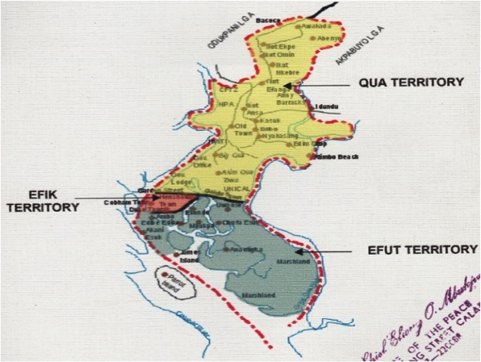
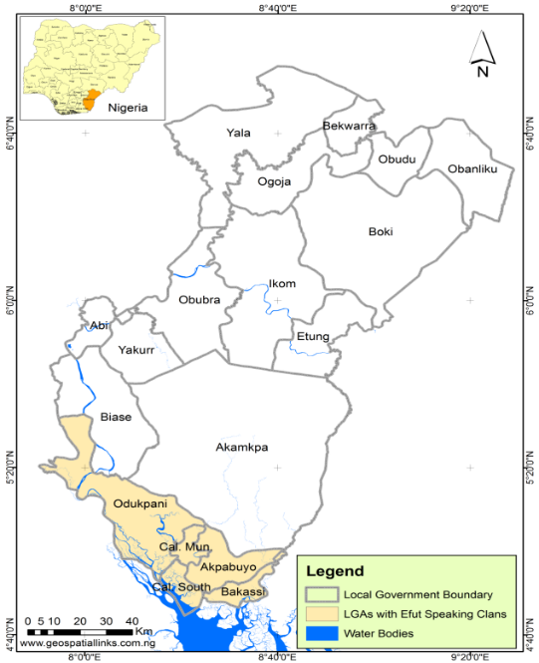
Map I Efut Speaking Local Government Areas in Cross River State, (CRS), Nigeria.

Map II Map of Calabar Demarcating Efut Territory from Efik and Qua in Cross River State.


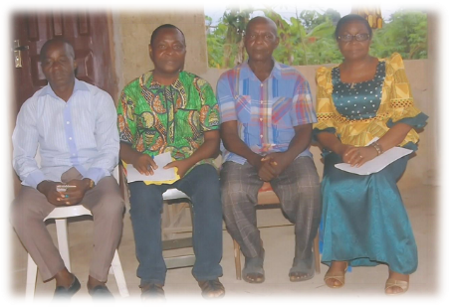
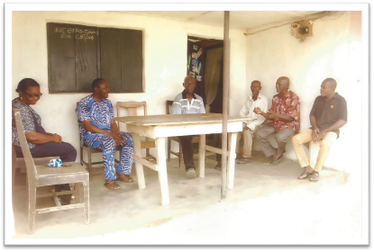

Pix I: Researchers’ Arrival at the Residence of the Village Head of Ikot Effiom

Pix II: Researchers with Main Informant and Chief Gabriel Etim (far left), who piloted the inaugural fieldtrip

Pix III: Main Informant (2nd from right) explains our Fieldtrip Mission to the Village Head of Ikot Effiom

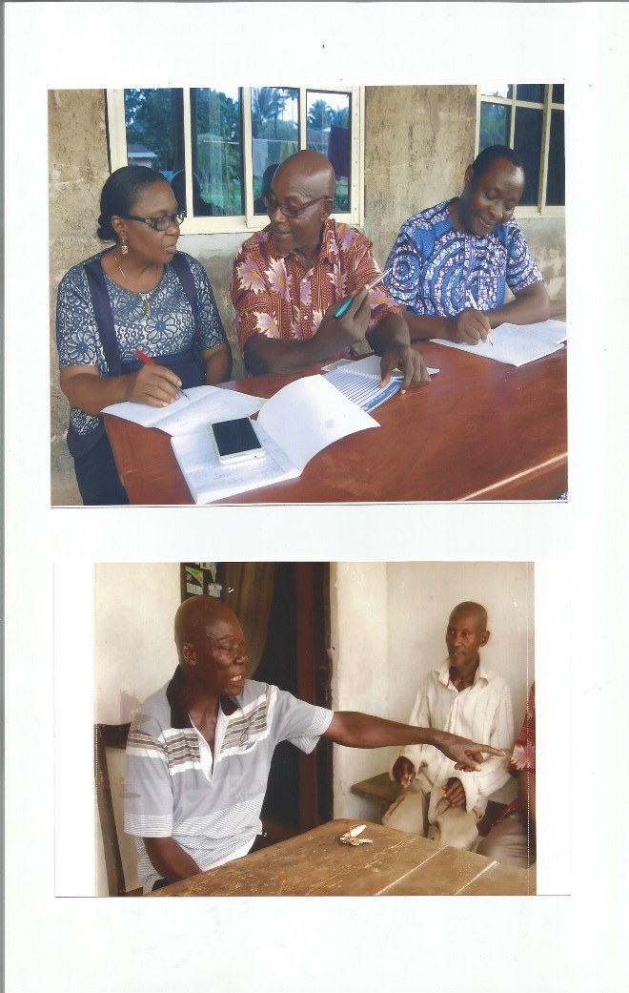
Pix IV: Chief Ekpo Edet Effiom, Village Head of Ikot Effiom, makes an Illustration.

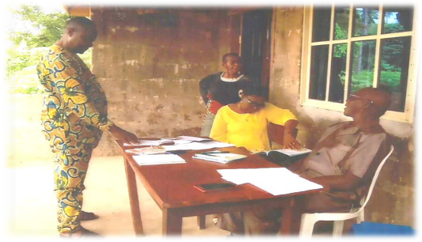

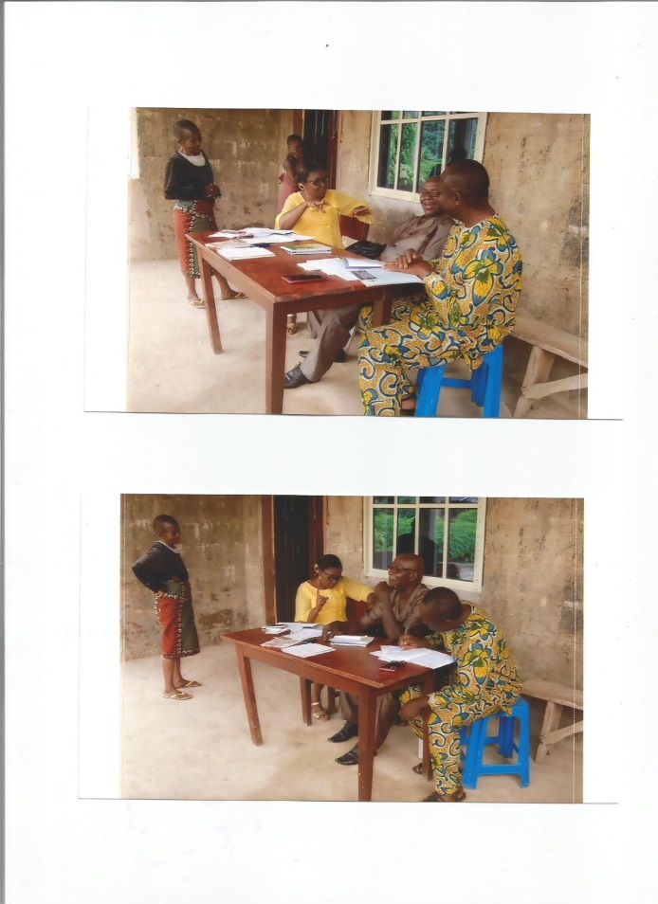
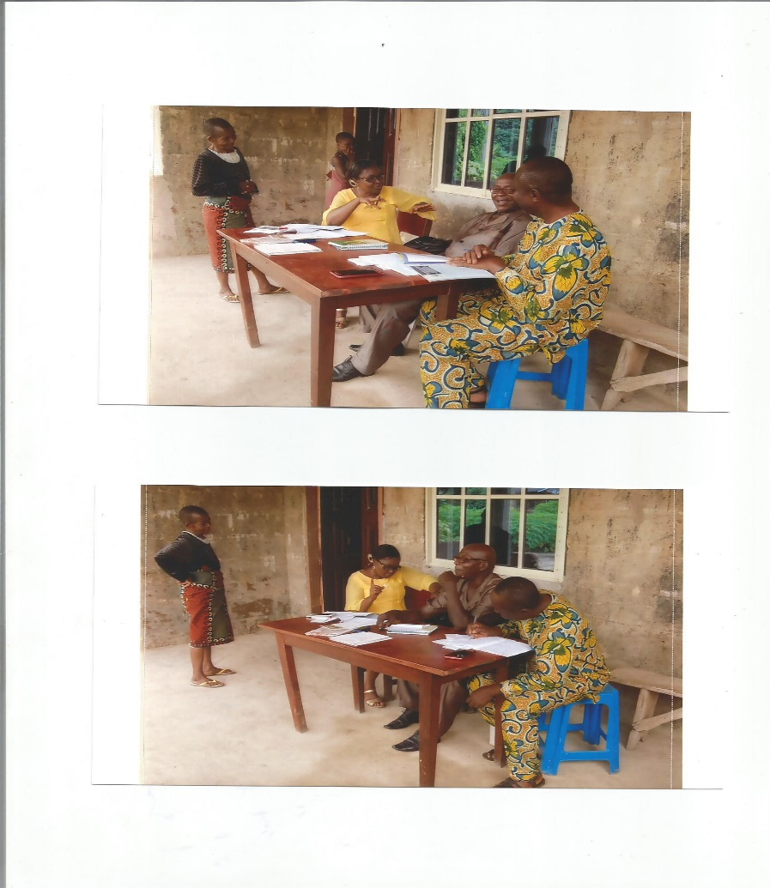
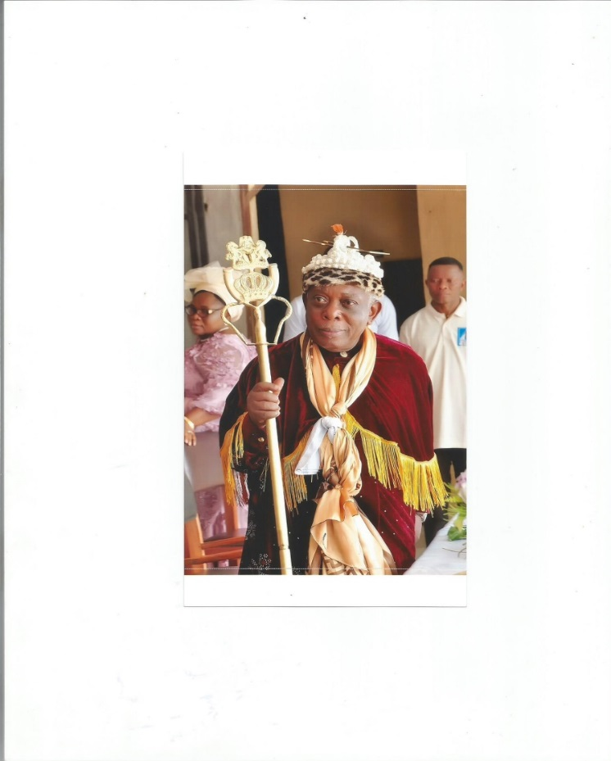
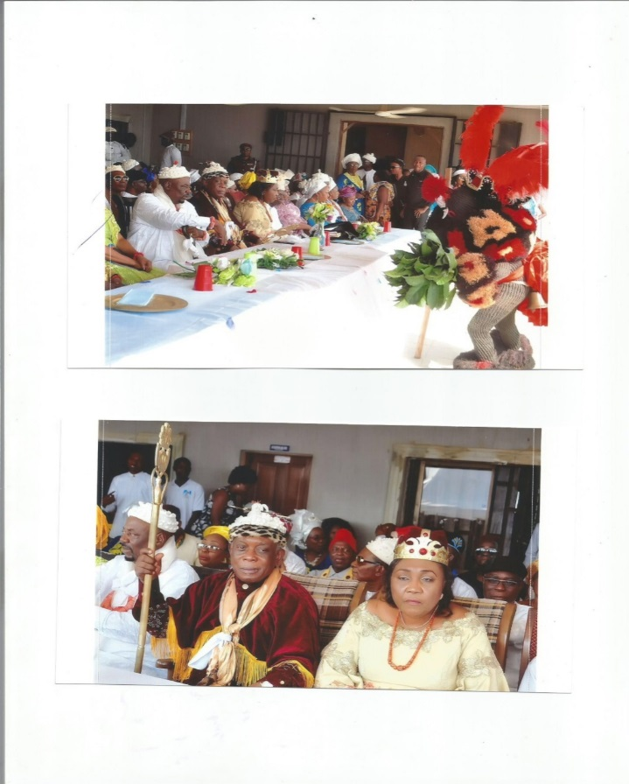
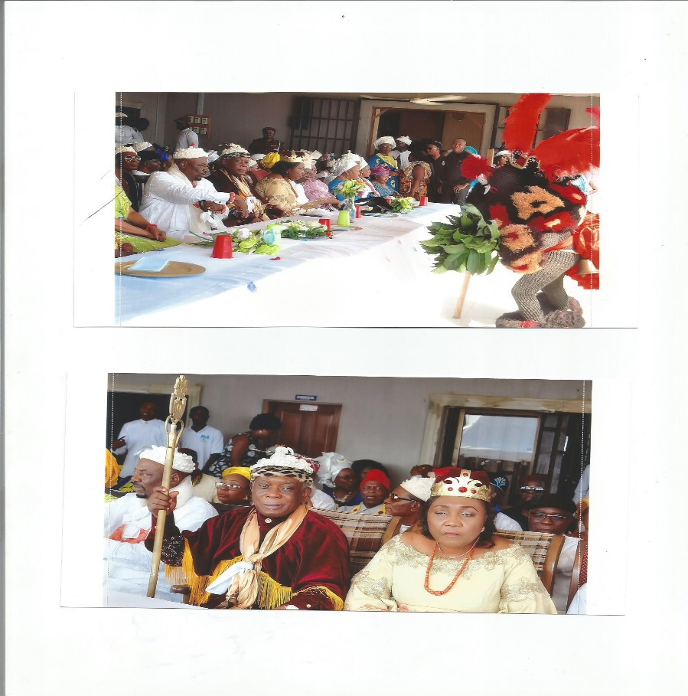
Pix V: Main Informant (male sitting) confirms a point with the 2nd informant (female standing)

Pix VI: Researchers compare notes
(During data collection)

Pix VII: Lead Author reads Efut data for feedback,
Second Author makes notes

Pix VIII: Question and Answer session between Researchers and Informants

Pix IX: Ekpe Masquerade at Muri Munene
Inauguration

Pix X: The Monarch of Efut, HRM Muri Munene,
Prof. Itam Hogan Itam

