The Title Consist of Not More Than 15 Words with Prepositions in Lower Case and in Goudy Old Style Font 14pt

¹Name and ²Name
¹youremail@xxxx.com, ²youremail@xxxx.com
¹Department, Faculty, University, City, Country
²Department, Faculty, University, City, Country

Abstract: Please write your abstract here with the font size and type of lettering as suggested by this template. The abstract is not just a summary of your study. The abstract should introduce readers about your study by stating the purpose of why you decide to choose a certain study to deal with. The method used to analyze and interpret your study is also informed in the abstract, along with the main findings to finalize your abstract. A total of 150-300 words are required for Celt journal’s abstract.
Key words: Key words are words that help readers to be directed to your manuscript when the words are fed into a google search engine. Three to five key words are written here.

Abstrak: Because Celt journal is published in Indonesia, thus, this part is allocated for the translation of the above English abstract into Indonesian. Seperti diinformasikan di atas, dalam abstract bahasa Indonesia, tujuan dari penulisan artikel kemudian metodologi yang dipakai dalam studi yang dibahas, beserta hasil studi atau kajian yang didapat diharapkan untuk diinformasikan dalan abtrak ini. Jumlah kata yang diminta adalah sekitar 150-300 kata. Font yang dipakai adalah italic karena bahasa yang dipakai bukan bahasa Inggris.
Kata kunci: Kata kunci merupakan pilihan kata yang apabila dipakai dalam google search engine, para pembaca akan diberikan pilihan artikel yang antara lain adalah artikel anda. Tiga sampai dengan lima kata kunci diminta untuk dituliskan disini.
INTRODUCTION
Introduction should introduce the reason why you are writing this manuscript or article. If there have been previous studies that inspires you to write or do research on the topic you are going to discuss in this manuscript, then you should mention them here by showing the references (Name of author, 2001, p. 55). Please use the inbuilt computer’s referencing style by clicking the APA. It will help you insert your bibliography with ease.
When you have citations you must follow the APA guidelines. Examples on how to write them are as follows:
In-Text Citations:
- Paraphrased content examples
Imber-Black (2009) found that dogs can be a source of therapy for sick people.
In support of the idea that the drug industry do have a relationship to psychiatry, Smith’s (2008) research show that pharmacists would do annual workshops with psychiatrist.

- Direct Quotes (under 40 words)
Culture is a “a system of belief” that includes… (Hall, 2005, p.13).
Hall (2005) stated that the “system of belief” in culture is …
The study showed that research in culture is “a reflection of…” (Smith & Tyler, 2013, para. 8).
On the other hand, Goddard (2014) believes that “the data was unreliable” (Methods section, para. 6).

- Block Quotes (direct quotes over 40 words)
Indent block quotes five spaces or half an inch and do not use quotation marks. Like used in the rest of the paper, APA block quotes should use double spacing. In block quotes, the period goes before the parentheses. This is different from short quotes.
Williamson states that examining the outcome of research as follows:
The research outcome becomes the most important of the data as it shows the effectiveness of the research performance. Data that is collected from interviews are usually coded first to enable some kind of categorization, which later gives researchers the ability to analyze and present as the outcome. (2008, p. 205)

LITERATURE REVIEW
- Sub title
The literature review section is the place where you talk about the state of the art in detail. You should tell readers the kinds of research, journal articles and books you have been reading to help you decide on why you have decided to do a research or deal with an issue, which you consider interesting to write for this manuscript. Usually this is the portion where many references and citations are seen. An example of what should be written in the Literature Review is as follows.

Positive teacher-student relationship is known to facilitate conducive classroom climate that will enhance students’ learning and interaction in the classroom. A good, positive classroom environment is important because this situation provides the students’ opportunities to feel capable, worthy, and confident. With these feelings, the students’ would feel brave to share, express opinions, ask questions, convey difficulties, and to work without pressure. This condition is supported by Mazer (2012, p. 99 as cited in Da Luz, 2015) who states that students who experience heightened emotional interest are more energized, excited, and emotionally engaged by the material given in the classroom. Nielson & Lorber (2009) also note that exposure towards positive emotional stimuli will make the students able to recall newly learned information better than those who are not given any stimuli.
Upon discussion about the outcome of research, Williamson states that:
The research outcome becomes the most important of the data as it shows the effectiveness of the research performance. Data that is collected from interviews are usually coded first to enable some kind of categorization, which later gives researchers the ability to analyze and present as the outcome. (2008, p. 205)

The above statement from Williamson shows that xxxx xxxx xxxxx xxxx. With regards to this, Allen et al. (2013) classify features of teacher-student relationship into three major domains, i.e. emotional supports, classroom organization, and instructional supports. The emotional link xxx xxxx. The classroom organization xxx xxxx xxxx. Whereas, the instructional supports xxxx xxxx xxxx.
- Another sub title
In teaching using direct instruction, there are some strategies that can be employed in the classroom. Lecturing is one of the strategies used in direct instruction. In lecturing, the teacher XXXX XXXXX XXXX materials orally (Moore, 2012, pp. 23-26). In order to conduct an effective lecturing, the teacher can utilize some technologies as the teaching aids such as films, photograph, and interactive media to get the students’ attention like suggested by Muijs & Reyn (2011) and (Borich, 2017).
In applying the direct instruction, the teacher also provides questioning in the teaching-learning process, which goes through the following steps provided by Kunjono (2018, pp. 103-112) as follows:
- Xxxxxxxx xxxxxxxx
The xxxxx step is the first step to do because xxxxxxx xxxx xxxxx.
- Xxxxxxxx xxxxxxxx
The second step is xxxxx because it is xxxx xxxxxxxxx xxxxxxx. In doing this, a researcher will need to:
- Xxxxx xxxxx xxxx
- Xxxxx xxxxx xxxx
- Xxxxx xxxxx xxxx
There has been other research on the difference between the pragmatic competence of EFL learners and English native speakers. However, Tanck (2012) found that the non-native speakers of English tended to produce inappropriate complaints that may lead to unexpected situations. In addition, the non-native speakers were likely to personalize complaints, which in the American culture can be xxxxx xxxxxx xxxxx.
------- DELETED FOR SAMPLE TEMPLATE PURPOSES -------

METHODOLOGY
To collect the data, I used the XXX data since I want to get a clear picture on the subjects’ pragmatic competence. Hence, the study employed the Discourse Completion Tasks or Discourse Completion Tests (DCTs) (Tanck, 2002; Rinnert, Nogami, & Iwai, 2006; Umar, 2006; O'Keeffe, A., Clancy, B., and Adolphs, S., 2011) which were distributed to Indonesian EFL teachers, Indonesian EFL students and American native-speaker teachers, who were selected based on convenient sampling.
- Type of research
This research makes use of a mixture of quantitative and qualitative type. It is quantitative in the xxxxxx xxxxxx xxxx. This is necessary because Thompson (2015) claims that a research in xxxxx must xxxx xxxxx.
It is qualitative because, the research done has to xxxxx xxxx xxxxx. Thus, being xxxxx in nature, the qualitative aspects is following Henderson’s theory on xxxxxx (2010) to analyze and interpret the xxxxx xxxxxx xxxx .
- Research subjects
There were 30 EFL students from the English Department, of Faculty xxxx in xxxx University in Indonesia; and 15 EFL students from the English Department, of Faculty xxxx in xxxx University in Japan as subjects for the research.
The reason for having students from Indonesia and Japan was to xxxxxx xxxxxx xxxxxx xxxx. Therefore, xxxx xxxxx.
- Research procedure
With regards to a research procedure theorized by Williamson (2019) and Rinnert, Nogami & Iwai (2015), who believe that the following procedures must be made to make the research valid:
1. Interviewing
XXX XXXX XXXX. The purpose of the interview is to clarify the students’ opinion concerning the quality of teacher-student relationship that can develop supportive, positive learning environment. This is in line with Gablinske (2014), who states that “It is very important to… XXX XXXXX.
- Pre-test
Pre-test was administered in the first meeting. Students were asked to write 12 sentences with their own topics for 45 minutes. In doing the pre-test, the students were not allowed to access the internet, nor to consult a dictionary in order that the results reflected their original writing competence. The pre-test result was used as one of the indicators to classify a student’s XXXXXXX XXXX XXXX. However, this pre test XXXX XXXX XXXX.
- Observation
In doing the observation, the teacher used a checklist to observe the student’s participation in the class activities and the student’s behavior. The field notes pertaining to the students’ habit, interaction and behavior were also made. By having observation, the xxxx xxxxx xxxxx.
- Post-test
Post-test is as important as Pre-test for the reason that xxxxxx xxxxx is xxxxx in research, therefore, students who are xxxxx with xxxxx are xxxx xxxxx xxxx
- Questionnaire
Giving out a questionnaire that follows the Technology Acceptance Model (TAM) theorized by Henderson (2016, pp. 34-36) becomes the last procedure in the research. This is necessary in order to xxxxxx xxxxx

RESULTS AND DISCUSSIONS
- Results
The results of this study provide information of how the student’s are xxxx xxxxx. With more positive student’s perception, the more diligent the student could be in coming to class. A number of xxxxxx xxxxx xxxxx, thus, showing that the learning outcome of the students have been gained.
The result was based on the Pre-test, which shows that 13 students gained 12% of the xxxxx xxxxx. By comparison 15 students gained 33% of the xxxx xxxx xxxx for the xxxxx xxxx. Then, 29 students were …., thus making up 20% of the xxxx. The following table shows the result in more detail:
Table 1:
Students’ score range
DELETED FOR SAMPLE TEMPLATE PURPOSES -------
Range | Grade letter | Students | Percentage
81-100 | A | 1, 2, 5, 7, 10, 16, xx, xx… | 12%
71-80 | AB | Xx, xxx, xxx… | 33%
66-70 | B | Xx, xx, xx… | 20%
61-65 | BC | xx | 22%
56-60 | C | xx | 10%
46-55 | D | xx | 1%
0-45 | E | xx | 0%
The students’ level of ability in discussion and comprehension is based on the TAM questionnaire, which informs that, first, xxxxxxx. Second, xxxxx Third, xxxxx Lastly, xxxx xxxxx.
The questionnaire was made on a five-point scale rating from Likert, which finds the following recapitulation:
Table 2:
The recapitulation of the performance before and after
Aspect | Options
Aspect | Strongly Agree | Agree | Disagree | Strongly Disagree
Personal belief | 12.5% | 40.6% | 31.25% | 15.62%
Own checking | 21.8% | 50% | 18.75% | 9.3%
Own editing | 25% | 40.6% | 21.8% | 12.5%

The result as seen in Table 2 confirms that xxxxxxx xxxxxxx. This condition is possible because xxx xxxx xxxxx. The following Figure 1 is proof that xxxx xxxx xxxxx xxxxx.

Figure 1:
The chart of English teacher adjacency pair of xxxx in xxxxx xxxx xxxx

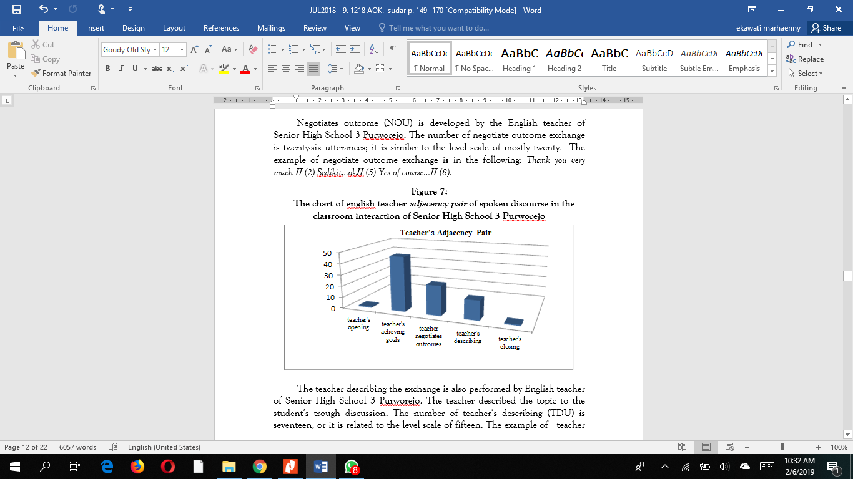

In the students’ perspectives the following result shows that xxxx xxxxx xxxx xxxxxx (see Figure 2):
Figure 2:
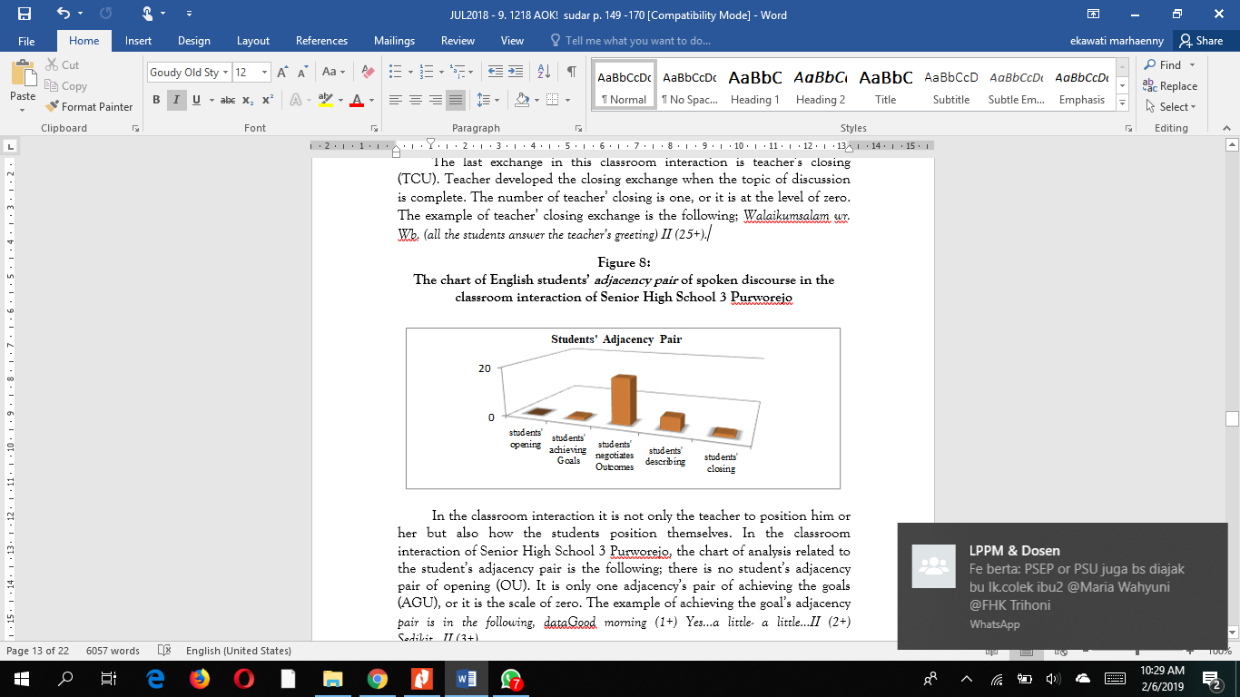
The chart of English students’ adjacency pair of xxx in xxx xxxx xxxx

The teacher’s and students’ opening remarks, thus becomes a xxxx xxxx towards the smooth process of English teaching and learning. For this reason, the best approach given to the Indonesian students are xxxx xxxx xxxx. By comparison, in the case of the Japanese students, the xxxx xxx xxxx.

CONCLUSION
To this point, I have presented how the xxxxx through xxxx ix a xxxx xxxx xxxx. Due to cultural aspects and exposures to the English pragmatic competence, there have been several differences and similarities performed by the Indonesian versus the Japanese.
In a situation that involved no power and social status between the speakers and their interlocutors, the two groups had different preferences for xxxx xxxx xxxxx.
The research, is therefore significant because xxxx xxxxx xxxxx
------- DELETED FOR SAMPLE TEMPLATE PURPOSES -------

ACKNOWLEDGEMENT
Parts of this paper have been presented at the 5th Xxxx Xxx xxxx International Conference in Xxxxx, during 9-11th September 20XX. The conference was a project funded by the Ministry of Xxxxx, Xxxxx, and Xxxxx with contract no. XXX-XXX-XXXX.

REFERENCES
Antoro, B., & Muldian, W. (2015). Buku saku gerakan literasi sekolah Ditjen Dikdasmen Kemendikbud [Pocket book for the school literacy movement Directorate General of Primary and Secondary Education Ministry of Education and Culture].
Bienacki, P., & Waldorf, D. (2010). Snowball Sampling. Sociological Methods and Research, 10(2), 141-163.
Clinkenbeard, P. R. (2012). Motivation and gifted students: Implications of theory and research. Psychology in the Schools, vol. 49(7), 622-630. doi: 10.1002/pits.21628
Egan, D. (Writer), & Alexander, J. (Director). (2008). Failure to communicate [Televison series episode]. In D. Shore (Executive producer), House. New York, NY: Fox Broadcasting.
Eresha, G., Haring, M., Endrass, B., Andr, E., & Obaid, M. (2013). Investigating the Inﬂuence of Culture on Proxemic Behaviors for Humanoid Robots. Proceedings of the 22nd IEEE International Symposium on Robot and Human Interactive Communication, August 26-29, pp. 430-443, Gyeongju, Korea.
Flaws, B. (Trans.) (2014) The classic of difficulties: A translation of the Nan Jing (3rd ed.). Boulder, CO: Blue Poppy Press.
Hall, E. T. (2012). A System for the Notation of Proxemic Behavior. American Anthropologist, 65(5), 1003–1026. doi:10.1525/aa.1963.65.5.02a00020.
Harford, H., & Baird, J. (2009). Cambridge English Lexicon. Cambridge: Cambridge University Press.
Hedge, T. (2015). Resource books for teachers: Writing (2nd ed.). New York: Oxford University Press.
Haryo, G. (2016). Patung tani [Farmer statue] [Photograph]. Retrieved from http://collections.terang.govt.id/object/886583
Jandciu, E., Stewart, J. J., Stoodley, R., Birol, G., Han, A., & Fox, J. A. (2015). Bridging the Gap: Embedding Communication Courses in the Science Undergraduate Curriculum. Journal on Excellence in College Teaching, 26(4), 103-123.
Linse, C. T. (2013). Practical English language teaching: Young learner. (D. Nunan, Ed.). New York: Mc Graw Hill, Inc.
Lucida, N. (2012). Self-discipline in pre-school children. (A. N. Chandra, Trans.). New Jersey, USA: Consultants Bureau.
National Academies (Producer). (2008 June 6). Progress in preventing childhood obesity: How do we measure up? The Sounds of Science Podcast. Podcast retrieved from http://media.nap.edu/podcasts
Ningrum, P. (2010). Personal space pada mahasiswa (Studi pada kelompok mahasiswa di Kantin Fakultas Sastra Universitas Indonesia) [Personal space for students (Study in a group of students in the Canteen of the Faculty of Literature, University of Indonesia)] (Unpublished bachelor thesis. Universitas Indonesia, Jakarta). http://lib.ui.ac.id/ opac/themes/libri2/ detail.jsp?id=20286939&lokasi=lokal
O’Keefe, E. (n.d.). Egoism & the crisis in Western values. Retrieved from http://www.onlineoriginals.com/showitem.asp?itemID=135
Schiraldi, G.R. (2011). Piaget’s theory on cognitive development. [Adobe Digital Editions version]. doi:10.1036/0071393722
Smith, T. (2008, May 18). Psychiatry link with drug industry. Retrieved November 2, 2013, from The New York Times: http//www.nytimes.com
Sonya, T. S. (2009, August 21). Interview by C. A. Budiarto [audio tape recording]. Giong Xi Fa Cai Project, Anthropolgy Association. AA Archievs, Manado.
Ting, J.Y., Florsheim, P. &Huang, W. (2008) Mental health help-seeking in ethnic minority populations: A theoretical perspective. Manuscript submitted for publication.
Van Nuys, D. (Producer). (2017, December 19). Shrink rap radio [Audio podcast]/ Retrieved from http://www.shrinkrapradio.com/
Vansieleghem, N. (2006). Listening to dialogue. Studies in Philosophy and Education, 25(1-2), 175-190.
Yang, Y. C., & Gamble, J. (2013). Effective and practical critical thinking-enhanced EFL instruction. ELT Journal, 67(4), 398-412.
APPENDICES:
Part 1:
Discourse Completion Test
Directions: Please write your response in the blank area. Do not spend a lot of time thinking about what answer you should provide; instead, please respond as naturally as possible and write your response as you feel you would say it in the situation.
A classmate that you have known for a couple of years stops by your desk at the library and invites you to lunch. You want to leave school early today, so you would rather work through lunch to get ahead on your project.
Classmate: “Hi. How have you been? Hey, do you want to go to the cafeteria and get a bite to eat?”
You: ____________________________________________________
--------DELETED FOR SAMPLE TEMPLATE PURPOSE--------

Part 2.
Demographic Information
1. Age and Gender:
2. Nationality:
- Occupation:
- Educational background:
- First language:
Thank You

IN SUBMITTING YOUR MANUSCRIPT, PLEASE ALSO WRITE 15-20 WORDS FOR CELT JOURNAL TO USE AS SUBJECT INDEX. EXAMPLES OF THE CHOICE OF WORDS AND HOW IT WOULD LOOK LIKE IS BELOW:

competence
grammatical competence
language competence
pragmatic competence
complaints
direct complaints
indirect complaints
speech act of complaints
culture
cultural aspect

EFL learner
English language
face-saving strategies
foreign language speakers
interlocutors
morphological
native speaker teachers
phonological
pragmatics

