(Application of Green Architecture Concepts in Wanakota Apartments)
Andiyan; Abdul Gani alfarizi
Architecture Study Program, Faculty of Science and Engineering, Universitas Faletehan
Jl.Parakan Resik No.2 Bandung
andiyanarch@gmail.com
alfarizigani2@gmail.com
Abstract
The shrinking land in urban areas and the worsening world climate crisis have created a new residential development problem. One way to maximize land designated for residential use is to build vertical housing, such as constructing flats and apartments that can accommodate more residents in a limited area. However, it also creates new problems because the use of energy required for a building will be extensive. The application of Green Architecture is an effort to reduce energy use for buildings and reduce the negative impact of buildings on the environment. one helpful reference is applying green architectural concepts. The apartment Wanakota is designed using the green building concept with the Indonesian Green Building Council (GBCI). Wanaka means City Forest, and trees inspire this name as trees. This tree is not only an aesthetic enhancer but as a CO2 absorber and oxygen supplier in the environment.
Keywords: climate crisis, housing, apartment, green architecture.

- INTRODUCTION
The narrower land in urban areas and the increasing number of people is a problem that often occurs in big cities. The need for housing that continues to increase and limited land makes land or the price of an urban dwelling very expensive. (Balaras, C. A., Droutsa, K., Argiriou, A. A., & Asimakopoulos, 2000)
Apart from little ground, big cities also have complex environmental problems, such as clean water, air pollution, and a lack of greening land and water absorption.
With the increasing difficulties, development experts and environmental activists do not remain silent, looking for and researching solutions and answers to these problems.
Vertical housing is one of the options to overcome the limited residential area in urban areas. A standing residence such as an apartment can accommodate more residents. By applying the correct design, problems in dense environments can be resolved well with vertical occupancy.
However, vertical housing also has problems using a lot of energy consumption. Applying green architecture to vertical residences such as apartments is beneficial for reducing energy consumption, reducing greenhouse gases, water treatment, and air improvement.
Big cities in other parts of the country are starting to actively campaign and use the concept of green architecture or sustainable architecture. This is an effort to respond to the climate crisis that is happening and improving the quality of housing and the environment in urban areas. This research is expected to be a reference for his research and can be developed again to a broader scale. (Andiyan,Nurrisman, 2021)

- METHODOLOGY
The design of the Wanakota Apartment is designed by applying the Green architectural concept, which will prioritize the plan with green architectural principles. A method is needed in the stages of collecting data for data analysis. The data will be taken into consideration in planning and designing the apartment. The process of collecting data is by conducting field surveys and precedent studies to obtain activity patterns and space requirements at the apartment. The second step is data analysis by processing data from all the information received and summarizing the data processing results. The third step is a synthesis of the conclusions of the results obtained from each stage to obtain the results in the form of a design concept. The fourth step is design transformation, and the fifth is design by visualizing the design concept into working drawings and 3D in the form of the final design.

- RESULTS AND DISCUSSION
3.1 General Concept
An apartment can be defined as a multi-story building with more than one floor. It collects several residential units, with each room unit having an entire living space, where the residents share the same facilities. (Arsitur Studio, 2020)
The green architecture approach to building design refers to the green building criteria of the Green Building Council Indonesia
- Appropriate Site Development/ASD
- Energy Efficiency & Refrigerant/EER
- Water Conservation/WAC
- Material Resources & Cycle/MRC
- Indoor Air Health & Comfort/IHC
- Building & Environment Management
The shape of the building is processed with climatic and pragmatic concepts to find a form following the environmental conditions and following the climate in the area. (A, Aristia. Putri, m. Rohman, Arif. dan Utomo, 2021)

3.2 Location
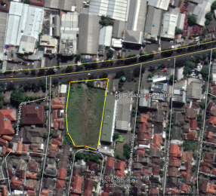
Figure 1. Location map
(Source: Google Earth Pro)
Location :Jl.Soekarno-Hatta, Batununggal, Kec. Bandung Kidul, Bandung City, West Java 40266
Large : 6.335 m²
BCR : 6.335m2x30%=1.900,5m2
FAR 4.0 :6.335m2x4=25.340
GAC 60% :6.335M2X60%=3.801 m2
Number of floors:12
(Source : RDTR Bandung City 2011-2031)

Land Boundary
- North, Jalan Soekarno Hatta
- South, Parakan Waas road
- East, Yamaha Flag ship Shop
-West, Hotel Parakan wangi & PKK Building

3.3 Land use

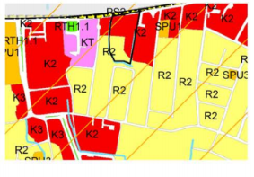
SWK KORDON MAP
Figure 2. Land use
(Source: SWK Kordon Map)
The area around the site is a cultivation zone for a medium-density residential area, government offices, and a service trade cultivation zone.
3.4 Geographical Conditions
Geographically, the Batununggal sub-district, Bandung Kidul Subdistrict, has a flat/undulating area of ​​100% of the total area. Judging from the ground level, sub-district Batununggal is located at an altitude of 500 m above sea level. The maximum and minimum temperatures in sub-district Batununggal. It ranges from 19-27⁰C, while in terms of rain, it ranges from 240 mm/year, and the number of days with the most rainfall is 45 days.

- LAND ANALYSIS
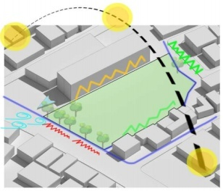
Figure 3. site analysis
(Source: private document)
4.1 Noise Analysis
Problem
- Low noise on the west and south side
Car repair shops cause-Moderate noise in the east
- The high noise on the north side is due to the city artery road
Response
- zoning residential and office areas to the south so that the noise from the road is slightly reduced and does not interfere with the activities of residents and employees.
- plant some trees in the front area to buffer the sound from the road
4.2 Siting Analysis of the Sun
Land extending from north to south requires handling good building period formation and responding well to sunlight. If not paid attention to it can cause neglect problems in the building, building openings must also maintain its comfort.
Response
- The building will use secondary skin to reduce the heat and glare of the afternoon sun.
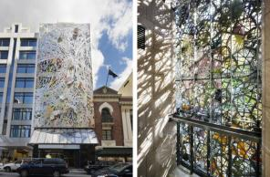
- The building is angled slightly to create a shading effect.

Figure 4. secondary skin
(Source: https://inhabitat.com/wp-content/blogs.dir/1/files/2012/07/Wintergarden-Studio-505-7.jpg)
4.3 Vegetation analysis
` When viewed from the Google Earth satellite imagery, the land is a field that is not planted with trees, pretty shady trees are only on the edge of the land in the north, and one tree in the south.
Response
Planting lots of trees as an effort of greening and land conditioning
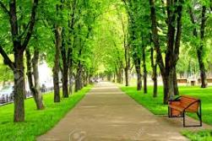

Figure 5. parks and trees
(Source: https://encrypted-tbn0.gstatic.com/images?q=tbn:ANd9GcS3QomTiHSbQ5Wup3fuYEVPOAkB7IxQiCBYXA&usqp=CAU)

4.4 Drainage Analysis
Rainfall in the city of Bandung is relatively high. In the rainy season, the drainage channels are always total and even cause a flood, the drainage channel around the site, especially on the west side, is small drainage that also borders Homes.
Response
I am creating retention ponds and infiltration wells to reduce water runoff directly leading to city drainage channels.
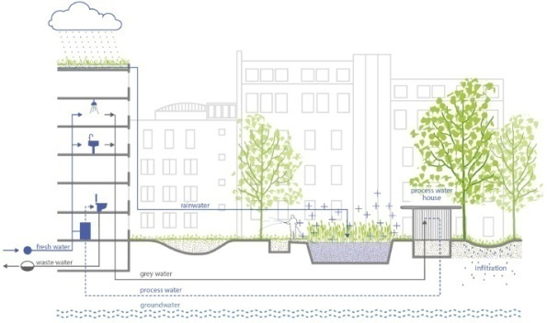
Figure 6. infiltration wells
(Source:https://newberkeley.files.wordpress.com/2016/01/ infiltration wells.jpg)
4.5 Contextual Analysis
Judging from the data of Kelurahan Batunggal, it is known that the most significant number of jobs include students/university students, private employees, so that the building can be used and useful for the surrounding community, co-working space and micro-library facilities are added, this function is also as a support for the priority education program of Batunggal sub-district.(Slezkine, 1994)
Judging from the data on Park entertainment facilities in Batununggal Village, there are only three pieces. With a relatively dense population, the presence of public spaces can help become community recreation choices.(Kwak, Min Jung, Yoo Suk Hong, 2007)
In addition, it can be seen from the data on sports facilities in Batununggal village that it does not yet have a basketball court for the general public. The basketball court can be added to public apartment facilities in Tamarah provides a jogging track for apartment residents and the community. The public space also functions as a performance space for art and cultural activists in the Batununggal sub-district.(Garcia, D. Astiaso, 2014)
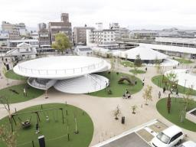
Figure 7. Public Area
(Source:https://inhabitat.com/wp-content/blogs.dir/1/files/2017/06/CoFuFun-by-Nendo-4-889x666.jpg)

- CONCEPT OF DESIGN
5.1 Green Building
- Appropriate Site Development
his category includes access to public facilities, reduced vehicles, Motorized rain, use of bicycles, landscaping green plants, heat island efficiency, reduction of the load volume of rainwater runoff, site management, attention to surrounding buildings or facilities. (Proulx, 1995)
- Energy Efficiency and Conservation
This category includes the optimization of the efficiency of energy use In buildings, re-commissioning of air conditioning equipment, saving energy on lighting and air conditioning systems, recording And supervision of energy use, operation, and maintenance of air conditioning equipment,
Use of renewable energy and reduction of energy emissions. (John, 1996)
- Water Conservation
The Water Conservation category includes sub-metering water consumption, maintenance and Checking the plumbing system, the efficient use of clean water, testing water quality, using recycled water, using the filtration system to produce drinking water, reducing the use of water from deep wells, and using kranauto stop. (Balaras, C. A., Droutsa, K., Dascalaki, E., & Kontoyiannidis, 2005)
- Indoor Health and Comfort
This category includes indoor air quality, environmental regulation of cigarette smoke, monitoring of CO2 and CO gases, measuring indoor air quality, size of visual comfort, measurement of sound levels, and survey of building comfort.(Cohen, S., Glass, D. C., & Singer, 1973)
- Material Resources and Cycle
This category includes refrigerant use, friendly materials environment, waste management, waste sorting, hazardous waste management, and distribution of used goods.(Chau, K., Ma, V., & Ho, 2001)
5.2 Building Mass Concept
Site size and shape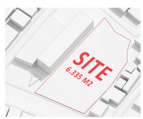
Figure 8.site
(Source: Private document)
The area is built according to regulations
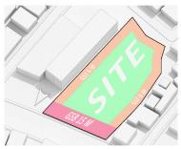
Figure 9. awakened area
(Source: Private document)
Added horizontal zoning
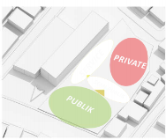
Figure 10.Zoning
(Source: Private document)
Addition of podium floors 1 and 2 apartments.
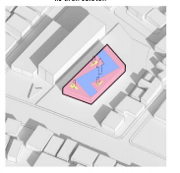
Figure 11.massing 1
(Source: Private document)
Additional apartment tower mass.
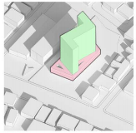
Figure 12.massing 2
(Source: Private document)
Additional areas to be planted with trees
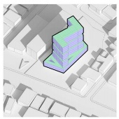
Figure 13.massing 3
(Source: Private document)

5.3 Facade Concept
The facade of this apartment building uses two concepts: the application of metal cladding as a second skin in the podium area and the concept of a tree as the building facade.
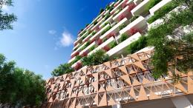
Figure 14. Facade Concept
(Source: Private document)

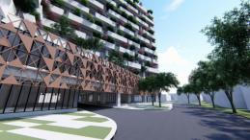

Figure 15. Facade Concept
(Source: Private document)

5.4 Structure Concept
The structural concept used is the rigid frame structure, a load-bearing frame with straight or curved members and is connected by most rigid joints, which withstand the motion induced in the movement of member's joints. The members can take bending, shear, and axial loads.

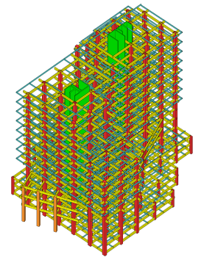

Figure 16. Structure Concept
(Source: Private document)
VII. CONCLUSION
The apartment Wanaka OTA is designed using the green building concept with the Indonesian Green Building Council (GBCI). Wanaka means City Forest, trees inspired this name as trees. This tree is not only an aesthetic enhancer but as a CO2 absorber and oxygen supplier in the environment.

BIBLIOGRAPHY
A, Aristia . Putri, m. Rohman, Arif . dan Utomo, C. (2021). Penilaian Kriteria Green Building pada Gedung Teknik Sipil ITS. Jurnal Teknik ITS, 1(1).
Andiyan,Nurrisman, O. (2021). Implementation of the New Function of the Sarinah Braga Building ( Hotel De Braga By Artotel ). Solid State Technology, 7. https://www.solidstatetechnology.us/index.php/JSST/article/view/10569
Arsitur Studio. (2020). definisi Apartemen menurut para ahli. https://www.arsitur.com/2017/03/pengertian-definisi-apartemen-menurut.html
Balaras, C. A., Droutsa, K., Argiriou, A. A., & Asimakopoulos, D. N. (2000). Potential for energy conservation in apartment buildings. Energy and Buildings.
Balaras, C. A., Droutsa, K., Dascalaki, E., & Kontoyiannidis, S. (2005). Energy and Buildings.
Chau, K., Ma, V., & Ho, D. (2001). The pricing of “luckiness” in the apartment market. Journal of Real Estate Literature.
Cohen, S., Glass, D. C., & Singer, J. E. (1973). Apartment noise, auditory discrimination, and reading ability in children. Journal of Experimental Social Psychology.
Garcia, D. Astiaso, et al. (2014). Eco-architecture, and sustainable mobility: An integrated approach in Ladispoli town. WIT Transactions on the Built Environment.
John, B. (1996). Mass transportation, apartment rentals, and property values. Journal of Real Estate Research.
Kwak, Min Jung, Yoo Suk Hong, and N. W. C. (2007). Eco-architecture analysis as a method of end-of-life decision making for sustainable product design. International Design Engineering Technical Conferences and Computers and Information in Engineering Conference, 48043.
Proulx, G. (1995). Evacuation time and movement in apartment buildings. Fire Safety Journal.
Slezkine, Y. (1994). The USSR as a communal apartment, or how a socialist state promoted ethnic particularism. Slavic Review.

