APPENDICES
Appendix A: DLSU-D ERC Certification

Appendix B: Pre-survey Results (Sample)
CODE | PROFILE | RESPONSES
SP 1 | Female, daily passenger | “Mahalaga ang pasensya; walang influence ng alak; kalmado palagi at sumusunod sa rules and regulations”
SP 2 | Male, non-professional driver | “Mentally fit ang driver sir if hindi agad mainitin ang ulo niya sa kalsada at kapag marunong siyang magparaya sa ibang driver.”  “Para sakin po is kung nag dadrive ka dapat po ay wala kang ibang ginagawa kundi humawak sa manibela and shift knob. Anything na gawin mo na wala naman po relate sa pagddrive mo while the car is moving ay pwedeng maging sanhi ng kahit anong aksidente sayo or sa paligid mo.”  “Minsan po naiinip, kasi yung ibang pedestrian lalo na kapag wala naman sa pedestrian crossing na tumatawid. And minsan naman kasi yung iba is yung tapos na yung signal light for pedestrian e humahabol pa kaya naiinip. Pero ako naman po is kapag may nakikita akong tumatawid lalo na kung may edad na or bata is pinagbibigyan ko na.”  “…opo sir minsan. Kasi po sa area po aming sobrang daming tricycle and jeepney. Hindi naman lahat pero karamihan sa kanila is hindi nag sasakay or bababa sa tamang lugar. Minsan yung iba naman oovertake ng biglaan ng walang signal. Yung iba naman minsan gumigitna kahit mabagal…”
Note: SP = Survey Participant

Appendix C: Interview Transcription (Sample)
Pseudonym: Marcos (Interviewee 1)
Date: 07/20/2019 Location: Brgy. Sampaloc 1, Dasmariñas, Cavite
1  2  3  4  5  6  7  8  9  10  11  12  13  14  15  16  17  18 | L: bale ang tanong ko lang sayo, pano mo masasabi if mentally fit ang isang driver, ano yung mga characteristics ng isang driver based dun sa aming experience mo na parang masasabi mon a mentally fit siya  M: siguro una yung sa pagiging responsible driver or defensive driver yung term nila dun sa LTO. Kasi pag sinabi mo aming defensive driver di naman ibig sabihin nun, porket nasa tama ka, lagi ka ng mag… or ipupush mo na yung sarli mo sa situation na tama ka… pag sinabing defensive driver naman kasi, kahit minsan mali ka na, or I mean tama ka na, tas mali yung kasabay mo sa kalsada, pero nag give way ka, yun yung parang masasabi mong mentally fit ka dun kasi you can observe kung ano yung possible na mangyayaring masama kapag nakipagsabayan ka sa mali  L: so ibig sabihin, mapagbigay?  M: oo parang ganun, mapagbigay ka sa daan, ahmm observant, pag sinabi mo naman kasing observant, kelangan yung focus mo hindi lang sa speed mo sa highway, kelanga I check mo din yung mga pedestrian sa gilid kailangan maging observant pati yung sa mga traffic signs, kasi minsan, one way na pala or bawal pala mag u-turn dun tas mag u-turn ka  L: minsan naganun mo na, parang pumasok ka dun sa one way pala, hindi mo napansin, or inoobserve mo talaga, binabantayan mo talaga?  M: ako kasi kabisado ko yung dun sa phase namin so alam ko kung san yung mga one way kaya hindi pa naman ako nakakadaan sa mga one way  L: may mga instances ba na parang bigla na lang nagkaroon ng aberya yung sasakyan?  M: oo, ang ginawa ko nung nangyari, ay tinry ko muna kung magagawa ko ng paraan, pero nung wala talaga, pinababa ko yung kasama ko sa sasakyan para tumulong siya mag ayos ng traffic kasi nasa traffic light kami nun eh, stop light, so magccause ng traffic yun kapag walang mag aassit, syempre yung mga nasa likod, di naman nila alam na may problema yung sasakyan, so ang ginawa ko, pinababa ko agad yung kasama ko sa sasakyan para i-assist yung, yung mga sasakyan habang finifigure out ko kung anong gagawin ko dun sa sasakyan.

Appendix D: Initial Items Generated (Sample)
No | Items Generated | Filipino Translation | Supporting  Pre-survey/ Interview Transcription | Supporting Literature Review
1 | A driver who feels drowsy while driving  - should drive faster to reach the destination quick  - ?  - should find a place to stop and rest | Ang isang drayber na nakararamdam ng antok habang nagmamaneho  - ay dapat magmaneho ng mas mabilis upang makarating agad sa kanyang destinasyon  - ?  - ay dapat humanap ng lugar kung saan maaring huminto at magpahinga | “…Mas maganda kapag medyo nakakaramdam ka ng antok, ipahinga mo saglit, or mas maganda, yung may kausap ka…  Mas okay nga siya kapag long drive na may kausap ka kasi kahit papano, hindi ka nabobore sa byahe, hindi ka na aantok…”  (Interviewee 1) | Schwarz, J., Geisler, P., Hajak, G., & Zulley, J. (2015). The effect of partial sleep deprivation on computer-based measures of fitness to drive. Sleep And Breathing, 20(1). doi:10.1007/s11325-015-1220-0  Bener, A., Yildirim, E., Özkan, T., & Lajunen, T. (2017). Driver sleepiness, fatigue, careless behavior and risk of motor vehicle crash and injury: Population based case and control study. Journal of Traffic and Transportation Engineering, 4(5), 496-502. doi:/10.1016/j.jtte.2017.07.005
2 | I will not hesitate to find a place to rest if I find myself having intolerable discomfort while driving.  - True  - ?  - No, I will just endure | Hindi ako mag aatubiling humanap ng lugar kung saan maaring magpahinga kapag nakaramdam ako ng hindi matiis na kakulangan sa kaginhawaan habang nagmamaneho.  - Totoo  - ?  - Hindi, titiisin ko na lamang | “…actually, oo yun yung nagiging problema, sa mga long drive kaya kapag long drive ka lalo gabi, tas malamig yung paligid, medyo ano, medyo comfortable, comfy yung environment, mas maganda kapag medyo nakakaramdam ka ng antok, ipahinga mo saglit…”  (Interviewee 1) | Schwarz, J., Geisler, P., Hajak, G., & Zulley, J. (2015). The effect of partial sleep deprivation on computer-based measures of fitness to drive. Sleep And Breathing, 20(1). doi:10.1007/s11325-015-1220-0  Bener, A., Yildirim, E., Özkan, T., & Lajunen, T. (2017). Driver sleepiness, fatigue, careless behavior and risk of motor vehicle crash and injury: Population based case and control study. Journal of Traffic and Transportation Engineering, 4(5), 496-502. doi:/10.1016/j.jtte.2017.07.005

Appendix E: Validation of Filipino Translation (Sample)
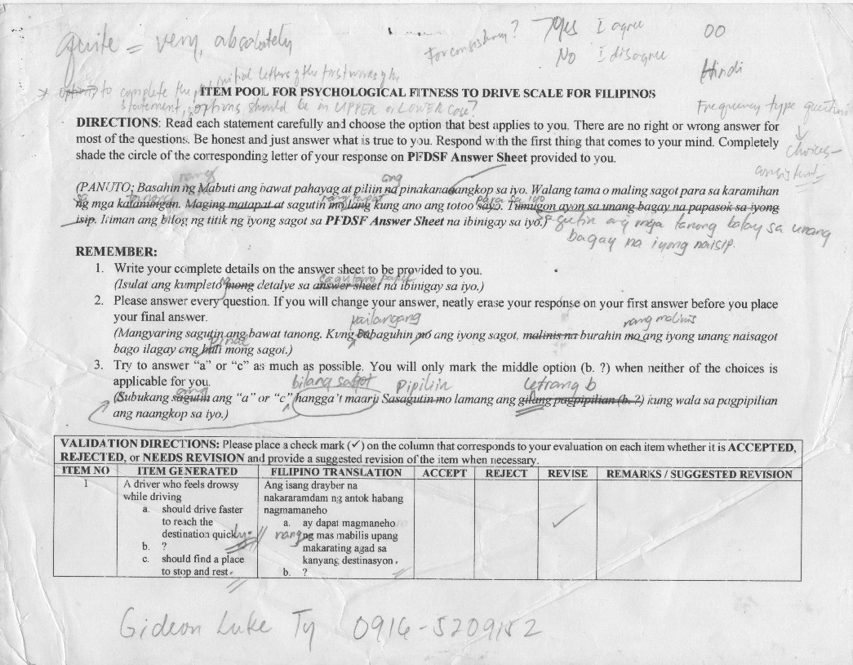
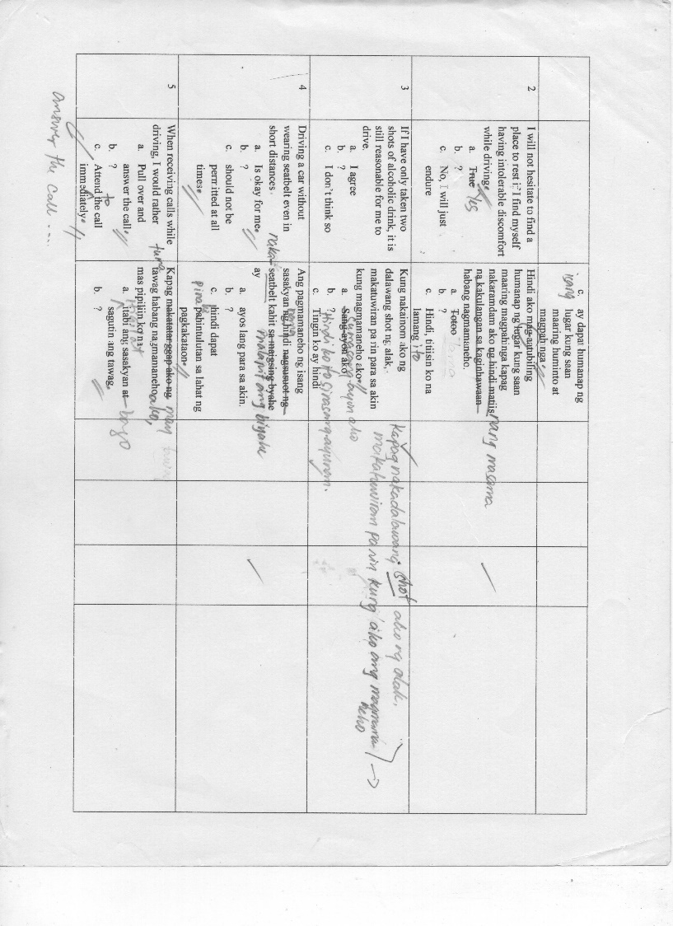

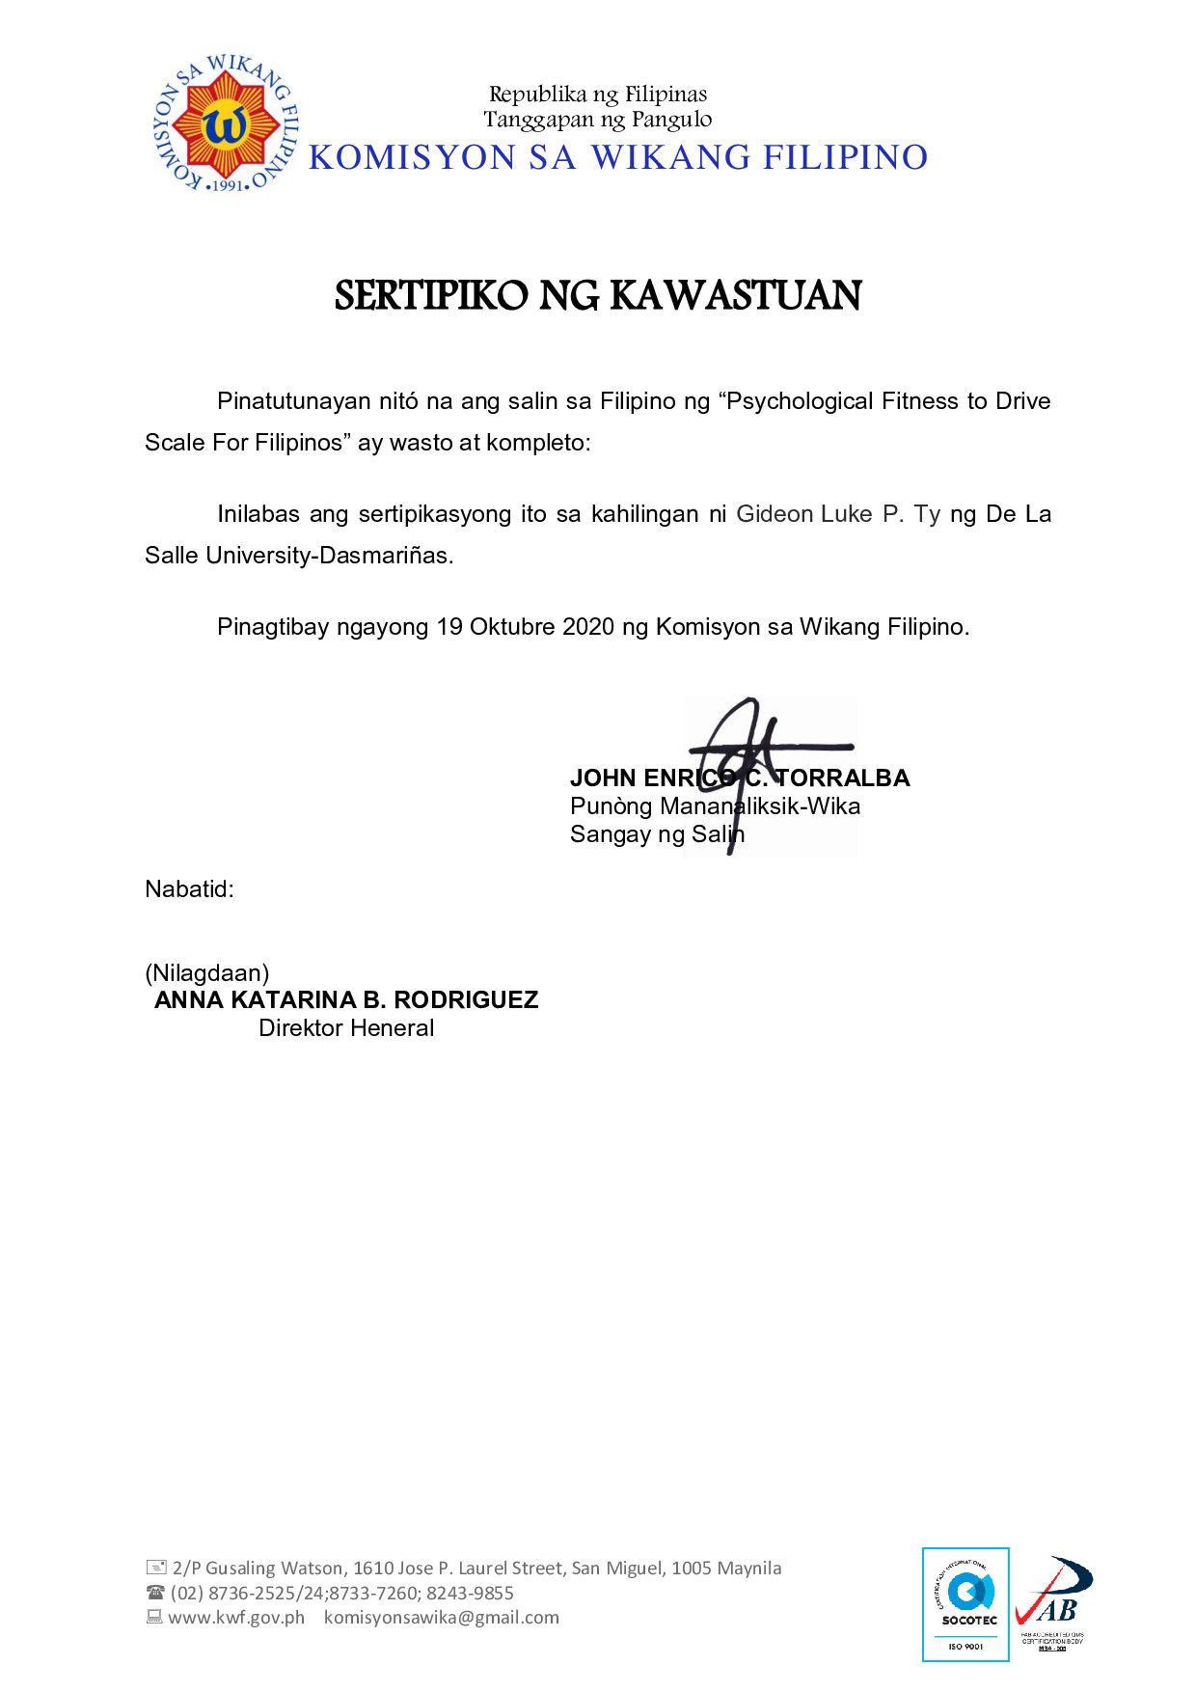

Appendix F: Digital Poster for Pilot Testing and Field Testing

Appendix G: Sample Test Booklet (English)

Appendix H: Sample Test Booklet (Filipino)
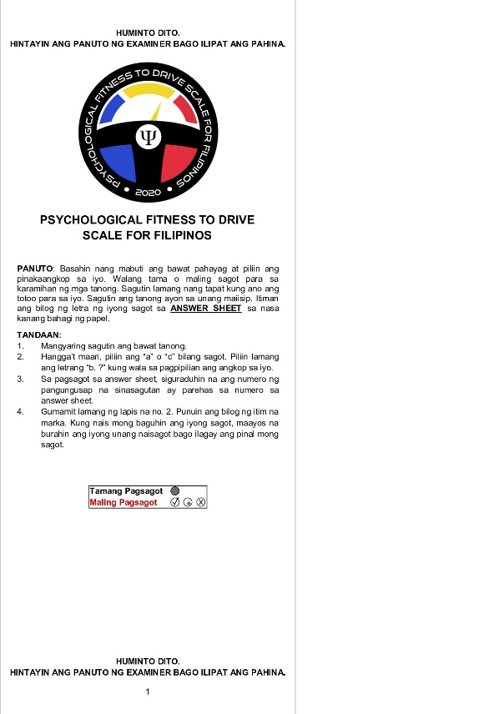

Appendix I: Certificate of Statistical Analysis
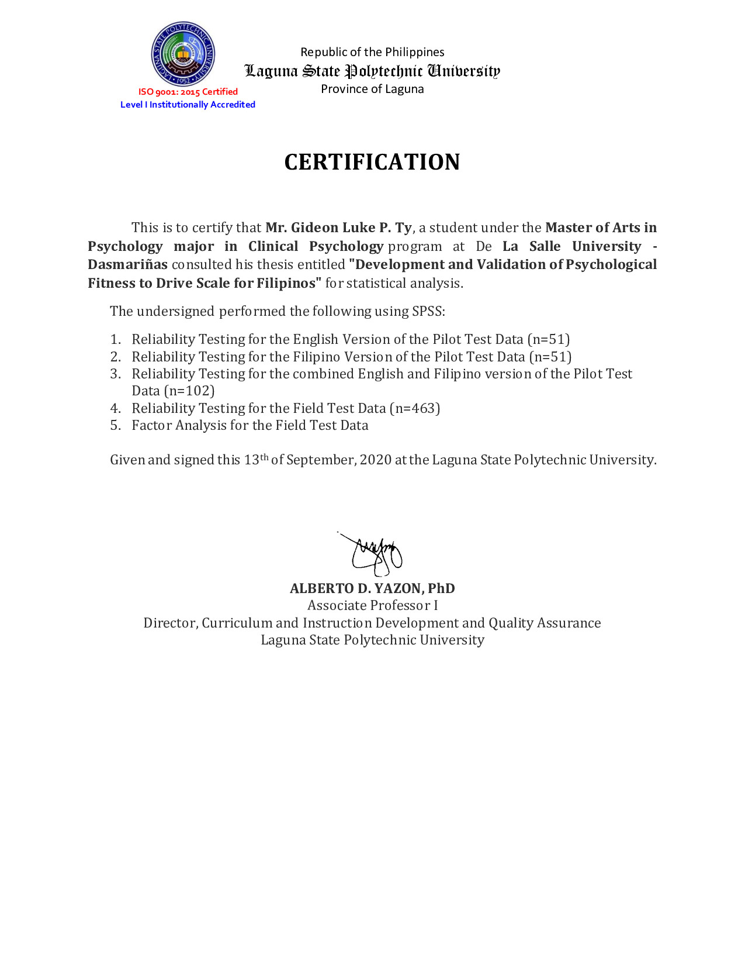

Appendix J: Result of Statistical Analysis
- Result of Reliability Analysis for Pilot Testing
How to Interpret the Reliability Index?
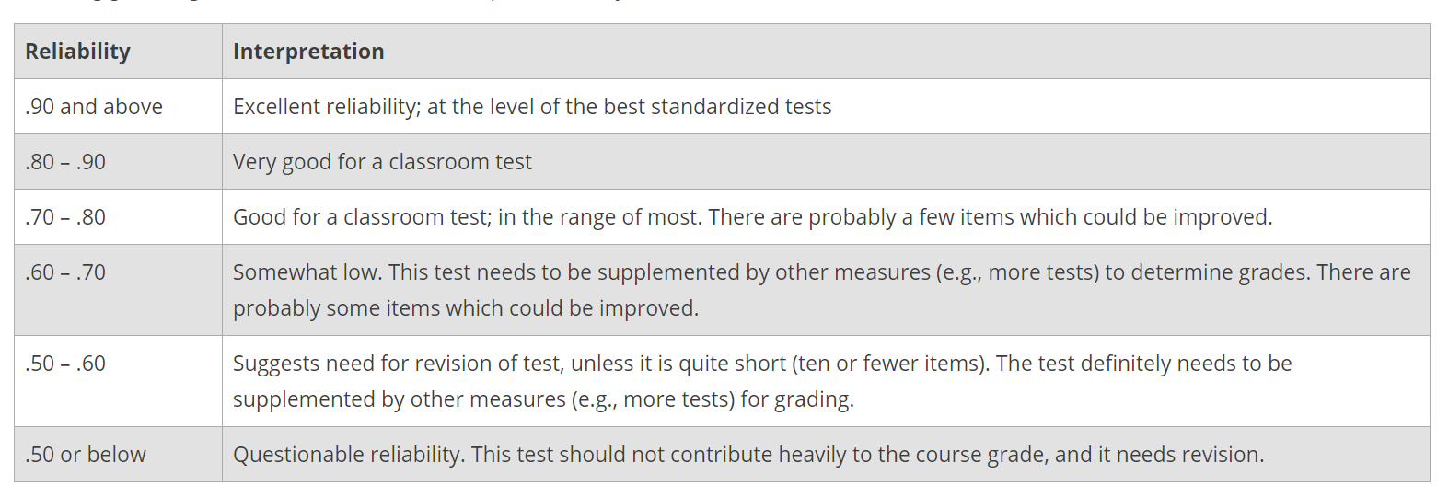
Source: ScorePak® is Cronbach’s Alpha; https://www.washington.edu/assessment/scanning-scoring/scoring/reports/item-analysis/

Reliability (English Version)
Scale: ALL VARIABLES
Case Processing Summary
 |  |  | N |  | %
Cases | Valid |  | 43 |  | 84.3
 | Excludedª |  | 8 |  | 15.7
 | Total |  | 51 |  | 100.0
a. Listwise deletion based on all variables in the procedure.
Reliability Statistics
Cronbach's Alpha |  | N of Items
.879 |  | 154
VERY GOOD RELIABILITY

Reliability (Filipino Version)
Scale: ALL VARIABLES
Case Processing Summary
 |  |  | N |  | %
Cases | Valid |  | 42 |  | 82.4
 | Excludedª |  | 9 |  | 17.6
 | Total |  | 51 |  | 100.0
a. Listwise deletion based on all variables in the procedure.
Reliability Statistics
Cronbach's Alpha |  | N of Items
.907 |  | 154
EXCELLENT RELIABILITY

Reliability (English and Filipino Version)
Scale: ALL VARIABLES
Case Processing Summary
 |  |  | N |  | %
Cases | Valid |  | 85 |  | 83.3
 | Excludedª |  | 17 |  | 16.7
 | Total |  | 102 |  | 100.0
a. Listwise deletion based on all variables in the procedure.
Reliability Statistics
Cronbach's Alpha |  | N of Items
.891 |  | 154
VERY GOOD RELIABILITY

- Result of Initial Reliability Analysis for Field Testing
Reliability (FIELD TESTING DATA)

Scale: ALL VARIABLES
Case Processing Summary
 |  | N | %
Cases | Valid | 463 | 100.0
 | Excludedª | 0 | .0
 | Total | 463 | 100.0
a. Listwise deletion based on all variables in the procedure.

Reliability Statistics
Cronbach's Alpha | N of Items
.966 | 154

EXCELLENT RELIABILITY

- Result of First Exploratory Factor Analysis
FACTOR ANALYSIS
KMO and Bartlett's Test
Kaiser-Meyer-Olkin Measure of Sampling Adequacy. |  | .905
Bartlett's Test of Sphericity | Approx. Chi-Square | 38245.145
 | df | 11781
 | Sig. | .000

The communalities of the indicators in each factor are above .30, which can be described as moderate to high. This may indicate that the variables chosen for this analysis are substantially related with each other. The value for Kaiser-Meyer-Olkin Measure of Sampling Adequacy (KMO) which is equal to .905 clearly indicates a very satisfactory factor analysis. Bartlett’s Test of Sphericity, which lets us know if there is a relationship between the variables, generated a p value < 0.05 denotes that there are significant relationships between the factors.
One hundred fifty – four (154) items relating to Psychological Fitness to Drive were factor analyzed using principal component analysis (PCA) with Varimax (orthogonal) rotation. The analysis yielded forty – two (42) factors (eigenvalues > 1) explaining a total of 68.37% of the variance for the entire set of variables (SEE DETAILED RESULTS IN EXCEL FILE).

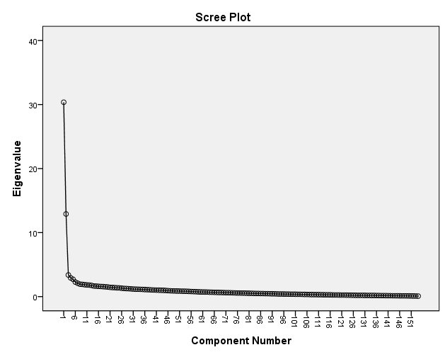
- Result of Second Factor Analysis
Factor Analysis with 154 items on two factors
Descriptive Statistics
 | Mean | Std. Deviation | Analysis N
VAR00001 | 1.5313 | .82611 | 463
VAR00002 | 1.4600 | .86165 | 463
VAR00003 | 1.7667 | .59727 | 463
VAR00004 | 1.4060 | .88232 | 463
VAR00005 | 1.4600 | .86165 | 463
VAR00006 | 1.7732 | .59795 | 463
VAR00007 | .8747 | .96333 | 463
VAR00008 | 1.4536 | .85881 | 463
VAR00009 | 1.6739 | .69903 | 463
VAR00010 | 1.5054 | .83968 | 463
VAR00011 | 1.3888 | .89252 | 463
VAR00012 | 1.6803 | .67531 | 463
VAR00013 | 1.5767 | .77993 | 463
VAR00014 | .8661 | .94628 | 463
VAR00015 | 1.6458 | .72061 | 463
VAR00016 | 1.5464 | .80414 | 463
VAR00017 | 1.6782 | .69483 | 463
VAR00018 | 1.7754 | .60058 | 463
VAR00019 | 1.5896 | .77296 | 463
VAR00020 | .7279 | .93247 | 463
VAR00021 | 1.8164 | .53330 | 463
VAR00022 | .9266 | .96643 | 463
VAR00023 | 1.7106 | .66648 | 463
VAR00024 | 1.2462 | .93966 | 463
VAR00025 | 1.5162 | .82655 | 463
VAR00026 | 1.0540 | .99962 | 463
VAR00027 | .8510 | .98990 | 463
VAR00028 | .3456 | .75694 | 463
VAR00029 | 1.6674 | .70677 | 463
VAR00030 | 1.7387 | .63344 | 463
VAR00031 | 1.2441 | .94367 | 463
VAR00032 | 1.3823 | .88437 | 463
VAR00033 | 1.6069 | .75658 | 463
VAR00034 | 1.3218 | .90100 | 463
VAR00035 | 1.6156 | .60225 | 463
VAR00036 | 1.6717 | .70573 | 463
VAR00037 | 1.7171 | .66113 | 463
VAR00038 | 1.6890 | .68568 | 463
VAR00039 | 1.6631 | .71689 | 463
VAR00040 | 1.7948 | .56887 | 463
VAR00041 | 1.9525 | .21297 | 463
VAR00042 | 1.9590 | .19859 | 463
VAR00043 | .7883 | .94119 | 463
VAR00044 | 1.6933 | .69701 | 463
VAR00045 | .4471 | .79290 | 463
VAR00046 | 1.2829 | .91634 | 463
VAR00047 | 1.7041 | .66199 | 463
VAR00048 | 1.6328 | .72012 | 463
VAR00049 | 1.6868 | .68311 | 463
VAR00050 | 1.0540 | .96435 | 463
VAR00051 | 1.0648 | .97374 | 463
VAR00052 | 1.4600 | .84900 | 463
VAR00053 | 1.7041 | .67494 | 463
VAR00054 | .8920 | .96093 | 463
VAR00055 | 1.2073 | .94902 | 463
VAR00056 | 1.3261 | .91376 | 463
VAR00057 | 1.5810 | .76265 | 463
VAR00058 | 1.6544 | .72181 | 463
VAR00059 | 1.6415 | .73042 | 463
VAR00060 | 1.4708 | .83660 | 463
VAR00061 | 1.2808 | .93917 | 463
VAR00062 | 1.7473 | .61270 | 463
VAR00063 | .4644 | .81006 | 463
VAR00064 | 1.3888 | .87290 | 463
VAR00065 | 1.6868 | .69878 | 463
VAR00066 | 1.9136 | .28125 | 463
VAR00067 | 1.9222 | .26807 | 463
VAR00068 | 1.9330 | .25021 | 463
VAR00069 | 1.6112 | .76450 | 463
VAR00070 | 1.6156 | .74376 | 463
VAR00071 | 1.8099 | .54905 | 463
VAR00072 | .9762 | .95203 | 463
VAR00073 | 1.4212 | .86649 | 463
VAR00074 | 1.0670 | .97026 | 463
VAR00075 | 1.6004 | .77163 | 463
VAR00076 | 1.1987 | .94859 | 463
VAR00077 | 1.4017 | .89404 | 463
VAR00078 | 1.2721 | .91844 | 463
VAR00079 | 1.4190 | .87623 | 463
VAR00080 | 1.3067 | .92401 | 463
VAR00081 | 1.7019 | .66265 | 463
VAR00082 | 1.1857 | .94894 | 463
VAR00083 | 1.2894 | .90599 | 463
VAR00084 | 1.3261 | .91376 | 463
VAR00085 | 1.0432 | .97272 | 463
VAR00086 | 1.3521 | .90407 | 463
VAR00087 | 1.6048 | .74245 | 463
VAR00088 | 1.1901 | .95264 | 463
VAR00089 | 1.1210 | .94574 | 463
VAR00090 | 1.3261 | .91376 | 463
VAR00091 | 1.7927 | .58126 | 463
VAR00092 | 1.6933 | .69077 | 463
VAR00093 | 1.3024 | .92543 | 463
VAR00094 | 1.6868 | .69255 | 463
VAR00095 | 1.6220 | .76001 | 463
VAR00096 | 1.4060 | .86748 | 463
VAR00097 | 1.6890 | .68568 | 463
VAR00098 | 1.2873 | .92908 | 463
VAR00099 | 1.6782 | .69171 | 463
VAR00100 | 1.4060 | .88721 | 463
VAR00101 | 1.7948 | .57266 | 463
VAR00102 | 1.5313 | .79948 | 463
VAR00103 | 1.5810 | .76265 | 463
VAR00104 | 1.7343 | .64520 | 463
VAR00105 | 1.4536 | .85881 | 463
VAR00106 | 1.3866 | .88249 | 463
VAR00107 | 1.6609 | .71738 | 463
VAR00108 | 1.7019 | .67559 | 463
VAR00109 | 1.2246 | .93586 | 463
VAR00110 | 1.1879 | .94509 | 463
VAR00111 | 1.0778 | .96833 | 463
VAR00112 | 1.6156 | .72609 | 463
VAR00113 | .6955 | .89981 | 463
VAR00114 | 1.1577 | .94604 | 463
VAR00115 | 1.5918 | .75571 | 463
VAR00116 | 1.6544 | .71881 | 463
VAR00117 | 1.0713 | .96771 | 463
VAR00118 | 1.5961 | .77218 | 463
VAR00119 | 1.6739 | .68968 | 463
VAR00120 | 1.2635 | .90675 | 463
VAR00121 | 1.8294 | .52124 | 463
VAR00122 | 1.6652 | .68867 | 463
VAR00123 | 1.0022 | .95459 | 463
VAR00124 | 1.3153 | .90688 | 463
VAR00125 | 1.3758 | .86366 | 463
VAR00126 | 1.5356 | .77733 | 463
VAR00127 | 1.4449 | .86583 | 463
VAR00128 | 1.0907 | .96720 | 463
VAR00129 | 1.3369 | .89906 | 463
VAR00130 | 1.3737 | .89534 | 463
VAR00131 | 1.8056 | .54754 | 463
VAR00132 | 1.4600 | .84389 | 463
VAR00133 | 1.2095 | .94052 | 463
VAR00134 | 1.3629 | .89375 | 463
VAR00135 | .6652 | .90586 | 463
VAR00136 | 1.5054 | .81880 | 463
VAR00137 | 1.4752 | .84447 | 463
VAR00138 | 1.0691 | .25392 | 463
VAR00139 | 1.6847 | .68370 | 463
VAR00140 | 1.2765 | .93583 | 463
VAR00141 | 1.1555 | .95437 | 463
VAR00142 | 1.6652 | .70421 | 463
VAR00143 | 1.4471 | .85591 | 463
VAR00144 | .7927 | .92827 | 463
VAR00145 | 1.3909 | .88792 | 463
VAR00146 | .8013 | .93480 | 463
VAR00147 | .9849 | .97245 | 463
VAR00148 | 1.6199 | .74888 | 463
VAR00149 | 1.7451 | .61708 | 463
VAR00150 | 1.7279 | .63742 | 463
VAR00151 | .9870 | .96914 | 463
VAR00152 | 1.4644 | .84408 | 463
VAR00153 | 1.7451 | .61357 | 463
VAR00154 | 1.5248 | .81844 | 463

KMO and Bartlett's Test
Kaiser-Meyer-Olkin Measure of Sampling Adequacy. |  |  | .905
Bartlett's Test of Sphericity | Approx. Chi-Square |  | 38245.145
 | df |  | 11781
 | Sig. |  | 0.000
Communalities
 |  | Initial |  | Extraction
VAR00001 |  | 1.000 |  | .470
VAR00002 |  | 1.000 |  | .433
VAR00003 |  | 1.000 |  | .232
VAR00004 |  | 1.000 |  | .427
VAR00005 |  | 1.000 |  | .392
VAR00006 |  | 1.000 |  | .236
VAR00007 |  | 1.000 |  | .048
VAR00008 |  | 1.000 |  | .415
VAR00009 |  | 1.000 |  | .208
VAR00010 |  | 1.000 |  | .435
VAR00011 |  | 1.000 |  | .541
VAR00012 |  | 1.000 |  | .279
VAR00013 |  | 1.000 |  | .308
VAR00014 |  | 1.000 |  | .101
VAR00015 |  | 1.000 |  | .397
VAR00016 |  | 1.000 |  | .364
VAR00017 |  | 1.000 |  | .229
VAR00018 |  | 1.000 |  | .221
VAR00019 |  | 1.000 |  | .212
VAR00020 |  | 1.000 |  | .135
VAR00021 |  | 1.000 |  | .303
VAR00022 |  | 1.000 |  | .208
VAR00023 |  | 1.000 |  | .374
VAR00024 |  | 1.000 |  | .257
VAR00025 |  | 1.000 |  | .366
VAR00026 |  | 1.000 |  | .285
VAR00027 |  | 1.000 |  | .114
VAR00028 |  | 1.000 |  | .123
VAR00029 |  | 1.000 |  | .273
VAR00030 |  | 1.000 |  | .144
VAR00031 |  | 1.000 |  | .411
VAR00032 |  | 1.000 |  | .362
VAR00033 |  | 1.000 |  | .271
VAR00034 |  | 1.000 |  | .311
VAR00035 |  | 1.000 |  | .059
VAR00036 |  | 1.000 |  | .246
VAR00037 |  | 1.000 |  | .345
VAR00038 |  | 1.000 |  | .322
VAR00039 |  | 1.000 |  | .321
VAR00040 |  | 1.000 |  | .246
VAR00041 |  | 1.000 |  | .078
VAR00042 |  | 1.000 |  | .104
VAR00043 |  | 1.000 |  | .069
VAR00044 |  | 1.000 |  | .216
VAR00045 |  | 1.000 |  | .137
VAR00046 |  | 1.000 |  | .323
VAR00047 |  | 1.000 |  | .255
VAR00048 |  | 1.000 |  | .258
VAR00049 |  | 1.000 |  | .379
VAR00050 |  | 1.000 |  | .266
VAR00051 |  | 1.000 |  | .364
VAR00052 |  | 1.000 |  | .372
VAR00053 |  | 1.000 |  | .282
VAR00054 |  | 1.000 |  | .130
VAR00055 |  | 1.000 |  | .313
VAR00056 |  | 1.000 |  | .314
VAR00057 |  | 1.000 |  | .238
VAR00058 |  | 1.000 |  | .352
VAR00059 |  | 1.000 |  | .365
VAR00060 |  | 1.000 |  | .413
VAR00061 |  | 1.000 |  | .519
VAR00062 |  | 1.000 |  | .277
VAR00063 |  | 1.000 |  | .220
VAR00064 |  | 1.000 |  | .378
VAR00065 |  | 1.000 |  | .264
VAR00066 |  | 1.000 |  | .074
VAR00067 |  | 1.000 |  | .086
VAR00068 |  | 1.000 |  | .015
VAR00069 |  | 1.000 |  | .182
VAR00070 |  | 1.000 |  | .292
VAR00071 |  | 1.000 |  | .348
VAR00072 |  | 1.000 |  | .133
VAR00073 |  | 1.000 |  | .428
VAR00074 |  | 1.000 |  | .174
VAR00075 |  | 1.000 |  | .225
VAR00076 |  | 1.000 |  | .407
VAR00077 |  | 1.000 |  | .379
VAR00078 |  | 1.000 |  | .318
VAR00079 |  | 1.000 |  | .425
VAR00080 |  | 1.000 |  | .388
VAR00081 |  | 1.000 |  | .160
VAR00082 |  | 1.000 |  | .131
VAR00083 |  | 1.000 |  | .092
VAR00084 |  | 1.000 |  | .399
VAR00085 |  | 1.000 |  | .168
VAR00086 |  | 1.000 |  | .422
VAR00087 |  | 1.000 |  | .202
VAR00088 |  | 1.000 |  | .244
VAR00089 |  | 1.000 |  | .216
VAR00090 |  | 1.000 |  | .386
VAR00091 |  | 1.000 |  | .264
VAR00092 |  | 1.000 |  | .305
VAR00093 |  | 1.000 |  | .315
VAR00094 |  | 1.000 |  | .329
VAR00095 |  | 1.000 |  | .370
VAR00096 |  | 1.000 |  | .448
VAR00097 |  | 1.000 |  | .348
VAR00098 |  | 1.000 |  | .393
VAR00099 |  | 1.000 |  | .331
VAR00100 |  | 1.000 |  | .495
VAR00101 |  | 1.000 |  | .224
VAR00102 |  | 1.000 |  | .176
VAR00103 |  | 1.000 |  | .369
VAR00104 |  | 1.000 |  | .329
VAR00105 |  | 1.000 |  | .437
VAR00106 |  | 1.000 |  | .341
VAR00107 |  | 1.000 |  | .196
VAR00108 |  | 1.000 |  | .247
VAR00109 |  | 1.000 |  | .398
VAR00110 |  | 1.000 |  | .293
VAR00111 |  | 1.000 |  | .404
VAR00112 |  | 1.000 |  | .224
VAR00113 |  | 1.000 |  | .082
VAR00114 |  | 1.000 |  | .199
VAR00115 |  | 1.000 |  | .201
VAR00116 |  | 1.000 |  | .301
VAR00117 |  | 1.000 |  | .142
VAR00118 |  | 1.000 |  | .325
VAR00119 |  | 1.000 |  | .319
VAR00120 |  | 1.000 |  | .369
VAR00121 |  | 1.000 |  | .262
VAR00122 |  | 1.000 |  | .386
VAR00123 |  | 1.000 |  | .150
VAR00124 |  | 1.000 |  | .397
VAR00125 |  | 1.000 |  | .133
VAR00126 |  | 1.000 |  | .225
VAR00127 |  | 1.000 |  | .366
VAR00128 |  | 1.000 |  | .291
VAR00129 |  | 1.000 |  | .011
VAR00130 |  | 1.000 |  | .451
VAR00131 |  | 1.000 |  | .210
VAR00132 |  | 1.000 |  | .455
VAR00133 |  | 1.000 |  | .387
VAR00134 |  | 1.000 |  | .379
VAR00135 |  | 1.000 |  | .077
VAR00136 |  | 1.000 |  | .361
VAR00137 |  | 1.000 |  | .159
VAR00138 |  | 1.000 |  | .046
VAR00139 |  | 1.000 |  | .283
VAR00140 |  | 1.000 |  | .288
VAR00141 |  | 1.000 |  | .462
VAR00142 |  | 1.000 |  | .289
VAR00143 |  | 1.000 |  | .360
VAR00144 |  | 1.000 |  | .170
VAR00145 |  | 1.000 |  | .483
VAR00146 |  | 1.000 |  | .088
VAR00147 |  | 1.000 |  | .193
VAR00148 |  | 1.000 |  | .294
VAR00149 |  | 1.000 |  | .307
VAR00150 |  | 1.000 |  | .335
VAR00151 |  | 1.000 |  | .358
VAR00152 |  | 1.000 |  | .385
VAR00153 |  | 1.000 |  | .279
VAR00154 |  | 1.000 |  | .171
Extraction Method: Principal Component Analysis.

Total Variance Explained
Component | Initial Eigenvalues |  |  | Extraction Sums of Squared Loadings |  |  | Rotation Sums of Squared Loadingsª
 | Total | % of Variance | Cumulative % | Total | % of Variance | Cumulative % | Total
1 | 30.361 | 19.715 | 19.715 | 30.361 | 19.715 | 19.715 | 25.548
2 | 12.907 | 8.381 | 28.096 | 12.907 | 8.381 | 28.096 | 21.341
3 | 3.379 | 2.194 | 30.290
4 | 2.930 | 1.903 | 32.193
5 | 2.700 | 1.754 | 33.946
6 | 2.283 | 1.483 | 35.429
7 | 2.095 | 1.361 | 36.790
8 | 1.944 | 1.262 | 38.052
9 | 1.913 | 1.242 | 39.294
10 | 1.865 | 1.211 | 40.505
11 | 1.826 | 1.186 | 41.691
12 | 1.803 | 1.171 | 42.862
13 | 1.747 | 1.135 | 43.996
14 | 1.652 | 1.073 | 45.069
15 | 1.637 | 1.063 | 46.132
16 | 1.612 | 1.047 | 47.179
17 | 1.585 | 1.029 | 48.208
18 | 1.563 | 1.015 | 49.223
19 | 1.528 | .992 | 50.215
20 | 1.510 | .980 | 51.196
21 | 1.446 | .939 | 52.135
22 | 1.425 | .925 | 53.060
23 | 1.407 | .914 | 53.974
24 | 1.370 | .890 | 54.863
25 | 1.360 | .883 | 55.746
26 | 1.314 | .853 | 56.599
27 | 1.282 | .833 | 57.432
28 | 1.260 | .818 | 58.250
29 | 1.240 | .805 | 59.055
30 | 1.210 | .786 | 59.841
31 | 1.184 | .769 | 60.610
32 | 1.161 | .754 | 61.364
33 | 1.155 | .750 | 62.114
34 | 1.139 | .740 | 62.854
35 | 1.128 | .732 | 63.586
36 | 1.106 | .718 | 64.305
37 | 1.086 | .705 | 65.010
38 | 1.072 | .696 | 65.706
39 | 1.045 | .678 | 66.384
40 | 1.035 | .672 | 67.057
41 | 1.020 | .662 | 67.719
42 | 1.009 | .655 | 68.374
43 | .998 | .648 | 69.022
44 | .982 | .638 | 69.660
45 | .962 | .625 | 70.285
46 | .930 | .604 | 70.888
47 | .904 | .587 | 71.476
48 | .892 | .579 | 72.055
49 | .880 | .571 | 72.627
50 | .870 | .565 | 73.192
51 | .861 | .559 | 73.751
52 | .853 | .554 | 74.305
53 | .843 | .548 | 74.852
54 | .838 | .544 | 75.397
55 | .818 | .531 | 75.928
56 | .796 | .517 | 76.445
57 | .781 | .507 | 76.952
58 | .765 | .497 | 77.449
59 | .746 | .485 | 77.934
60 | .736 | .478 | 78.411
61 | .723 | .470 | 78.881
62 | .719 | .467 | 79.348
63 | .712 | .462 | 79.810
64 | .690 | .448 | 80.258
65 | .683 | .444 | 80.702
66 | .673 | .437 | 81.139
67 | .662 | .430 | 81.569
68 | .650 | .422 | 81.991
69 | .646 | .420 | 82.411
70 | .630 | .409 | 82.820
71 | .618 | .401 | 83.221
72 | .613 | .398 | 83.619
73 | .600 | .390 | 84.009
74 | .585 | .380 | 84.389
75 | .579 | .376 | 84.765
76 | .563 | .366 | 85.131
77 | .558 | .362 | 85.493
78 | .550 | .357 | 85.850
79 | .547 | .355 | 86.205
80 | .535 | .347 | 86.553
81 | .524 | .340 | 86.893
82 | .518 | .336 | 87.229
83 | .503 | .327 | 87.556
84 | .495 | .321 | 87.878
85 | .487 | .316 | 88.194
86 | .482 | .313 | 88.507
87 | .474 | .308 | 88.815
88 | .468 | .304 | 89.119
89 | .460 | .299 | 89.417
90 | .451 | .293 | 89.710
91 | .445 | .289 | 89.999
92 | .441 | .286 | 90.285
93 | .419 | .272 | 90.557
94 | .412 | .268 | 90.825
95 | .407 | .265 | 91.090
96 | .404 | .262 | 91.352
97 | .396 | .257 | 91.609
98 | .393 | .255 | 91.865
99 | .383 | .249 | 92.114
100 | .382 | .248 | 92.362
101 | .374 | .243 | 92.605
102 | .366 | .238 | 92.843
103 | .364 | .237 | 93.079
104 | .349 | .227 | 93.306
105 | .345 | .224 | 93.530
106 | .339 | .220 | 93.750
107 | .329 | .213 | 93.963
108 | .318 | .207 | 94.170
109 | .310 | .202 | 94.372
110 | .308 | .200 | 94.572
111 | .306 | .198 | 94.770
112 | .301 | .196 | 94.966
113 | .293 | .190 | 95.156
114 | .288 | .187 | 95.343
115 | .281 | .183 | 95.525
116 | .275 | .179 | 95.704
117 | .264 | .172 | 95.876
118 | .258 | .168 | 96.043
119 | .256 | .166 | 96.210
120 | .250 | .163 | 96.372
121 | .246 | .160 | 96.532
122 | .243 | .158 | 96.690
123 | .234 | .152 | 96.842
124 | .229 | .149 | 96.990
125 | .224 | .145 | 97.136
126 | .218 | .141 | 97.277
127 | .210 | .137 | 97.414
128 | .204 | .132 | 97.546
129 | .202 | .131 | 97.677
130 | .198 | .129 | 97.806
131 | .194 | .126 | 97.932
132 | .191 | .124 | 98.056
133 | .185 | .120 | 98.176
134 | .181 | .117 | 98.294
135 | .179 | .116 | 98.410
136 | .177 | .115 | 98.525
137 | .165 | .107 | 98.632
138 | .159 | .103 | 98.735
139 | .158 | .103 | 98.837
140 | .151 | .098 | 98.935
141 | .147 | .095 | 99.030
142 | .143 | .093 | 99.123
143 | .135 | .088 | 99.211
144 | .132 | .086 | 99.296
145 | .129 | .084 | 99.380
146 | .123 | .080 | 99.460
147 | .121 | .078 | 99.539
148 | .116 | .075 | 99.614
149 | .114 | .074 | 99.688
150 | .110 | .072 | 99.760
151 | .104 | .068 | 99.828
152 | .096 | .062 | 99.890
153 | .090 | .059 | 99.948
154 | .079 | .052 | 100.000
Extraction Method: Principal Component Analysis.
a. When components are correlated, sums of squared loadings cannot be added to obtain a total variance.

Component Matrixª
 | Component
 | 1 | 2
VAR00011 | .717
VAR00061 | .690
VAR00001 | .685
VAR00132 | .675
VAR00100 | .673
VAR00145 | .665
VAR00130 | .639
VAR00060 | .633
VAR00141 | .632
VAR00010 | .628
VAR00008 | .624
VAR00105 | .615
VAR00096 | .613
VAR00002 | .610
VAR00052 | .607
VAR00111 | .604
VAR00031 | .593
VAR00073 | .588
VAR00015 | .586
VAR00077 | .585
VAR00133 | .583
VAR00127 | .580
VAR00124 | .579
VAR00076 | .579
VAR00143 | .576
VAR00079 | .576 | -.305
VAR00152 | .574
VAR00084 | .574
VAR00103 | .572
VAR00151 | .572
VAR00025 | .569
VAR00134 | .568
VAR00004 | .567 | -.324
VAR00064 | .562
VAR00086 | .561 | -.328
VAR00032 | .560
VAR00016 | .559
VAR00098 | .557
VAR00109 | .548 | -.313
VAR00005 | .547 | -.304
VAR00106 | .538
VAR00140 | .532
VAR00051 | .525
VAR00080 | .524 | -.336
VAR00090 | .521 | -.339
VAR00093 | .517
VAR00034 | .512
VAR00120 | .506 | -.336
VAR00013 | .504
VAR00026 | .504
VAR00046 | .495
VAR00056 | .494
VAR00038 | .492
VAR00078 | .490
VAR00023 | .488 | .369
VAR00095 | .481 | .372
VAR00122 | .481 | .393
VAR00128 | .481
VAR00055 | .477
VAR00110 | .475
VAR00049 | .472 | .396
VAR00058 | .471 | .361
VAR00059 | .468 | .382
VAR00118 | .458 | .340
VAR00097 | .458 | .372
VAR00099 | .458 | .348
VAR00092 | .453 | .315
VAR00039 | .448 | .346
VAR00037 | .447 | .381
VAR00150 | .446 | .368
VAR00136 | .443 | .406
VAR00104 | .439 | .369
VAR00116 | .438 | .330
VAR00094 | .435 | .374
VAR00153 | .429 | .309
VAR00062 | .428 | .305
VAR00119 | .423 | .375
VAR00024 | .422
VAR00108 | .421
VAR00147 | .419
VAR00050 | .417 | -.303
VAR00149 | .415 | .368
VAR00019 | .410
VAR00006 | .409
VAR00148 | .406 | .360
VAR00048 | .405 | .307
VAR00040 | .402
VAR00053 | .399 | .350
VAR00033 | .396 | .338
VAR00036 | .392 | .303
VAR00012 | .387 | .360
VAR00003 | .383
VAR00070 | .383 | .381
VAR00047 | .379 | .333
VAR00018 | .378
VAR00017 | .376
VAR00029 | .373 | .366
VAR00065 | .368 | .360
VAR00044 | .366
VAR00114 | .360
VAR00088 | .354 | -.345
VAR00107 | .348
VAR00101 | .346 | .323
VAR00115 | .337
VAR00089 | .335 | -.322
VAR00009 | .332 | .313
VAR00074 | .325
VAR00030 | .321
VAR00117 | .315
VAR00069 | .306
VAR00045
VAR00125
VAR00082
VAR00042
VAR00014
VAR00041
VAR00067
VAR00007
VAR00138
VAR00071 | .395 | .438
VAR00142 | .326 | .427
VAR00091 | .317 | .404
VAR00121 | .320 | .400
VAR00144 |  | -.398
VAR00021 | .387 | .391
VAR00063 |  | -.381
VAR00139 | .374 | .379
VAR00057 | .321 | .367
VAR00126 | .323 | .347
VAR00075 | .326 | .344
VAR00131 | .304 | .343
VAR00081 |  | .342
VAR00112 | .329 | .341
VAR00022 | .303 | -.341
VAR00087 |  | .338
VAR00020 |  | -.337
VAR00137 |  | .328
VAR00085 |  | -.325
VAR00102 |  | .318
VAR00123 |  | -.306
VAR00072 |  | -.302
VAR00154
VAR00146
VAR00083
VAR00113
VAR00054
VAR00028
VAR00027
VAR00135
VAR00035
VAR00066
VAR00043
VAR00068
VAR00129
Extraction Method: Principal Component Analysis.
a. 2 components extracted.

Pattern Matrixª
 | Component
 | 1 | 2
VAR00061 | .655
VAR00004 | .648
VAR00086 | .646
VAR00011 | .644
VAR00141 | .644
VAR00096 | .642
VAR00079 | .641
VAR00100 | .640
VAR00073 | .637
VAR00145 | .633
VAR00109 | .626
VAR00080 | .625
VAR00105 | .625
VAR00002 | .625
VAR00090 | .625
VAR00005 | .619
VAR00130 | .618
VAR00076 | .617
VAR00098 | .615
VAR00120 | .612
VAR00084 | .610
VAR00031 | .609
VAR00010 | .606
VAR00124 | .602
VAR00051 | .598
VAR00015 | .596
VAR00064 | .591
VAR00152 | .590
VAR00134 | .587
VAR00111 | .585
VAR00133 | .584
VAR00008 | .573
VAR00016 | .572
VAR00032 | .569
VAR00077 | .567
VAR00103 | .566
VAR00025 | .566
VAR00046 | .563
VAR00078 | .560
VAR00055 | .559
VAR00106 | .557
VAR00056 | .552
VAR00127 | .548
VAR00151 | .546
VAR00060 | .544
VAR00143 | .543
VAR00013 | .537
VAR00093 | .536
VAR00110 | .535
VAR00034 | .534
VAR00128 | .528
VAR00001 | .524 | .344
VAR00050 | .523
VAR00024 | .510
VAR00088 | .506
VAR00026 | .497
VAR00132 | .496 | .363
VAR00052 | .490
VAR00089 | .476
VAR00022 | .465
VAR00114 | .452
VAR00140 | .442
VAR00074 | .425
VAR00085 | .415
VAR00147 | .401
VAR00123 | .392
VAR00117 | .378
VAR00082 | .371
VAR00054 | .367
VAR00072 | .364
VAR00144 | .364
VAR00020 | .349
VAR00027 | .343
VAR00014 | .325
VAR00083
VAR00043
VAR00146
VAR00007
VAR00122 |  | .601
VAR00049 |  | .598
VAR00071 |  | .594
VAR00136 |  | .592
VAR00059 |  | .585
VAR00023 |  | .584
VAR00095 |  | .583
VAR00037 |  | .572
VAR00097 |  | .570
VAR00058 |  | .568
VAR00150 |  | .561
VAR00094 |  | .560
VAR00104 |  | .558
VAR00119 |  | .554
VAR00099 |  | .549
VAR00021 |  | .549
VAR00142 |  | .547
VAR00149 |  | .544
VAR00039 |  | .543
VAR00118 |  | .542
VAR00070 |  | .538
VAR00148 |  | .532
VAR00139 |  | .531
VAR00116 |  | .523
VAR00091 |  | .523
VAR00012 |  | .522
VAR00121 |  | .520
VAR00029 |  | .520
VAR00053 |  | .519
VAR00092 |  | .518
VAR00065 |  | .511
VAR00038 |  | .510
VAR00033 |  | .508
VAR00153 |  | .500
VAR00062 |  | .496
VAR00047 |  | .494
VAR00057 |  | .493
VAR00048 |  | .485
VAR00063 |  | -.479
VAR00126 |  | .476
VAR00075 |  | .475
VAR00036 |  | .475
VAR00112 |  | .474
VAR00040 |  | .470
VAR00101 |  | .467
VAR00131 |  | .463
VAR00003 |  | .460
VAR00017 |  | .459
VAR00108 |  | .456
VAR00087 |  | .453
VAR00009 |  | .451
VAR00006 |  | .449
VAR00018 |  | .446
VAR00044 |  | .445
VAR00115 |  | .439
VAR00107 |  | .425
VAR00102 |  | .424
VAR00069 |  | .423
VAR00154 |  | .412
VAR00081 |  | .409
VAR00137 |  | .408
VAR00019 |  | .403
VAR00028 |  | -.355
VAR00125 |  | .354
VAR00030 |  | .349
VAR00045 |  | -.349
VAR00042 |  | .311
VAR00067
VAR00066
VAR00113
VAR00135
VAR00041
VAR00035
VAR00138
VAR00068
VAR00129
Extraction Method: Principal Component Analysis.
Rotation Method: Oblimin with Kaiser Normalization.
a. Rotation converged in 6 iterations.

Structure Matrix
 | Component
 | 1 | 2
VAR00011 | .696 | .380
VAR00061 | .696 | .331
VAR00100 | .680 | .322
VAR00145 | .672 | .317
VAR00141 | .669
VAR00096 | .663
VAR00004 | .653
VAR00130 | .652
VAR00073 | .651
VAR00105 | .651
VAR00079 | .651
VAR00086 | .649
VAR00002 | .649
VAR00010 | .641
VAR00076 | .634
VAR00031 | .632
VAR00109 | .630
VAR00084 | .627
VAR00005 | .625
VAR00098 | .625
VAR00124 | .623
VAR00080 | .623
VAR00090 | .621
VAR00015 | .621
VAR00111 | .618
VAR00008 | .615 | .318
VAR00152 | .613
VAR00133 | .611
VAR00064 | .609
VAR00134 | .608
VAR00120 | .607
VAR00051 | .603
VAR00077 | .599
VAR00001 | .598 | .456
VAR00060 | .597 | .361
VAR00016 | .594
VAR00103 | .594
VAR00025 | .593
VAR00032 | .592
VAR00127 | .583
VAR00151 | .579
VAR00143 | .578
VAR00106 | .577
VAR00132 | .574 | .469
VAR00046 | .568
VAR00078 | .564
VAR00056 | .560
VAR00055 | .559
VAR00093 | .554
VAR00034 | .552
VAR00013 | .551
VAR00052 | .549 | .378
VAR00110 | .541
VAR00128 | .538
VAR00026 | .522
VAR00050 | .514
VAR00024 | .507
VAR00140 | .490 | .318
VAR00088 | .482
VAR00089 | .454
VAR00114 | .445
VAR00022 | .437
VAR00147 | .425
VAR00074 | .414
VAR00085 | .384
VAR00117 | .376
VAR00123 | .362
VAR00082 | .353
VAR00054 | .341
VAR00072 | .331
VAR00027 | .317
VAR00014 | .315
VAR00020 | .303
VAR00144 | .302
VAR00043
VAR00083
VAR00007
VAR00146
VAR00122 |  | .617
VAR00049 |  | .613
VAR00023 |  | .604
VAR00095 |  | .602
VAR00059 |  | .600
VAR00136 |  | .600
VAR00071 |  | .590
VAR00058 |  | .587
VAR00097 |  | .586
VAR00037 |  | .584
VAR00150 |  | .575
VAR00094 |  | .571
VAR00104 |  | .571
VAR00099 |  | .568
VAR00119 |  | .563
VAR00118 |  | .563
VAR00039 |  | .560
VAR00149 |  | .553
VAR00021 |  | .550
VAR00038 |  | .545
VAR00092 |  | .542
VAR00116 |  | .541
VAR00148 |  | .541
VAR00070 |  | .540
VAR00142 |  | .534
VAR00139 |  | .532
VAR00053 |  | .529
VAR00012 |  | .528
VAR00029 |  | .523
VAR00153 |  | .520
VAR00033 |  | .519
VAR00062 |  | .517
VAR00065 |  | .514
VAR00091 |  | .511
VAR00121 |  | .510
VAR00047 |  | .503
VAR00048 |  | .502
VAR00036 |  | .490
VAR00040 |  | .489
VAR00057 |  | .487
VAR00108 |  | .482
VAR00003 |  | .476
VAR00126 |  | .474
VAR00075 |  | .474
VAR00017 |  | .474
VAR00112 |  | .474
VAR00006 |  | .473
VAR00101 |  | .473
VAR00063 |  | -.464
VAR00018 |  | .463
VAR00044 |  | .460
VAR00131 |  | .458
VAR00009 |  | .456
VAR00087 |  | .449
VAR00115 |  | .447
VAR00107 |  | .438
VAR00019 |  | .435
VAR00069 |  | .426
VAR00102 |  | .419
VAR00154 |  | .413
VAR00137 |  | .394
VAR00081 |  | .390
VAR00030 |  | .369
VAR00045 |  | -.364
VAR00125 |  | .362
VAR00028 |  | -.350
VAR00042 |  | .320
VAR00067
VAR00041
VAR00066
VAR00113
VAR00135
VAR00138
VAR00035
VAR00068
VAR00129
Extraction Method: Principal Component Analysis.
Rotation Method: Oblimin with Kaiser Normalization.

Component Correlation Matrix
Component | 1 | 2
1 | 1.000 | .214
2 | .214 | 1.000
Extraction Method: Principal Component Analysis.
Rotation Method: Oblimin with Kaiser Normalization.

- Result of Factor Analysis for 74 items
Factor Analysis with 74 items for two factors
KMO and Bartlett's Test
Kaiser-Meyer-Olkin Measure of Sampling Adequacy. |  | .950
Bartlett's Test of Sphericity | Approx. Chi-Square | 18195.731
 | df | 2701
 | Sig. | 0.000

Communalities
 | Initial | Extraction
VAR00001 | 1.000 | .496
VAR00002 | 1.000 | .443
VAR00004 | 1.000 | .426
VAR00005 | 1.000 | .399
VAR00008 | 1.000 | .428
VAR00010 | 1.000 | .455
VAR00011 | 1.000 | .553
VAR00013 | 1.000 | .331
VAR00015 | 1.000 | .417
VAR00016 | 1.000 | .372
VAR00021 | 1.000 | .307
VAR00023 | 1.000 | .391
VAR00025 | 1.000 | .373
VAR00031 | 1.000 | .418
VAR00032 | 1.000 | .364
VAR00034 | 1.000 | .303
VAR00037 | 1.000 | .377
VAR00038 | 1.000 | .366
VAR00039 | 1.000 | .307
VAR00046 | 1.000 | .316
VAR00049 | 1.000 | .392
VAR00051 | 1.000 | .346
VAR00052 | 1.000 | .388
VAR00055 | 1.000 | .322
VAR00056 | 1.000 | .310
VAR00058 | 1.000 | .373
VAR00059 | 1.000 | .395
VAR00060 | 1.000 | .431
VAR00061 | 1.000 | .525
VAR00064 | 1.000 | .389
VAR00071 | 1.000 | .352
VAR00073 | 1.000 | .438
VAR00076 | 1.000 | .396
VAR00077 | 1.000 | .382
VAR00078 | 1.000 | .325
VAR00079 | 1.000 | .418
VAR00080 | 1.000 | .377
VAR00084 | 1.000 | .401
VAR00086 | 1.000 | .430
VAR00090 | 1.000 | .399
VAR00092 | 1.000 | .335
VAR00093 | 1.000 | .319
VAR00094 | 1.000 | .346
VAR00095 | 1.000 | .391
VAR00096 | 1.000 | .438
VAR00097 | 1.000 | .373
VAR00098 | 1.000 | .391
VAR00099 | 1.000 | .381
VAR00100 | 1.000 | .506
VAR00103 | 1.000 | .385
VAR00104 | 1.000 | .350
VAR00105 | 1.000 | .445
VAR00106 | 1.000 | .345
VAR00109 | 1.000 | .396
VAR00111 | 1.000 | .389
VAR00116 | 1.000 | .314
VAR00118 | 1.000 | .353
VAR00119 | 1.000 | .355
VAR00120 | 1.000 | .386
VAR00122 | 1.000 | .389
VAR00124 | 1.000 | .403
VAR00127 | 1.000 | .376
VAR00130 | 1.000 | .450
VAR00132 | 1.000 | .464
VAR00133 | 1.000 | .387
VAR00134 | 1.000 | .372
VAR00136 | 1.000 | .359
VAR00141 | 1.000 | .461
VAR00143 | 1.000 | .372
VAR00145 | 1.000 | .499
VAR00149 | 1.000 | .329
VAR00150 | 1.000 | .361
VAR00151 | 1.000 | .364
VAR00152 | 1.000 | .399
Extraction Method: Principal Component Analysis.

Total Variance Explained
Component | Initial Eigenvalues |  |  | Extraction Sums of Squared Loadings |  |  | Rotation Sums of Squared Loadingsª
 | Total | % of Variance | Cumulative % | Total | % of Variance | Cumulative % | Total
1 | 22.933 | 30.991 | 30.991 | 22.933 | 30.991 | 30.991 | 21.986
2 | 5.878 | 7.944 | 38.935 | 5.878 | 7.944 | 38.935 | 12.443
3 | 1.951 | 2.636 | 41.571
4 | 1.855 | 2.506 | 44.077
5 | 1.515 | 2.048 | 46.125
6 | 1.334 | 1.802 | 47.927
7 | 1.272 | 1.719 | 49.646
8 | 1.215 | 1.641 | 51.287
9 | 1.205 | 1.628 | 52.915
10 | 1.164 | 1.573 | 54.488
11 | 1.103 | 1.491 | 55.979
12 | 1.068 | 1.444 | 57.422
13 | 1.040 | 1.406 | 58.828
14 | 1.007 | 1.361 | 60.189
15 | .952 | 1.286 | 61.475
16 | .918 | 1.241 | 62.716
17 | .909 | 1.229 | 63.945
18 | .889 | 1.201 | 65.146
19 | .887 | 1.199 | 66.345
20 | .840 | 1.135 | 67.480
21 | .818 | 1.105 | 68.585
22 | .796 | 1.075 | 69.660
23 | .786 | 1.062 | 70.722
24 | .761 | 1.028 | 71.751
25 | .742 | 1.002 | 72.753
26 | .736 | .994 | 73.747
27 | .717 | .968 | 74.716
28 | .694 | .938 | 75.654
29 | .675 | .912 | 76.565
30 | .655 | .885 | 77.451
31 | .647 | .874 | 78.325
32 | .612 | .827 | 79.152
33 | .602 | .813 | 79.965
34 | .589 | .795 | 80.761
35 | .579 | .783 | 81.543
36 | .561 | .758 | 82.301
37 | .557 | .753 | 83.054
38 | .537 | .726 | 83.779
39 | .524 | .708 | 84.488
40 | .520 | .702 | 85.190
41 | .499 | .675 | 85.865
42 | .495 | .670 | 86.534
43 | .483 | .653 | 87.187
44 | .471 | .637 | 87.825
45 | .449 | .607 | 88.431
46 | .437 | .590 | 89.022
47 | .422 | .571 | 89.593
48 | .415 | .561 | 90.154
49 | .406 | .549 | 90.702
50 | .404 | .546 | 91.249
51 | .379 | .512 | 91.761
52 | .372 | .502 | 92.263
53 | .350 | .472 | 92.736
54 | .348 | .470 | 93.206
55 | .340 | .459 | 93.665
56 | .332 | .449 | 94.114
57 | .325 | .439 | 94.553
58 | .318 | .430 | 94.983
59 | .299 | .404 | 95.387
60 | .287 | .388 | 95.775
61 | .281 | .380 | 96.155
62 | .274 | .370 | 96.525
63 | .265 | .357 | 96.882
64 | .261 | .352 | 97.235
65 | .254 | .344 | 97.578
66 | .241 | .325 | 97.904
67 | .231 | .313 | 98.216
68 | .226 | .305 | 98.522
69 | .212 | .286 | 98.808
70 | .202 | .273 | 99.080
71 | .191 | .259 | 99.339
72 | .173 | .234 | 99.573
73 | .165 | .223 | 99.795
74 | .151 | .205 | 100.000
Extraction Method: Principal Component Analysis.
a. When components are correlated, sums of squared loadings cannot be added to obtain a total variance.

Component Matrixª
 | Component
 | 1 | 2
VAR00011 | .742 | -.055
VAR00061 | .723 | -.040
VAR00100 | .707 | -.084
VAR00145 | .702 | -.082
VAR00001 | .692 | .132
VAR00132 | .669 | .124
VAR00010 | .668 | -.094
VAR00141 | .664 | -.140
VAR00130 | .663 | -.103
VAR00060 | .656 | .027
VAR00105 | .655 | -.129
VAR00002 | .655 | -.119
VAR00008 | .654 | -.034
VAR00096 | .643 | -.155
VAR00031 | .638 | -.108
VAR00015 | .635 | -.118
VAR00073 | .632 | -.198
VAR00079 | .623 | -.173
VAR00052 | .621 | .038
VAR00111 | .619 | -.074
VAR00124 | .618 | -.142
VAR00084 | .616 | -.144
VAR00004 | .616 | -.215
VAR00076 | .615 | -.134
VAR00133 | .613 | -.105
VAR00152 | .612 | -.157
VAR00077 | .612 | -.086
VAR00127 | .610 | -.066
VAR00103 | .610 | -.114
VAR00086 | .608 | -.245
VAR00143 | .607 | -.065
VAR00151 | .601 | -.056
VAR00064 | .600 | -.169
VAR00025 | .600 | -.113
VAR00005 | .597 | -.206
VAR00098 | .596 | -.191
VAR00109 | .595 | -.205
VAR00134 | .595 | -.134
VAR00016 | .594 | -.141
VAR00032 | .591 | -.122
VAR00090 | .580 | -.251
VAR00080 | .578 | -.206
VAR00106 | .572 | -.136
VAR00051 | .557 | -.188
VAR00120 | .557 | -.277
VAR00093 | .552 | -.119
VAR00013 | .552 | -.165
VAR00034 | .537 | -.123
VAR00046 | .534 | -.176
VAR00078 | .526 | -.220
VAR00056 | .526 | -.183
VAR00055 | .524 | -.216
VAR00038 | .443 | .412
VAR00071 | .310 | .506
VAR00037 | .367 | .493
VAR00049 | .386 | .492
VAR00059 | .395 | .488
VAR00136 | .356 | .482
VAR00119 | .353 | .480
VAR00099 | .392 | .477
VAR00097 | .382 | .477
VAR00095 | .409 | .473
VAR00023 | .411 | .472
VAR00122 | .409 | .471
VAR00021 | .302 | .465
VAR00150 | .383 | .463
VAR00149 | .339 | .463
VAR00094 | .363 | .463
VAR00104 | .373 | .459
VAR00058 | .406 | .456
VAR00118 | .391 | .447
VAR00092 | .399 | .419
VAR00039 | .367 | .415
VAR00116 | .377 | .414
Extraction Method: Principal Component Analysis.
a. 2 components extracted.

Pattern Matrixª
 | Component
 | 1 | 2 | F1 - F2
VAR00086 | .693 | -.105 | 0.80
VAR00073 | .680 | -.047 | 0.73
VAR00004 | .679 | -.070 | 0.75
VAR00011 | .678 | .134 | 0.54
VAR00090 | .672 | -.118 | 0.79
VAR00120 | .670 | -.152 | 0.82
VAR00141 | .669 | .023 | 0.65
VAR00100 | .667 | .094 | 0.57
VAR00145 | .662 | .094 | 0.57
VAR00096 | .661 | .001 | 0.66
VAR00005 | .656 | -.065 | 0.72
VAR00079 | .656 | -.023 | 0.68
VAR00109 | .654 | -.065 | 0.72
VAR00105 | .653 | .032 | 0.62
VAR00061 | .652 | .144 | 0.51
VAR00002 | .646 | .043 | 0.60
VAR00098 | .645 | -.050 | 0.70
VAR00130 | .643 | .061 | 0.58
VAR00010 | .641 | .072 | 0.57
VAR00080 | .640 | -.070 | 0.71
VAR00152 | .636 | -.009 | 0.64
VAR00064 | .634 | -.025 | 0.66
VAR00124 | .631 | .009 | 0.62
VAR00084 | .630 | .006 | 0.62
VAR00015 | .629 | .038 | 0.59
VAR00031 | .624 | .050 | 0.57
VAR00076 | .622 | .016 | 0.61
VAR00051 | .610 | -.057 | 0.67
VAR00016 | .609 | .004 | 0.61
VAR00134 | .605 | .011 | 0.59
VAR00078 | .604 | -.098 | 0.70
VAR00103 | .604 | .037 | 0.57
VAR00133 | .602 | .046 | 0.56
VAR00055 | .600 | -.095 | 0.70
VAR00025 | .595 | .035 | 0.56
VAR00032 | .593 | .023 | 0.57
VAR00013 | .589 | -.034 | 0.62
VAR00077 | .587 | .066 | 0.52
VAR00008 | .587 | .134 | 0.45
VAR00106 | .586 | .003 | 0.58
VAR00111 | .585 | .082 | 0.50
VAR00046 | .581 | -.050 | 0.63
VAR00056 | .579 | -.059 | 0.64
VAR00127 | .571 | .088 | 0.48
VAR00143 | .568 | .088 | 0.48
VAR00093 | .558 | .015 | 0.54
VAR00151 | .557 | .096 | 0.46
VAR00060 | .548 | .199 | 0.35
VAR00034 | .548 | .007 | 0.54
VAR00052 | .510 | .202 | 0.31
VAR00001 | .507 | .320 | 0.19
VAR00132 | .493 | .307 | 0.19
VAR00049 | -.003 | .627 | -0.63
VAR00059 | .008 | .625 | -0.62
VAR00037 | -.020 | .622 | -0.64
VAR00071 | -.078 | .622 | -0.70
VAR00095 | .030 | .612 | -0.58
VAR00099 | .012 | .612 | -0.60
VAR00023 | .033 | .611 | -0.58
VAR00122 | .032 | .610 | -0.58
VAR00097 | .004 | .609 | -0.60
VAR00136 | -.022 | .608 | -0.63
VAR00119 | -.023 | .605 | -0.63
VAR00150 | .014 | .594 | -0.58
VAR00058 | .038 | .593 | -0.56
VAR00094 | -.002 | .589 | -0.59
VAR00104 | .008 | .588 | -0.58
VAR00149 | -.023 | .583 | -0.61
VAR00118 | .033 | .580 | -0.55
VAR00021 | -.056 | .576 | -0.63
VAR00038 | .101 | .556 | -0.45
VAR00092 | .058 | .552 | -0.49
VAR00116 | .042 | .541 | -0.50
VAR00039 | .034 | .539 | -0.51
Extraction Method: Principal Component Analysis.
Rotation Method: Oblimin with Kaiser Normalization.
a. Rotation converged in 4 iterations.

Pattern Matrixª
 | Component
 | 1 | 2
VAR00086 | .693
VAR00073 | .680
VAR00004 | .679
VAR00011 | .678
VAR00090 | .672
VAR00120 | .670
VAR00141 | .669
VAR00100 | .667
VAR00145 | .662
VAR00096 | .661
VAR00005 | .656
VAR00079 | .656
VAR00109 | .654
VAR00105 | .653
VAR00061 | .652
VAR00002 | .646
VAR00098 | .645
VAR00130 | .643
VAR00010 | .641
VAR00080 | .640
VAR00152 | .636
VAR00064 | .634
VAR00124 | .631
VAR00084 | .630
VAR00015 | .629
VAR00031 | .624
VAR00076 | .622
VAR00051 | .610
VAR00016 | .609
VAR00134 | .605
VAR00078 | .604
VAR00103 | .604
VAR00133 | .602
VAR00055 | .600
VAR00025 | .595
VAR00032 | .593
VAR00013 | .589
VAR00077 | .587
VAR00008 | .587
VAR00106 | .586
VAR00111 | .585
VAR00046 | .581
VAR00056 | .579
VAR00127 | .571
VAR00143 | .568
VAR00093 | .558
VAR00151 | .557
VAR00060 | .548
VAR00034 | .548
VAR00052 | .510
VAR00001 | .507 | .320
VAR00132 | .493 | .307
VAR00049 |  | .627
VAR00059 |  | .625
VAR00037 |  | .622
VAR00071 |  | .622
VAR00095 |  | .612
VAR00099 |  | .612
VAR00023 |  | .611
VAR00122 |  | .610
VAR00097 |  | .609
VAR00136 |  | .608
VAR00119 |  | .605
VAR00150 |  | .594
VAR00058 |  | .593
VAR00094 |  | .589
VAR00104 |  | .588
VAR00149 |  | .583
VAR00118 |  | .580
VAR00021 |  | .576
VAR00038 |  | .556
VAR00092 |  | .552
VAR00116 |  | .541
VAR00039 |  | .539
Extraction Method: Principal Component Analysis.
Rotation Method: Oblimin with Kaiser Normalization.
a. Rotation converged in 4 iterations.

Component Correlation Matrix
Component | 1 | 2
1 | 1.000 | .418
2 | .418 | 1.000
Extraction Method: Principal Component Analysis.
Rotation Method: Oblimin with Kaiser Normalization.

Rotated Component Matrixª
 | Component
 | 1 | 2
VAR00011 | .688 | .283
VAR00100 | .670 | .241
VAR00061 | .665 | .287
VAR00145 | .664 | .240
VAR00141 | .657 | .172
VAR00086 | .654 | .053
VAR00073 | .653 | .106
VAR00004 | .647 | .083
VAR00096 | .644 | .149
VAR00105 | .643 | .177
VAR00010 | .639 | .214
VAR00130 | .639 | .204
VAR00002 | .639 | .186
VAR00079 | .635 | .124
VAR00090 | .631 | .035
VAR00005 | .626 | .083
VAR00109 | .624 | .083
VAR00120 | .622 | .002
VAR00015 | .621 | .178
VAR00031 | .619 | .189
VAR00098 | .618 | .095
VAR00152 | .618 | .134
VAR00124 | .617 | .150
VAR00084 | .616 | .147
VAR00064 | .612 | .118
VAR00076 | .610 | .155
VAR00080 | .609 | .075
VAR00008 | .600 | .262
VAR00103 | .596 | .171
VAR00133 | .596 | .180
VAR00016 | .594 | .140
VAR00134 | .592 | .146
VAR00111 | .587 | .211
VAR00025 | .587 | .168
VAR00077 | .586 | .196
VAR00032 | .583 | .156
VAR00051 | .583 | .081
VAR00127 | .575 | .214
VAR00060 | .575 | .318
VAR00106 | .572 | .134
VAR00143 | .572 | .213
VAR00078 | .569 | .039
VAR00013 | .567 | .099
VAR00055 | .566 | .041
VAR00151 | .562 | .218
VAR00001 | .560 | .427
VAR00046 | .556 | .081
VAR00056 | .552 | .072
VAR00093 | .547 | .140
VAR00132 | .543 | .411
VAR00052 | .539 | .312
VAR00034 | .535 | .130
VAR00059 | .135 | .613
VAR00049 | .125 | .613
VAR00095 | .154 | .606
VAR00023 | .157 | .605
VAR00037 | .108 | .605
VAR00122 | .155 | .604
VAR00099 | .137 | .602
VAR00097 | .128 | .597
VAR00071 | .051 | .591
VAR00136 | .103 | .590
VAR00058 | .159 | .590
VAR00119 | .101 | .587
VAR00150 | .135 | .585
VAR00104 | .128 | .577
VAR00094 | .118 | .576
VAR00118 | .150 | .575
VAR00038 | .212 | .566
VAR00149 | .097 | .566
VAR00092 | .169 | .554
VAR00021 | .063 | .551
VAR00116 | .152 | .539
VAR00039 | .143 | .535
Extraction Method: Principal Component Analysis.
Rotation Method: Varimax with Kaiser Normalization.
a. Rotation converged in 3 iterations.

- Result of Factor Analysis for 72 items
Factor Analysis for 72 items with two factors
Communalities
 | Initial | Extraction
VAR00002 | 1.000 | .441
VAR00004 | 1.000 | .426
VAR00005 | 1.000 | .397
VAR00008 | 1.000 | .426
VAR00010 | 1.000 | .450
VAR00011 | 1.000 | .550
VAR00013 | 1.000 | .329
VAR00015 | 1.000 | .411
VAR00016 | 1.000 | .368
VAR00021 | 1.000 | .304
VAR00023 | 1.000 | .391
VAR00025 | 1.000 | .367
VAR00031 | 1.000 | .419
VAR00032 | 1.000 | .365
VAR00034 | 1.000 | .304
VAR00037 | 1.000 | .382
VAR00038 | 1.000 | .367
VAR00039 | 1.000 | .307
VAR00046 | 1.000 | .318
VAR00049 | 1.000 | .395
VAR00051 | 1.000 | .348
VAR00055 | 1.000 | .322
VAR00056 | 1.000 | .313
VAR00058 | 1.000 | .372
VAR00059 | 1.000 | .398
VAR00061 | 1.000 | .527
VAR00064 | 1.000 | .391
VAR00071 | 1.000 | .350
VAR00073 | 1.000 | .438
VAR00076 | 1.000 | .397
VAR00077 | 1.000 | .378
VAR00078 | 1.000 | .327
VAR00079 | 1.000 | .418
VAR00080 | 1.000 | .379
VAR00084 | 1.000 | .401
VAR00086 | 1.000 | .433
VAR00090 | 1.000 | .401
VAR00092 | 1.000 | .341
VAR00093 | 1.000 | .319
VAR00094 | 1.000 | .351
VAR00095 | 1.000 | .391
VAR00096 | 1.000 | .439
VAR00097 | 1.000 | .378
VAR00098 | 1.000 | .392
VAR00099 | 1.000 | .382
VAR00100 | 1.000 | .508
VAR00103 | 1.000 | .380
VAR00104 | 1.000 | .345
VAR00105 | 1.000 | .447
VAR00106 | 1.000 | .348
VAR00109 | 1.000 | .398
VAR00111 | 1.000 | .394
VAR00116 | 1.000 | .315
VAR00118 | 1.000 | .353
VAR00119 | 1.000 | .354
VAR00120 | 1.000 | .387
VAR00122 | 1.000 | .390
VAR00124 | 1.000 | .403
VAR00127 | 1.000 | .374
VAR00130 | 1.000 | .453
VAR00133 | 1.000 | .390
VAR00134 | 1.000 | .373
VAR00136 | 1.000 | .361
VAR00141 | 1.000 | .463
VAR00143 | 1.000 | .369
VAR00145 | 1.000 | .503
VAR00149 | 1.000 | .333
VAR00150 | 1.000 | .360
VAR00151 | 1.000 | .367
VAR00152 | 1.000 | .399
VAR00052 | 1.000 | .382
VAR00060 | 1.000 | .427
Extraction Method: Principal Component Analysis.

KMO and Bartlett's Test
Kaiser-Meyer-Olkin Measure of Sampling Adequacy. |  | .949
Bartlett's Test of Sphericity | Approx. Chi-Square | 17342.909
 | df | 2556
 | Sig. | 0.000

Total Variance Explained
Component | Initial Eigenvalues |  |  | Extraction Sums of Squared Loadings |  |  | Rotation Sums of Squared Loadingsª
 | Total | % of Variance | Cumulative % | Total | % of Variance | Cumulative % | Total
1 | 22.032 | 30.600 | 30.600 | 22.032 | 30.600 | 30.600 | 21.182
2 | 5.847 | 8.121 | 38.721 | 5.847 | 8.121 | 38.721 | 11.906
3 | 1.862 | 2.586 | 41.307
4 | 1.833 | 2.545 | 43.852
5 | 1.480 | 2.055 | 45.907
6 | 1.333 | 1.851 | 47.759
7 | 1.263 | 1.754 | 49.513
8 | 1.206 | 1.676 | 51.189
9 | 1.196 | 1.661 | 52.850
10 | 1.157 | 1.607 | 54.457
11 | 1.088 | 1.512 | 55.969
12 | 1.063 | 1.476 | 57.445
13 | 1.035 | 1.438 | 58.883
14 | .973 | 1.352 | 60.235
15 | .950 | 1.319 | 61.554
16 | .911 | 1.265 | 62.819
17 | .903 | 1.254 | 64.073
18 | .886 | 1.231 | 65.304
19 | .878 | 1.220 | 66.524
20 | .824 | 1.145 | 67.669
21 | .814 | 1.131 | 68.800
22 | .791 | 1.099 | 69.899
23 | .785 | 1.090 | 70.989
24 | .741 | 1.030 | 72.019
25 | .737 | 1.024 | 73.043
26 | .729 | 1.013 | 74.055
27 | .716 | .995 | 75.050
28 | .692 | .961 | 76.011
29 | .673 | .934 | 76.945
30 | .636 | .884 | 77.829
31 | .615 | .854 | 78.682
32 | .609 | .846 | 79.528
33 | .598 | .831 | 80.359
34 | .581 | .806 | 81.166
35 | .579 | .804 | 81.970
36 | .551 | .765 | 82.735
37 | .542 | .752 | 83.487
38 | .525 | .730 | 84.217
39 | .522 | .725 | 84.942
40 | .503 | .698 | 85.641
41 | .496 | .689 | 86.330
42 | .488 | .678 | 87.008
43 | .479 | .666 | 87.673
44 | .461 | .640 | 88.314
45 | .440 | .611 | 88.925
46 | .427 | .593 | 89.517
47 | .415 | .577 | 90.094
48 | .407 | .565 | 90.659
49 | .401 | .557 | 91.216
50 | .389 | .541 | 91.756
51 | .378 | .525 | 92.282
52 | .362 | .502 | 92.784
53 | .349 | .485 | 93.269
54 | .342 | .475 | 93.743
55 | .333 | .462 | 94.205
56 | .325 | .451 | 94.656
57 | .317 | .440 | 95.096
58 | .302 | .420 | 95.516
59 | .298 | .414 | 95.929
60 | .280 | .389 | 96.318
61 | .275 | .382 | 96.700
62 | .265 | .368 | 97.068
63 | .258 | .358 | 97.427
64 | .256 | .356 | 97.782
65 | .240 | .334 | 98.116
66 | .233 | .324 | 98.440
67 | .212 | .294 | 98.734
68 | .202 | .280 | 99.014
69 | .201 | .280 | 99.294
70 | .184 | .256 | 99.550
71 | .169 | .235 | 99.786
72 | .154 | .214 | 100.000
Extraction Method: Principal Component Analysis.
a. When components are correlated, sums of squared loadings cannot be added to obtain a total variance.

Component Matrixª
 | Component
 | 1 | 2
VAR00011 | .740
VAR00061 | .725
VAR00100 | .709
VAR00145 | .705
VAR00141 | .668
VAR00130 | .666
VAR00010 | .664
VAR00105 | .657
VAR00002 | .654
VAR00060 | .653
VAR00008 | .652
VAR00096 | .646
VAR00031 | .640
VAR00073 | .634
VAR00015 | .630
VAR00079 | .625
VAR00111 | .624
VAR00124 | .621
VAR00004 | .619
VAR00084 | .619
VAR00076 | .617
VAR00052 | .617
VAR00133 | .617
VAR00086 | .614
VAR00152 | .613
VAR00077 | .609
VAR00127 | .608
VAR00103 | .607
VAR00064 | .605
VAR00143 | .605
VAR00151 | .604
VAR00109 | .600
VAR00098 | .599
VAR00134 | .597
VAR00005 | .596
VAR00025 | .596
VAR00032 | .593
VAR00016 | .591
VAR00090 | .585
VAR00080 | .583
VAR00106 | .576
VAR00051 | .562
VAR00120 | .561
VAR00093 | .554
VAR00013 | .550
VAR00034 | .539
VAR00046 | .539
VAR00078 | .532
VAR00056 | .532
VAR00055 | .528
VAR00038 | .440 | .417
VAR00071 | .303 | .508
VAR00037 | .365 | .498
VAR00049 | .384 | .498
VAR00059 | .392 | .494
VAR00136 | .352 | .487
VAR00097 | .380 | .483
VAR00119 | .347 | .483
VAR00099 | .388 | .481
VAR00095 | .404 | .477
VAR00023 | .406 | .475
VAR00122 | .405 | .475
VAR00094 | .362 | .469
VAR00149 | .337 | .468
VAR00150 | .378 | .466
VAR00021 |  | .466
VAR00104 | .365 | .460
VAR00058 | .400 | .460
VAR00118 | .387 | .451
VAR00092 | .398 | .427
VAR00116 | .374 | .419
VAR00039 | .363 | .418
Extraction Method: Principal Component Analysis.
a. 2 components extracted.

Pattern Matrixª
 | Component
 | 1 | 2
VAR00086 | .692
VAR00073 | .679
VAR00004 | .677
VAR00011 | .676
VAR00090 | .672
VAR00120 | .669
VAR00141 | .668
VAR00100 | .667
VAR00145 | .662
VAR00096 | .660
VAR00079 | .655
VAR00005 | .654
VAR00109 | .653
VAR00105 | .653
VAR00061 | .651
VAR00002 | .645
VAR00098 | .644
VAR00130 | .642
VAR00080 | .639
VAR00010 | .639
VAR00152 | .635
VAR00064 | .633
VAR00124 | .630
VAR00084 | .630
VAR00015 | .627
VAR00031 | .624
VAR00076 | .621
VAR00051 | .609
VAR00016 | .607
VAR00134 | .604
VAR00078 | .604
VAR00103 | .602
VAR00133 | .601
VAR00055 | .600
VAR00025 | .593
VAR00032 | .593
VAR00013 | .588
VAR00106 | .586
VAR00008 | .586
VAR00077 | .586
VAR00111 | .585
VAR00046 | .581
VAR00056 | .579
VAR00127 | .570
VAR00143 | .567
VAR00093 | .557
VAR00151 | .557
VAR00034 | .547
VAR00060 | .547
VAR00052 | .509
VAR00049 |  | .629
VAR00059 |  | .627
VAR00037 |  | .625
VAR00071 |  | .620
VAR00099 |  | .613
VAR00097 |  | .612
VAR00095 |  | .612
VAR00023 |  | .611
VAR00122 |  | .610
VAR00136 |  | .609
VAR00119 |  | .604
VAR00150 |  | .594
VAR00058 |  | .593
VAR00094 |  | .592
VAR00149 |  | .586
VAR00104 |  | .584
VAR00118 |  | .580
VAR00021 |  | .573
VAR00038 |  | .557
VAR00092 |  | .557
VAR00116 |  | .542
VAR00039 |  | .539
Extraction Method: Principal Component Analysis.
Rotation Method: Oblimin with Kaiser Normalization.
a. Rotation converged in 3 iterations.

Structure Matrix
 | Component
 | 1 | 2
VAR00011 | .732 | .414
VAR00061 | .713 | .419
VAR00100 | .707 | .374
VAR00145 | .703 | .374
VAR00141 | .680 | .305
VAR00130 | .670 | .333
VAR00105 | .668 | .306
VAR00010 | .668 | .334
VAR00002 | .663 | .311
VAR00096 | .662
VAR00073 | .661
VAR00086 | .652
VAR00004 | .650
VAR00079 | .646
VAR00031 | .646 | .312
VAR00008 | .641 | .376
VAR00015 | .640
VAR00124 | .635
VAR00084 | .634
VAR00152 | .632
VAR00076 | .630
VAR00109 | .629
VAR00060 | .628 | .424
VAR00005 | .627
VAR00064 | .625
VAR00098 | .625
VAR00090 | .625
VAR00133 | .622 | .300
VAR00111 | .622 | .331
VAR00103 | .616
VAR00080 | .613
VAR00077 | .612 | .307
VAR00134 | .610
VAR00120 | .608
VAR00016 | .607
VAR00127 | .606 | .323
VAR00025 | .606
VAR00032 | .604
VAR00143 | .603 | .321
VAR00151 | .598 | .331
VAR00052 | .591 | .410
VAR00106 | .590
VAR00051 | .588
VAR00013 | .573
VAR00078 | .566
VAR00093 | .565
VAR00046 | .563
VAR00055 | .562
VAR00056 | .557
VAR00034 | .551
VAR00059 |  | .631
VAR00049 |  | .629
VAR00095 |  | .624
VAR00023 |  | .624
VAR00122 |  | .623
VAR00099 |  | .618
VAR00037 |  | .618
VAR00097 |  | .615
VAR00058 |  | .609
VAR00136 |  | .601
VAR00150 |  | .600
VAR00038 | .332 | .599
VAR00119 |  | .594
VAR00118 |  | .594
VAR00094 |  | .592
VAR00071 |  | .587
VAR00104 |  | .587
VAR00092 |  | .581
VAR00149 |  | .577
VAR00116 |  | .560
VAR00039 |  | .553
VAR00021 |  | .549
Extraction Method: Principal Component Analysis.
Rotation Method: Oblimin with Kaiser Normalization.

Component Correlation Matrix
Component | 1 | 2
1 | 1.000 | .414
2 | .414 | 1.000
Extraction Method: Principal Component Analysis.
Rotation Method: Oblimin with Kaiser Normalization.

- Result of Final Reliability
Reliability for Factor 1
Case Processing Summary
 |  | N | %
Cases | Valid | 463 | 100.0
 | Excludedª | 0 | 0.0
 | Total | 463 | 100.0
a. Listwise deletion based on all variables in the procedure.
Reliability Statistics
Cronbach's Alpha | N of Items
.968 | 50
Item Statistics
 | Mean | Std. Deviation | N
VAR00002 | 1.4600 | .86165 | 463
VAR00004 | 1.4060 | .88232 | 463
VAR00005 | 1.4600 | .86165 | 463
VAR00008 | 1.4536 | .85881 | 463
VAR00010 | 1.5054 | .83968 | 463
VAR00011 | 1.3888 | .89252 | 463
VAR00013 | 1.5767 | .77993 | 463
VAR00015 | 1.6458 | .72061 | 463
VAR00016 | 1.5464 | .80414 | 463
VAR00025 | 1.5162 | .82655 | 463
VAR00031 | 1.2441 | .94367 | 463
VAR00032 | 1.3823 | .88437 | 463
VAR00034 | 1.3218 | .90100 | 463
VAR00046 | 1.2829 | .91634 | 463
VAR00051 | 1.0648 | .97374 | 463
VAR00052 | 1.4600 | .84900 | 463
VAR00055 | 1.2073 | .94902 | 463
VAR00060 | 1.4708 | .83660 | 463
VAR00061 | 1.2808 | .93917 | 463
VAR00064 | 1.3888 | .87290 | 463
VAR00073 | 1.4212 | .86649 | 463
VAR00076 | 1.1987 | .94859 | 463
VAR00077 | 1.4017 | .89404 | 463
VAR00078 | 1.2721 | .91844 | 463
VAR00079 | 1.4190 | .87623 | 463
VAR00080 | 1.3067 | .92401 | 463
VAR00084 | 1.3261 | .91376 | 463
VAR00086 | 1.3521 | .90407 | 463
VAR00093 | 1.3024 | .92543 | 463
VAR00096 | 1.4060 | .86748 | 463
VAR00098 | 1.2873 | .92908 | 463
VAR00100 | 1.4060 | .88721 | 463
VAR00103 | 1.5810 | .76265 | 463
VAR00105 | 1.4536 | .85881 | 463
VAR00106 | 1.3866 | .88249 | 463
VAR00109 | 1.2246 | .93586 | 463
VAR00111 | 1.0778 | .96833 | 463
VAR00120 | 1.2635 | .90675 | 463
VAR00124 | 1.3153 | .90688 | 463
VAR00127 | 1.4449 | .86583 | 463
VAR00130 | 1.3737 | .89534 | 463
VAR00133 | 1.2095 | .94052 | 463
VAR00134 | 1.3629 | .89375 | 463
VAR00141 | 1.1555 | .95437 | 463
VAR00143 | 1.4471 | .85591 | 463
VAR00145 | 1.3909 | .88792 | 463
VAR00151 | .9870 | .96914 | 463
VAR00152 | 1.4644 | .84408 | 463
VAR00090 | 1.3261 | .91376 | 463
VAR00056 | 1.3261 | .91376 | 463
Item-Total Statistics
 | Scale Mean if Item Deleted | Scale Variance if Item Deleted | Corrected Item-Total Correlation | Cronbach's Alpha if Item Deleted
VAR00002 | 66.4924 | 743.298 | .644 | .968
VAR00004 | 66.5464 | 743.352 | .627 | .968
VAR00005 | 66.4924 | 745.225 | .603 | .968
VAR00008 | 66.4989 | 744.359 | .623 | .968
VAR00010 | 66.4471 | 743.936 | .648 | .968
VAR00011 | 66.5637 | 738.796 | .716 | .967
VAR00013 | 66.3758 | 750.274 | .548 | .968
VAR00015 | 66.3067 | 749.343 | .620 | .968
VAR00016 | 66.4060 | 747.947 | .585 | .968
VAR00025 | 66.4363 | 747.173 | .586 | .968
VAR00031 | 66.7084 | 741.164 | .628 | .968
VAR00032 | 66.5702 | 745.345 | .584 | .968
VAR00034 | 66.6307 | 747.259 | .533 | .968
VAR00046 | 66.6695 | 746.295 | .543 | .968
VAR00051 | 66.8877 | 743.217 | .568 | .968
VAR00052 | 66.4924 | 746.783 | .578 | .968
VAR00055 | 66.7451 | 745.506 | .538 | .968
VAR00060 | 66.4816 | 745.523 | .615 | .968
VAR00061 | 66.6717 | 737.658 | .701 | .967
VAR00064 | 66.5637 | 744.718 | .605 | .968
VAR00073 | 66.5313 | 743.336 | .640 | .968
VAR00076 | 66.7538 | 741.831 | .611 | .968
VAR00077 | 66.5508 | 744.551 | .594 | .968
VAR00078 | 66.6803 | 746.118 | .545 | .968
VAR00079 | 66.5335 | 743.665 | .625 | .968
VAR00080 | 66.6458 | 743.731 | .590 | .968
VAR00084 | 66.6263 | 742.858 | .615 | .968
VAR00086 | 66.6004 | 742.522 | .629 | .968
VAR00093 | 66.6501 | 745.821 | .547 | .968
VAR00096 | 66.5464 | 743.196 | .642 | .968
VAR00098 | 66.6652 | 742.933 | .603 | .968
VAR00100 | 66.5464 | 740.196 | .690 | .967
VAR00103 | 66.3715 | 748.827 | .597 | .968
VAR00105 | 66.4989 | 743.290 | .647 | .968
VAR00106 | 66.5659 | 746.095 | .569 | .968
VAR00109 | 66.7279 | 742.493 | .607 | .968
VAR00111 | 66.8747 | 741.417 | .606 | .968
VAR00120 | 66.6890 | 744.669 | .582 | .968
VAR00124 | 66.6371 | 743.033 | .616 | .968
VAR00127 | 66.5076 | 745.753 | .588 | .968
VAR00130 | 66.5788 | 741.695 | .652 | .967
VAR00133 | 66.7430 | 742.490 | .604 | .968
VAR00134 | 66.5896 | 744.736 | .590 | .968
VAR00141 | 66.7970 | 739.050 | .662 | .967
VAR00143 | 66.5054 | 746.233 | .585 | .968
VAR00145 | 66.5616 | 740.329 | .687 | .967
VAR00151 | 66.9654 | 742.639 | .582 | .968
VAR00152 | 66.4881 | 745.445 | .611 | .968
VAR00090 | 66.6263 | 743.650 | .599 | .968
VAR00056 | 66.6263 | 746.854 | .533 | .968
Scale Statistics
Mean | Variance | Std. Deviation | N of Items
67.9525 | 774.314 | 27.82649 | 50

Reliability for Factor 2
Case Processing Summary
 |  | N | %
Cases | Valid | 463 | 100.0
 | Excludedª | 0 | 0.0
 | Total | 463 | 100.0
a. Listwise deletion based on all variables in the procedure.
Reliability Statistics
Cronbach's Alpha | N of Items
.915 | 22
Item Statistics
 | Mean | Std. Deviation | N
VAR00021 | 1.8164 | .53330 | 463
VAR00023 | 1.7106 | .66648 | 463
VAR00037 | 1.7171 | .66113 | 463
VAR00038 | 1.6890 | .68568 | 463
VAR00039 | 1.6631 | .71689 | 463
VAR00049 | 1.6868 | .68311 | 463
VAR00058 | 1.6544 | .72181 | 463
VAR00059 | 1.6415 | .73042 | 463
VAR00071 | 1.8099 | .54905 | 463
VAR00092 | 1.6933 | .69077 | 463
VAR00094 | 1.6868 | .69255 | 463
VAR00095 | 1.6220 | .76001 | 463
VAR00097 | 1.6890 | .68568 | 463
VAR00099 | 1.6782 | .69171 | 463
VAR00104 | 1.7343 | .64520 | 463
VAR00116 | 1.6544 | .71881 | 463
VAR00118 | 1.5961 | .77218 | 463
VAR00119 | 1.6739 | .68968 | 463
VAR00122 | 1.6652 | .68867 | 463
VAR00136 | 1.5054 | .81880 | 463
VAR00149 | 1.7451 | .61708 | 463
VAR00150 | 1.7279 | .63742 | 463
Item-Total Statistics
 | Scale Mean if Item Deleted | Scale Variance if Item Deleted | Corrected Item-Total Correlation | Cronbach's Alpha if Item Deleted
VAR00021 | 35.2441 | 76.916 | .490 | .912
VAR00023 | 35.3499 | 74.769 | .570 | .910
VAR00037 | 35.3434 | 74.966 | .557 | .911
VAR00038 | 35.3715 | 74.758 | .553 | .911
VAR00039 | 35.3974 | 75.028 | .503 | .912
VAR00049 | 35.3737 | 74.533 | .575 | .910
VAR00058 | 35.4060 | 74.285 | .561 | .910
VAR00059 | 35.4190 | 73.945 | .582 | .910
VAR00071 | 35.2505 | 76.405 | .529 | .911
VAR00092 | 35.3672 | 74.900 | .536 | .911
VAR00094 | 35.3737 | 74.771 | .545 | .911
VAR00095 | 35.4384 | 73.740 | .572 | .910
VAR00097 | 35.3715 | 74.632 | .564 | .910
VAR00099 | 35.3823 | 74.514 | .569 | .910
VAR00104 | 35.3261 | 75.311 | .541 | .911
VAR00116 | 35.4060 | 74.882 | .513 | .912
VAR00118 | 35.4644 | 73.942 | .546 | .911
VAR00119 | 35.3866 | 74.861 | .540 | .911
VAR00122 | 35.3952 | 74.469 | .576 | .910
VAR00136 | 35.5551 | 73.369 | .552 | .911
VAR00149 | 35.3153 | 75.792 | .522 | .911
VAR00150 | 35.3326 | 75.287 | .551 | .911
Scale Statistics
Mean | Variance | Std. Deviation | N of Items
37.0605 | 81.784 | 9.04346 | 22

Reliability Overall
Case Processing Summary
 |  | N | %
Cases | Valid | 463 | 100.0
 | Excludedª | 0 | 0.0
 | Total | 463 | 100.0
a. Listwise deletion based on all variables in the procedure.
Reliability Statistics
Cronbach's Alpha | N of Items
.967 | 72
Item Statistics
 | Mean | Std. Deviation | N
VAR00002 | 1.4600 | .86165 | 463
VAR00004 | 1.4060 | .88232 | 463
VAR00005 | 1.4600 | .86165 | 463
VAR00008 | 1.4536 | .85881 | 463
VAR00010 | 1.5054 | .83968 | 463
VAR00011 | 1.3888 | .89252 | 463
VAR00013 | 1.5767 | .77993 | 463
VAR00015 | 1.6458 | .72061 | 463
VAR00016 | 1.5464 | .80414 | 463
VAR00021 | 1.8164 | .53330 | 463
VAR00023 | 1.7106 | .66648 | 463
VAR00025 | 1.5162 | .82655 | 463
VAR00031 | 1.2441 | .94367 | 463
VAR00032 | 1.3823 | .88437 | 463
VAR00034 | 1.3218 | .90100 | 463
VAR00037 | 1.7171 | .66113 | 463
VAR00038 | 1.6890 | .68568 | 463
VAR00039 | 1.6631 | .71689 | 463
VAR00046 | 1.2829 | .91634 | 463
VAR00049 | 1.6868 | .68311 | 463
VAR00051 | 1.0648 | .97374 | 463
VAR00052 | 1.4600 | .84900 | 463
VAR00055 | 1.2073 | .94902 | 463
VAR00058 | 1.6544 | .72181 | 463
VAR00059 | 1.6415 | .73042 | 463
VAR00060 | 1.4708 | .83660 | 463
VAR00061 | 1.2808 | .93917 | 463
VAR00064 | 1.3888 | .87290 | 463
VAR00071 | 1.8099 | .54905 | 463
VAR00073 | 1.4212 | .86649 | 463
VAR00076 | 1.1987 | .94859 | 463
VAR00077 | 1.4017 | .89404 | 463
VAR00078 | 1.2721 | .91844 | 463
VAR00079 | 1.4190 | .87623 | 463
VAR00080 | 1.3067 | .92401 | 463
VAR00084 | 1.3261 | .91376 | 463
VAR00086 | 1.3521 | .90407 | 463
VAR00092 | 1.6933 | .69077 | 463
VAR00093 | 1.3024 | .92543 | 463
VAR00094 | 1.6868 | .69255 | 463
VAR00095 | 1.6220 | .76001 | 463
VAR00096 | 1.4060 | .86748 | 463
VAR00097 | 1.6890 | .68568 | 463
VAR00098 | 1.2873 | .92908 | 463
VAR00099 | 1.6782 | .69171 | 463
VAR00100 | 1.4060 | .88721 | 463
VAR00103 | 1.5810 | .76265 | 463
VAR00105 | 1.4536 | .85881 | 463
VAR00106 | 1.3866 | .88249 | 463
VAR00109 | 1.2246 | .93586 | 463
VAR00111 | 1.0778 | .96833 | 463
VAR00104 | 1.7343 | .64520 | 463
VAR00116 | 1.6544 | .71881 | 463
VAR00118 | 1.5961 | .77218 | 463
VAR00119 | 1.6739 | .68968 | 463
VAR00120 | 1.2635 | .90675 | 463
VAR00122 | 1.6652 | .68867 | 463
VAR00124 | 1.3153 | .90688 | 463
VAR00127 | 1.4449 | .86583 | 463
VAR00130 | 1.3737 | .89534 | 463
VAR00133 | 1.2095 | .94052 | 463
VAR00134 | 1.3629 | .89375 | 463
VAR00136 | 1.5054 | .81880 | 463
VAR00141 | 1.1555 | .95437 | 463
VAR00143 | 1.4471 | .85591 | 463
VAR00145 | 1.3909 | .88792 | 463
VAR00149 | 1.7451 | .61708 | 463
VAR00150 | 1.7279 | .63742 | 463
VAR00151 | .9870 | .96914 | 463
VAR00152 | 1.4644 | .84408 | 463
VAR00090 | 1.3261 | .91376 | 463
VAR00056 | 1.3261 | .91376 | 463
Item-Total Statistics
 | Scale Mean if Item Deleted | Scale Variance if Item Deleted | Corrected Item-Total Correlation | Cronbach's Alpha if Item Deleted
VAR00002 | 103.5529 | 1047.880 | .631 | .967
VAR00004 | 103.6069 | 1049.079 | .594 | .967
VAR00005 | 103.5529 | 1051.339 | .568 | .967
VAR00008 | 103.5594 | 1047.974 | .631 | .967
VAR00010 | 103.5076 | 1048.480 | .637 | .967
VAR00011 | 103.6242 | 1041.516 | .720 | .966
VAR00013 | 103.4363 | 1056.779 | .521 | .967
VAR00015 | 103.3672 | 1055.094 | .602 | .967
VAR00016 | 103.4665 | 1053.726 | .564 | .967
VAR00021 | 103.1965 | 1073.106 | .298 | .967
VAR00023 | 103.3024 | 1065.701 | .406 | .967
VAR00025 | 103.4968 | 1052.610 | .569 | .967
VAR00031 | 103.7689 | 1045.213 | .618 | .967
VAR00032 | 103.6307 | 1050.459 | .568 | .967
VAR00034 | 103.6911 | 1052.829 | .516 | .967
VAR00037 | 103.2959 | 1067.538 | .367 | .967
VAR00038 | 103.3240 | 1063.717 | .439 | .967
VAR00039 | 103.3499 | 1066.362 | .362 | .967
VAR00046 | 103.7300 | 1052.293 | .516 | .967
VAR00049 | 103.3261 | 1066.095 | .387 | .967
VAR00051 | 103.9482 | 1048.777 | .540 | .967
VAR00052 | 103.5529 | 1050.183 | .598 | .967
VAR00055 | 103.8056 | 1051.945 | .503 | .967
VAR00058 | 103.3585 | 1064.434 | .400 | .967
VAR00059 | 103.3715 | 1064.511 | .394 | .967
VAR00060 | 103.5421 | 1048.794 | .633 | .967
VAR00061 | 103.7322 | 1039.911 | .710 | .966
VAR00064 | 103.6242 | 1050.170 | .581 | .967
VAR00071 | 103.2030 | 1072.521 | .305 | .967
VAR00073 | 103.5918 | 1048.857 | .609 | .967
VAR00076 | 103.8143 | 1046.316 | .596 | .967
VAR00077 | 103.6112 | 1048.991 | .587 | .967
VAR00078 | 103.7408 | 1052.573 | .510 | .967
VAR00079 | 103.5940 | 1048.956 | .601 | .967
VAR00080 | 103.7063 | 1049.567 | .558 | .967
VAR00084 | 103.6868 | 1047.705 | .596 | .967
VAR00086 | 103.6609 | 1048.480 | .589 | .967
VAR00092 | 103.3197 | 1065.395 | .398 | .967
VAR00093 | 103.7106 | 1050.985 | .533 | .967
VAR00094 | 103.3261 | 1066.839 | .365 | .967
VAR00095 | 103.3909 | 1063.234 | .403 | .967
VAR00096 | 103.6069 | 1048.096 | .622 | .967
VAR00097 | 103.3240 | 1066.250 | .382 | .967
VAR00098 | 103.7257 | 1048.433 | .574 | .967
VAR00099 | 103.3348 | 1065.751 | .389 | .967
VAR00100 | 103.6069 | 1043.629 | .687 | .966
VAR00103 | 103.4320 | 1054.480 | .580 | .967
VAR00105 | 103.5594 | 1047.844 | .634 | .967
VAR00106 | 103.6263 | 1051.447 | .552 | .967
VAR00109 | 103.7883 | 1047.977 | .577 | .967
VAR00111 | 103.9352 | 1044.918 | .606 | .967
VAR00104 | 103.2786 | 1067.916 | .367 | .967
VAR00116 | 103.3585 | 1065.698 | .375 | .967
VAR00118 | 103.4168 | 1063.728 | .387 | .967
VAR00119 | 103.3391 | 1067.567 | .350 | .967
VAR00120 | 103.7495 | 1051.634 | .533 | .967
VAR00122 | 103.3477 | 1065.080 | .406 | .967
VAR00124 | 103.6976 | 1047.904 | .598 | .967
VAR00127 | 103.5680 | 1050.185 | .586 | .967
VAR00130 | 103.6393 | 1045.660 | .645 | .967
VAR00133 | 103.8035 | 1046.686 | .595 | .967
VAR00134 | 103.6501 | 1049.730 | .575 | .967
VAR00136 | 103.5076 | 1064.108 | .356 | .967
VAR00141 | 103.8575 | 1042.975 | .648 | .967
VAR00143 | 103.5659 | 1050.779 | .582 | .967
VAR00145 | 103.6220 | 1043.751 | .684 | .967
VAR00149 | 103.2678 | 1069.733 | .339 | .967
VAR00150 | 103.2851 | 1067.633 | .379 | .967
VAR00151 | 104.0259 | 1046.216 | .585 | .967
VAR00152 | 103.5486 | 1050.919 | .588 | .967
VAR00090 | 103.6868 | 1050.055 | .556 | .967
VAR00056 | 103.6868 | 1052.900 | .507 | .967
Scale Statistics
Mean | Variance | Std. Deviation | N of Items
105.0130 | 1083.809 | 32.92126 | 72

- Result of Fit Statistics
Notes for Model Fit 1
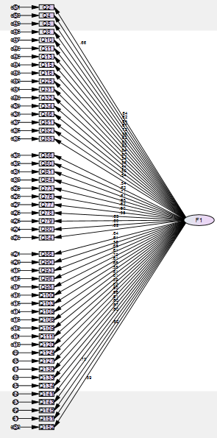

Notes for Model (Default model)

Computation of degrees of freedom (Default model)
Number of distinct sample moments: | 1275
Number of distinct parameters to be estimated: | 100
Degrees of freedom (1275 - 100): | 1175

Result (Default model)
Minimum was achieved
Chi-square = 2907.193
Degrees of freedom = 1175
Probability level = .000

Estimates (Group number 1 - Default model)

Scalar Estimates (Group number 1 - Default model)

Maximum Likelihood Estimates

Regression Weights: (Group number 1 - Default model)
 |  |  | Estimate | S.E. | C.R. | P | Label
Q151 | <--- | F1 | 1.000
Q145 | <--- | F1 | 1.081 | .087 | 12.424 | ***
Q143 | <--- | F1 | .888 | .080 | 11.036 | ***
Q141 | <--- | F1 | 1.114 | .092 | 12.053 | ***
Q134 | <--- | F1 | .933 | .084 | 11.090 | ***
Q133 | <--- | F1 | 1.007 | .089 | 11.307 | ***
Q130 | <--- | F1 | 1.035 | .086 | 11.964 | ***
Q127 | <--- | F1 | .902 | .081 | 11.076 | ***
Q124 | <--- | F1 | .987 | .086 | 11.449 | ***
Q120 | <--- | F1 | .930 | .085 | 10.946 | ***
Q111 | <--- | F1 | 1.035 | .092 | 11.296 | ***
Q109 | <--- | F1 | 1.000 | .089 | 11.288 | ***
Q106 | <--- | F1 | .894 | .082 | 10.836 | ***
Q105 | <--- | F1 | .988 | .083 | 11.924 | ***
Q103 | <--- | F1 | .808 | .072 | 11.217 | ***
Q100 | <--- | F1 | 1.089 | .087 | 12.493 | ***
Q98 | <--- | F1 | .992 | .088 | 11.281 | ***
Q96 | <--- | F1 | .987 | .083 | 11.829 | ***
Q93 | <--- | F1 | .890 | .086 | 10.407 | ***
Q90 | <--- | F1 | .969 | .086 | 11.228 | ***
Q86 | <--- | F1 | 1.001 | .086 | 11.597 | ***
Q84 | <--- | F1 | .990 | .087 | 11.407 | ***
Q80 | <--- | F1 | .966 | .087 | 11.101 | ***
Q79 | <--- | F1 | .969 | .084 | 11.586 | ***
Q78 | <--- | F1 | .877 | .085 | 10.346 | ***
Q77 | <--- | F1 | .938 | .084 | 11.137 | ***
Q76 | <--- | F1 | 1.021 | .090 | 11.354 | ***
Q73 | <--- | F1 | .981 | .083 | 11.786 | ***
Q64 | <--- | F1 | .931 | .083 | 11.276 | ***
Q61 | <--- | F1 | 1.161 | .092 | 12.556 | ***
Q60 | <--- | F1 | .913 | .080 | 11.469 | ***
Q56 | <--- | F1 | .862 | .084 | 10.243 | ***
Q55 | <--- | F1 | .901 | .087 | 10.299 | ***
Q52 | <--- | F1 | .869 | .080 | 10.924 | ***
Q51 | <--- | F1 | .971 | .091 | 10.709 | ***
Q46 | <--- | F1 | .875 | .085 | 10.346 | ***
Q34 | <--- | F1 | .847 | .083 | 10.219 | ***
Q32 | <--- | F1 | .918 | .083 | 11.044 | ***
Q31 | <--- | F1 | 1.050 | .090 | 11.640 | ***
Q25 | <--- | F1 | .862 | .078 | 11.079 | ***
Q16 | <--- | F1 | .835 | .076 | 11.050 | ***
Q15 | <--- | F1 | .796 | .069 | 11.579 | ***
Q13 | <--- | F1 | .764 | .072 | 10.552 | ***
Q11 | <--- | F1 | 1.136 | .089 | 12.812 | ***
Q10 | <--- | F1 | .976 | .081 | 12.016 | ***
Q8 | <--- | F1 | .955 | .082 | 11.636 | ***
Q5 | <--- | F1 | .925 | .082 | 11.329 | ***
Q4 | <--- | F1 | .979 | .084 | 11.610 | ***
Q2 | <--- | F1 | .986 | .083 | 11.878 | ***
Q152 | <--- | F1 | .914 | .080 | 11.401 | ***

Standardized Regression Weights: (Group number 1 - Default model)
 |  |  | Estimate
Q151 | <--- | F1 | .592
Q145 | <--- | F1 | .699
Q143 | <--- | F1 | .595
Q141 | <--- | F1 | .670
Q134 | <--- | F1 | .599
Q133 | <--- | F1 | .615
Q130 | <--- | F1 | .663
Q127 | <--- | F1 | .598
Q124 | <--- | F1 | .625
Q120 | <--- | F1 | .589
Q111 | <--- | F1 | .614
Q109 | <--- | F1 | .613
Q106 | <--- | F1 | .581
Q105 | <--- | F1 | .660
Q103 | <--- | F1 | .608
Q100 | <--- | F1 | .705
Q98 | <--- | F1 | .613
Q96 | <--- | F1 | .653
Q93 | <--- | F1 | .552
Q90 | <--- | F1 | .609
Q86 | <--- | F1 | .636
Q84 | <--- | F1 | .622
Q80 | <--- | F1 | .600
Q79 | <--- | F1 | .635
Q78 | <--- | F1 | .548
Q77 | <--- | F1 | .602
Q76 | <--- | F1 | .618
Q73 | <--- | F1 | .650
Q64 | <--- | F1 | .612
Q61 | <--- | F1 | .710
Q60 | <--- | F1 | .626
Q56 | <--- | F1 | .541
Q55 | <--- | F1 | .545
Q52 | <--- | F1 | .587
Q51 | <--- | F1 | .573
Q46 | <--- | F1 | .548
Q34 | <--- | F1 | .540
Q32 | <--- | F1 | .596
Q31 | <--- | F1 | .639
Q25 | <--- | F1 | .598
Q16 | <--- | F1 | .596
Q15 | <--- | F1 | .634
Q13 | <--- | F1 | .562
Q11 | <--- | F1 | .731
Q10 | <--- | F1 | .667
Q8 | <--- | F1 | .639
Q5 | <--- | F1 | .616
Q4 | <--- | F1 | .637
Q2 | <--- | F1 | .657
Q152 | <--- | F1 | .621

Variances: (Group number 1 - Default model)
 |  |  | Estimate | S.E. | C.R. | P | Label
F1 |  |  | .329 | .047 | 6.921 | ***
e1 |  |  | .608 | .041 | 14.939 | ***
e2 |  |  | .402 | .027 | 14.739 | ***
e3 |  |  | .472 | .032 | 14.935 | ***
e4 |  |  | .501 | .034 | 14.807 | ***
e5 |  |  | .511 | .034 | 14.930 | ***
e6 |  |  | .549 | .037 | 14.907 | ***
e7 |  |  | .448 | .030 | 14.821 | ***
e8 |  |  | .480 | .032 | 14.931 | ***
e9 |  |  | .500 | .034 | 14.891 | ***
e10 |  |  | .536 | .036 | 14.943 | ***
e11 |  |  | .583 | .039 | 14.908 | ***
e12 |  |  | .545 | .037 | 14.909 | ***
e13 |  |  | .515 | .034 | 14.953 | ***
e14 |  |  | .415 | .028 | 14.827 | ***
e15 |  |  | .366 | .025 | 14.917 | ***
e16 |  |  | .396 | .027 | 14.725 | ***
e17 |  |  | .538 | .036 | 14.910 | ***
e18 |  |  | .431 | .029 | 14.841 | ***
e19 |  |  | .594 | .040 | 14.988 | ***
e20 |  |  | .524 | .035 | 14.915 | ***
e21 |  |  | .486 | .033 | 14.873 | ***
e23 |  |  | .511 | .034 | 14.896 | ***
e24 |  |  | .545 | .037 | 14.928 | ***
e25 |  |  | .457 | .031 | 14.874 | ***
e26 |  |  | .589 | .039 | 14.992 | ***
e27 |  |  | .508 | .034 | 14.925 | ***
e28 |  |  | .555 | .037 | 14.902 | ***
e29 |  |  | .433 | .029 | 14.847 | ***
e30 |  |  | .475 | .032 | 14.910 | ***
e31 |  |  | .437 | .030 | 14.711 | ***
e32 |  |  | .424 | .029 | 14.888 | ***
e33 |  |  | .589 | .039 | 14.999 | ***
e35 |  |  | .632 | .042 | 14.996 | ***
e36 |  |  | .471 | .032 | 14.945 | ***
e37 |  |  | .636 | .042 | 14.964 | ***
e38 |  |  | .586 | .039 | 14.992 | ***
e39 |  |  | .574 | .038 | 15.001 | ***
e40 |  |  | .503 | .034 | 14.934 | ***
e41 |  |  | .526 | .035 | 14.867 | ***
e42 |  |  | .438 | .029 | 14.931 | ***
e43 |  |  | .416 | .028 | 14.933 | ***
e44 |  |  | .310 | .021 | 14.875 | ***
e45 |  |  | .415 | .028 | 14.977 | ***
e46 |  |  | .371 | .025 | 14.648 | ***
e47 |  |  | .390 | .026 | 14.813 | ***
e48 |  |  | .436 | .029 | 14.868 | ***
e49 |  |  | .460 | .031 | 14.904 | ***
e50 |  |  | .462 | .031 | 14.871 | ***
e51 |  |  | .421 | .028 | 14.834 | ***
e52 |  |  | .436 | .029 | 14.896 | ***

Model Fit Summary

CMIN
Model | NPAR | CMIN | DF | P | CMIN/DF
Default model | 100 | 2907.193 | 1175 | .000 | 2.474
Saturated model | 1275 | .000 | 0
Independence model | 50 | 12518.596 | 1225 | .000 | 10.219

RMR, GFI
Model | RMR | GFI | AGFI | PGFI
Default model | .036 | .777 | .759 | .716
Saturated model | .000 | 1.000
Independence model | .298 | .121 | .085 | .116

Baseline Comparisons
Model | NFI  Delta1 | RFI  rho1 | IFI  Delta2 | TLI  rho2 | CFI
Default model | .768 | .758 | .847 | .840 | .847
Saturated model | 1.000 |  | 1.000 |  | 1.000
Independence model | .000 | .000 | .000 | .000 | .000

Parsimony-Adjusted Measures
Model | PRATIO | PNFI | PCFI
Default model | .959 | .736 | .812
Saturated model | .000 | .000 | .000
Independence model | 1.000 | .000 | .000

NCP
Model | NCP | LO 90 | HI 90
Default model | 1732.193 | 1577.521 | 1894.495
Saturated model | .000 | .000 | .000
Independence model | 11293.596 | 10937.896 | 11655.793

FMIN
Model | FMIN | F0 | LO 90 | HI 90
Default model | 6.293 | 3.749 | 3.415 | 4.101
Saturated model | .000 | .000 | .000 | .000
Independence model | 27.097 | 24.445 | 23.675 | 25.229

RMSEA
Model | RMSEA | LO 90 | HI 90 | PCLOSE
Default model | .056 | .054 | .059 | .000
Independence model | .141 | .139 | .144 | .000

AIC
Model | AIC | BCC | BIC | CAIC
Default model | 3107.193 | 3132.011 | 3520.966 | 3620.966
Saturated model | 2550.000 | 2866.423 | 7825.602 | 9100.602
Independence model | 12618.596 | 12631.005 | 12825.483 | 12875.483

ECVI
Model | ECVI | LO 90 | HI 90 | MECVI
Default model | 6.726 | 6.391 | 7.077 | 6.779
Saturated model | 5.519 | 5.519 | 5.519 | 6.204
Independence model | 27.313 | 26.543 | 28.097 | 27.340

HOELTER
Model | HOELTER  .05 | HOELTER  .01
Default model | 200 | 206
Independence model | 49 | 50

Notes for Model Fit 2
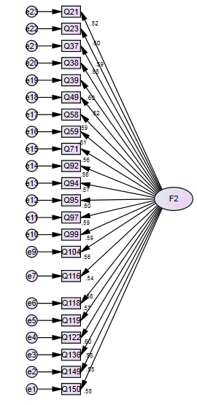

Notes for Model (Default model)

Computation of degrees of freedom (Default model)
Number of distinct sample moments: | 253
Number of distinct parameters to be estimated: | 44
Degrees of freedom (253 - 44): | 209

Result (Default model)
Minimum was achieved
Chi-square = 583.260
Degrees of freedom = 209
Probability level = .000

Estimates (Group number 1 - Default model)

Scalar Estimates (Group number 1 - Default model)

Maximum Likelihood Estimates

Regression Weights: (Group number 1 - Default model)
 |  |  | Estimate | S.E. | C.R. | P | Label
Q150 | <--- | F2 | 1.000
Q149 | <--- | F2 | .923 | .094 | 9.833 | ***
Q136 | <--- | F2 | 1.290 | .126 | 10.221 | ***
Q122 | <--- | F2 | 1.129 | .107 | 10.524 | ***
Q119 | <--- | F2 | 1.059 | .106 | 10.031 | ***
Q118 | <--- | F2 | 1.204 | .119 | 10.140 | ***
Q116 | <--- | F2 | 1.051 | .109 | 9.662 | ***
Q104 | <--- | F2 | .991 | .099 | 10.030 | ***
Q99 | <--- | F2 | 1.120 | .107 | 10.429 | ***
Q97 | <--- | F2 | 1.108 | .106 | 10.415 | ***
Q95 | <--- | F2 | 1.241 | .118 | 10.491 | ***
Q94 | <--- | F2 | 1.072 | .106 | 10.090 | ***
Q92 | <--- | F2 | 1.058 | .106 | 10.006 | ***
Q71 | <--- | F2 | .832 | .084 | 9.930 | ***
Q59 | <--- | F2 | 1.216 | .114 | 10.641 | ***
Q58 | <--- | F2 | 1.154 | .112 | 10.335 | ***
Q49 | <--- | F2 | 1.126 | .107 | 10.563 | ***
Q39 | <--- | F2 | 1.026 | .108 | 9.502 | ***
Q38 | <--- | F2 | 1.082 | .106 | 10.235 | ***
Q37 | <--- | F2 | 1.058 | .102 | 10.339 | ***
Q23 | <--- | F2 | 1.095 | .104 | 10.541 | ***
Q21 | <--- | F2 | .750 | .080 | 9.377 | ***

Standardized Regression Weights: (Group number 1 - Default model)
 |  |  | Estimate
Q150 | <--- | F2 | .575
Q149 | <--- | F2 | .549
Q136 | <--- | F2 | .578
Q122 | <--- | F2 | .601
Q119 | <--- | F2 | .563
Q118 | <--- | F2 | .572
Q116 | <--- | F2 | .536
Q104 | <--- | F2 | .563
Q99 | <--- | F2 | .594
Q97 | <--- | F2 | .593
Q95 | <--- | F2 | .599
Q94 | <--- | F2 | .568
Q92 | <--- | F2 | .562
Q71 | <--- | F2 | .556
Q59 | <--- | F2 | .611
Q58 | <--- | F2 | .587
Q49 | <--- | F2 | .604
Q39 | <--- | F2 | .525
Q38 | <--- | F2 | .579
Q37 | <--- | F2 | .587
Q23 | <--- | F2 | .603
Q21 | <--- | F2 | .516

Variances: (Group number 1 - Default model)
 |  |  | Estimate | S.E. | C.R. | P | Label
F2 |  |  | .134 | .021 | 6.516 | ***
e1 |  |  | .271 | .019 | 14.506 | ***
e2 |  |  | .266 | .018 | 14.596 | ***
e3 |  |  | .446 | .031 | 14.498 | ***
e4 |  |  | .302 | .021 | 14.406 | ***
e5 |  |  | .324 | .022 | 14.548 | ***
e6 |  |  | .401 | .028 | 14.520 | ***
e7 |  |  | .367 | .025 | 14.634 | ***
e9 |  |  | .284 | .019 | 14.548 | ***
e10 |  |  | .309 | .021 | 14.437 | ***
e11 |  |  | .304 | .021 | 14.441 | ***
e12 |  |  | .370 | .026 | 14.417 | ***
e13 |  |  | .324 | .022 | 14.533 | ***
e14 |  |  | .326 | .022 | 14.555 | ***
e15 |  |  | .208 | .014 | 14.573 | ***
e16 |  |  | .334 | .023 | 14.367 | ***
e17 |  |  | .341 | .024 | 14.465 | ***
e18 |  |  | .296 | .021 | 14.393 | ***
e19 |  |  | .372 | .025 | 14.667 | ***
e20 |  |  | .312 | .022 | 14.494 | ***
e21 |  |  | .286 | .020 | 14.464 | ***
e22 |  |  | .282 | .020 | 14.401 | ***
e23 |  |  | .208 | .014 | 14.692 | ***

Model Fit Summary

CMIN
Model | NPAR | CMIN | DF | P | CMIN/DF
Default model | 44 | 583.260 | 209 | .000 | 2.791
Saturated model | 253 | .000 | 0
Independence model | 22 | 3514.351 | 231 | .000 | 15.214

RMR, GFI
Model | RMR | GFI | AGFI | PGFI
Default model | .021 | .898 | .877 | .742
Saturated model | .000 | 1.000
Independence model | .151 | .300 | .233 | .274

Baseline Comparisons
Model | NFI  Delta1 | RFI  rho1 | IFI  Delta2 | TLI  rho2 | CFI
Default model | .834 | .817 | .887 | .874 | .886
Saturated model | 1.000 |  | 1.000 |  | 1.000
Independence model | .000 | .000 | .000 | .000 | .000

Parsimony-Adjusted Measures
Model | PRATIO | PNFI | PCFI
Default model | .905 | .755 | .802
Saturated model | .000 | .000 | .000
Independence model | 1.000 | .000 | .000

NCP
Model | NCP | LO 90 | HI 90
Default model | 374.260 | 306.065 | 450.102
Saturated model | .000 | .000 | .000
Independence model | 3283.351 | 3095.154 | 3478.870

FMIN
Model | FMIN | F0 | LO 90 | HI 90
Default model | 1.262 | .810 | .662 | .974
Saturated model | .000 | .000 | .000 | .000
Independence model | 7.607 | 7.107 | 6.699 | 7.530

RMSEA
Model | RMSEA | LO 90 | HI 90 | PCLOSE
Default model | .062 | .056 | .068 | .000
Independence model | .175 | .170 | .181 | .000

AIC
Model | AIC | BCC | BIC | CAIC
Default model | 671.260 | 675.871 | 853.320 | 897.320
Saturated model | 506.000 | 532.510 | 1552.845 | 1805.845
Independence model | 3558.351 | 3560.656 | 3649.381 | 3671.381

ECVI
Model | ECVI | LO 90 | HI 90 | MECVI
Default model | 1.453 | 1.305 | 1.617 | 1.463
Saturated model | 1.095 | 1.095 | 1.095 | 1.153
Independence model | 7.702 | 7.295 | 8.125 | 7.707

HOELTER
Model | HOELTER  .05 | HOELTER  .01
Default model | 194 | 206
Independence model | 36 | 38

Rules of Thumbs for Model Fitness Evaluation

Fit Measure
 | Good Fit | Acceptable Fit | Source
p Value | .05 ≤ p 1.00 | .01 ≤ p ≤ .05
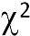/df | 0 ≤ / df ≤ 2  0 ≤ / df ≤ 2 | 2 < / df ≤ 3  2≤ / df ≤ 5 | Gefen etal;(2000);  Hocevar (1985);  Mckenly et al (2002)
RMSEA | 0 ≤ RMSEA ≤ .05 | .05 < RMSEA ≤ .08 | Browne & Cudeck (1993)
SRMR | 0 ≤ SRMR ≤ .05 | .05 < SRMR ≤ .10 | Arbucle (2005)
RMR | 0 ≤ RMR ≤ .04 | .04 < RMR ≤ .08 | Arbucle (2005)
GFI | .95 ≤ GFI ≤ 1.00 | .90 ≤ GFI < .95 | Hoyle (1995)
CFI  NFI  NNFI  AGFI  TLI  IFI | .97 ≤ CFI ≤ 1.00  .95 ≤ NFI ≤ 1.00  .95 ≤ NNFI ≤ 1.00  .90 ≤ AGFI ≤ 1.00  .95 ≤ TLI ≤ 1.00  .95 ≤ IFI ≤ 1.00 | .95 ≤ CFI < .97  .90 ≤ CFI <.95  .90 ≤ NNFI <.95  .80 ≤ AGFI <.90  .90 ≤ TLI <.95  .90 ≤ IFI <.95 | Bagozzi & Ye (1988)  Hair et al. (1998)  Hair et al. (1998)  Chau & Hu (2001)  Bagozzi & Ye (1988)  Hu & Bentler (1995)
Note: AGFI=Adjusted Goodness of Fit Index, CFI=Comparative Fit Index, GFI=Goodness of Fit, NFI=Normed Fit Index, NNFI=Non-Normed Fit Index, RMSEA=Root Mean Square Error Approximation, SRMR=Standardized Root Mean Square Residual, IFI=Incremental Fit Index, TLI=Tuker-Lewis Index

Factor Names and Items (sample Items)
 | Pattern Matrixª
Factor |  | Component
 |  | 1 | 2
Risky  Driving  Behavior | 86. Naiinip ako kapag masyadong mabagal tumawid sa kalsada ang isang pedestrian. (I find myself getting impatient when a pedestrian crosses the road very slowly.)  a. Totoo (True)  b. ?  c. Hindi totoo (False) | .692
 | 73. Nakakalimutan kong i-handbrake ang aking sasakyan pagkatapos itong iparada. (I forget to notch the handbrake of my vehicle after parking.)  a. Totoo (True)  b. ?  c. Hindi totoo (False) | .679
 | 4. Nakalilimutan kong dalhin ang aking lisensiya sa pagmamaneho. (I forget to bring my driving license.)  a. Totoo (True)  b. ?  c. Hindi totoo (False) | .677
 | 11. Tila gusto kong singitan o i-cut ang iba pang mga mas maliliit na sasakyan sa kalsada. (I feel like cutting off other smaller vehicles on the road.)  a. Totoo (True)  b. ?  c. Hindi totoo (False) | .676
 | 90. Pinipili ko pa ring magmaneho kahit sira ang speedometer ng aking sasakyan. (I still choose to drive even if the speedometer is broken.)  a. Totoo (True)  b. ?  c. Hindi totoo (False) | .672
 | 120. Dumadaan ako sa shoulder lane upang madaling makalusot sa trapiko. (I use the shoulder lane to make it easier for me to pass through traffic.)  a. Totoo (True)  b. ?  c. Hindi totoo (False) | .669
 | 100. Natutukso akong makipagkarera sa ibang mga drayber sa kalsada. (I feel tempted to race with other drivers on the road.)  a. Totoo (True)  b. ?  c. Hindi totoo (False) | .667
 | 145. Kahit na kakailaw lang ng pula ng traffic light, tinatawid ko pa rin ang interseksiyon. (Even when the traffic light just turned red, I take the risk of crossing the intersection.)  a. Totoo (True)  b. ?  c. Hindi totoo (False) | .662
Responsible and Safe Mobility | 49. Mahigpit akong sumusunod sa iskedyul ng number coding sa mga lungsod na aking dinaraanan. (I strictly comply with the number coding schedule in the cities I am passing through.)  a. Totoo (True)  b. ?  c. Hindi totoo (False) |  | .629
 | 59. Nakaugalian kong obserbahan ang kilos ng mga pedestrian upang malaman ko kung sila ay tatawid sa kalsada o hindi. (It has been a habit for me to observe the gestures of pedestrians to understand their intent to cross the road.)  a. Totoo (True)  b. ?  c. Hindi totoo (False) |  | .627
 | 37. Pinahahalagahan ko ang mga komento ng ibang tao sa paraan ng aking pagmamaneho. (I appreciate other people’s comment about the way I drive.)  a. Totoo (True)  b. ?  c. Hindi totoo (False) |  | .625
 | 71. Dala ko ang mga importanteng kagamitan ng aking sasakyan kapag ako ay nagmamaneho. (I have my important vehicle tools with me when I am driving.)  a. Totoo (True)  b. ?  c. Hindi totoo (False) |  | .620
 | 97. Sinisiguro kong mayroong regular na maintenance ang aking sasakyan. (I make sure that my vehicle gets regular maintenance.)  a. Totoo (True)  b. ?  c. Hindi totoo (False) |  | .612
 | 95. Nakagawian kong nang itsek ang preno ng aking sasakyan bago ako magmaneho. (It is my habit to check my vehicle brake before driving.)  a. Totoo (True)  b. ?  c. Hindi totoo (False) |  | .612
 | 23. Pinakikiramdaman ko kung maayos ang aking kondisyon bago ako magmaneho. (I check on myself whether I am in a healthy condition before I drive.)  a. Totoo (True)  b. ?  c. Hindi totoo (False) |  | .611
 | 122. Alerto ako sa mga sasakyang maaaring biglang sumulpot sa dinadaanan ko. (I am vigilant of other vehicles that may suddenly appear on my way.)  a. Totoo (True)  b. ?  c. Hindi totoo (False) |  | .610
 | 39. Nakaugalian ko na ang pagmemenor sa tuwing nakakakita ako ng pedestrian lane. (Reducing speed whenever I see a pedestrian lane has been a habit for me.)  a. Totoo (True)  b. ?  c. Hindi totoo (False) |  | .539
Extraction Method: Principal Component Analysis.
Rotation Method: Oblimin with Kaiser Normalization.
 | a. Rotation converged in 3 iterations.

Appendix K: Google Form (Online)
i
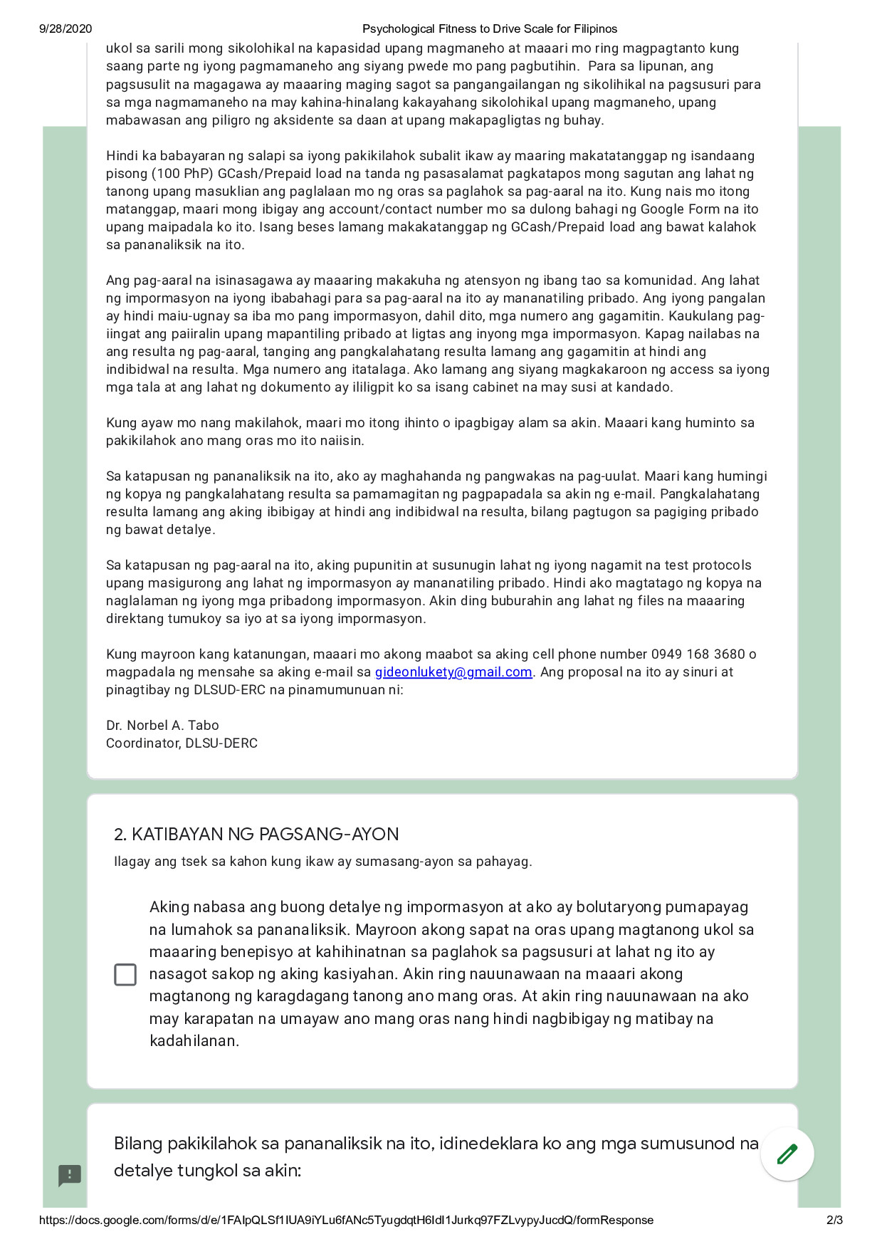

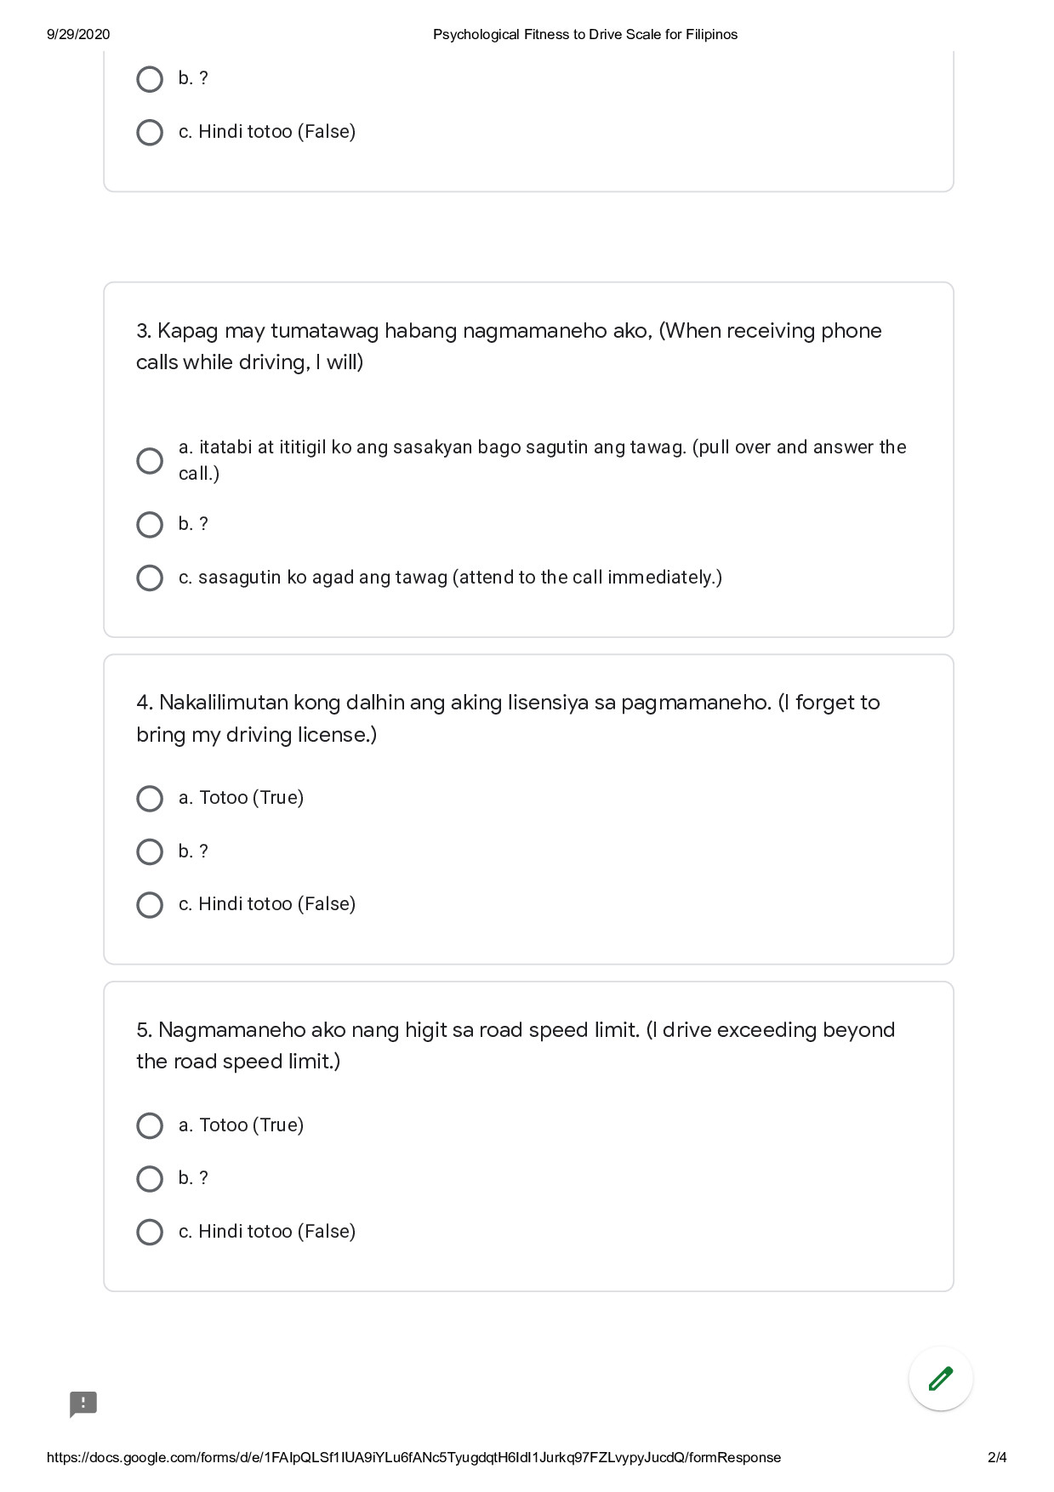
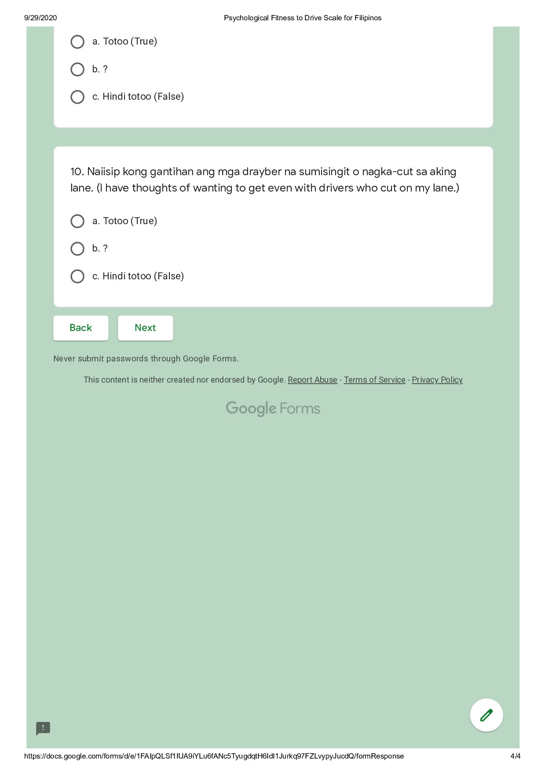

Appendix L: Pilot Testing Participants’ Agreement to Informed Consent (Sample)
Date | Code | Informed Consent Read and Signed
05/26/2020 | IE-001 | English
05/27/2020 | IE-002 | English
05/26/2020 | IE-003 | English
05/26/2020 | IE-004 | English
05/26/2020 | IE-005 | English
05/26/2020 | IE-006 | English
06/01/2020 | IE-007 | English
05/28/2020 | IE-008 | English
05/27/2020 | IE-009 | English
06/02/2020 | IE-010 | English
05/31/2020 | IE-011 | English
05/27/2020 | IE-012 | English
05/29/2020 | IE-013 | English
05/28/2020 | IE-014 | English
06/12/2020 | IE-015 | English
06/16/2020 | IE-016 | English
06/06/2020 | IE-017 | English
06/16/2020 | IE-018 | English
06/05/2020 | IE-019 | English
05/28/2020 | IE-020 | English
05/27/2020 | IE-021 | English
05/27/2020 | IE-022 | English
05/29/2020 | IE-023 | English
05/29/2020 | IE-024 | English
05/29/2020 | IE-025 | English
05/29/2020 | IE-026 | English
05/29/2020 | IE-027 | English
06/02/2020 | IE-028 | English
06/03/2020 | IE-029 | English
06/03/2020 | IE-030 | English
06/08/2020 | IE-031 | English
06/03/2020 | IE-032 | English
06/09/2020 | IE-033 | English
06/03/2020 | IE-034 | English
06/05/2020 | IE-035 | English
06/02/2020 | IE-036 | English
06/03/2020 | IE-037 | English
06/03/2020 | IE-038 | English
06/02/2020 | IE-039 | English
06/02/2020 | IE-040 | English

Appendix M: Field Testing Participants’ Agreement to Informed Consent
Timestamp in Google Sheets | Code | Informed Consent Read and Answered
8/19/2020 16:50:21 | FT-001 | Informed Consent (Filipino)
8/19/2020 16:59:45 | FT-002 | Informed Consent (Filipino)
8/19/2020 17:10:58 | FT-003 | Informed Consent (Filipino)
8/19/2020 17:11:15 | FT-004 | Informed Consent (Filipino)
8/19/2020 17:42:01 | FT-005 | Informed Consent (English)
8/19/2020 17:42:38 | FT-006 | Informed Consent (Filipino)
8/19/2020 17:50:51 | FT-007 | Informed Consent (English)
8/19/2020 17:51:10 | FT-008 | Informed Consent (English)
8/19/2020 17:55:54 | FT-009 | Informed Consent (English)
8/19/2020 17:56:02 | FT-010 | Informed Consent (Filipino)
8/19/2020 19:28:11 | FT-011 | Informed Consent (English)
8/19/2020 19:28:15 | FT-012 | Informed Consent (English)
8/19/2020 19:45:10 | FT-013 | Informed Consent (Filipino)
8/19/2020 20:24:46 | FT-014 | Informed Consent (English)
8/19/2020 20:25:44 | FT-015 | Informed Consent (Filipino)
8/19/2020 20:26:48 | FT-016 | Informed Consent (Filipino)
8/19/2020 20:29:43 | FT-017 | Informed Consent (English)
8/19/2020 20:47:20 | FT-018 | Informed Consent (Filipino)
8/19/2020 21:03:28 | FT-019 | Informed Consent (Filipino)
8/19/2020 21:04:22 | FT-020 | Informed Consent (English)
8/22/2020 11:57:58 | FT-435 | Informed Consent (Filipino)
8/22/2020 12:00:54 | FT-436 | Informed Consent (English)
8/22/2020 12:01:19 | FT-437 | Informed Consent (Filipino)
8/22/2020 12:02:10 | FT-438 | Informed Consent (Filipino)
8/22/2020 12:03:29 | FT-439 | Informed Consent (English)
8/22/2020 12:03:37 | FT-440 | Informed Consent (English)
8/22/2020 12:05:24 | FT-441 | Informed Consent (Filipino)
8/22/2020 12:08:34 | FT-442 | Informed Consent (English)
8/22/2020 12:09:03 | FT-443 | Informed Consent (Filipino)
8/22/2020 12:12:01 | FT-444 | Informed Consent (Filipino)
8/22/2020 12:16:44 | FT-445 | Informed Consent (Filipino)
8/22/2020 12:17:46 | FT-446 | Informed Consent (Filipino)
8/22/2020 12:17:54 | FT-447 | Informed Consent (Filipino)
8/22/2020 12:21:48 | FT-448 | Informed Consent (English)
8/22/2020 12:22:27 | FT-449 | Informed Consent (English)
8/22/2020 12:24:41 | FT-450 | Informed Consent (Filipino)
8/22/2020 12:26:55 | FT-451 | Informed Consent (Filipino)
8/22/2020 12:28:59 | FT-452 | Informed Consent (Filipino)
8/22/2020 12:30:08 | FT-453 | Informed Consent (Filipino)
8/22/2020 12:30:38 | FT-454 | Informed Consent (Filipino)
8/22/2020 12:33:20 | FT-455 | Informed Consent (Filipino)
8/22/2020 12:34:20 | FT-456 | Informed Consent (Filipino)
8/22/2020 12:34:24 | FT-457 | Informed Consent (Filipino)
8/22/2020 12:39:36 | FT-458 | Informed Consent (Filipino)
8/22/2020 12:43:02 | FT-459 | Informed Consent (Filipino)
8/22/2020 12:45:00 | FT-460 | Informed Consent (Filipino)
8/22/2020 12:45:31 | FT-461 | Informed Consent (Filipino)
8/22/2020 12:45:38 | FT-462 | Informed Consent (English)
8/22/2020 12:46:09 | FT-463 | Informed Consent (Filipino)

Appendix N: PFDSF Test Booklet, Answer Sheet, and Individual Record Form

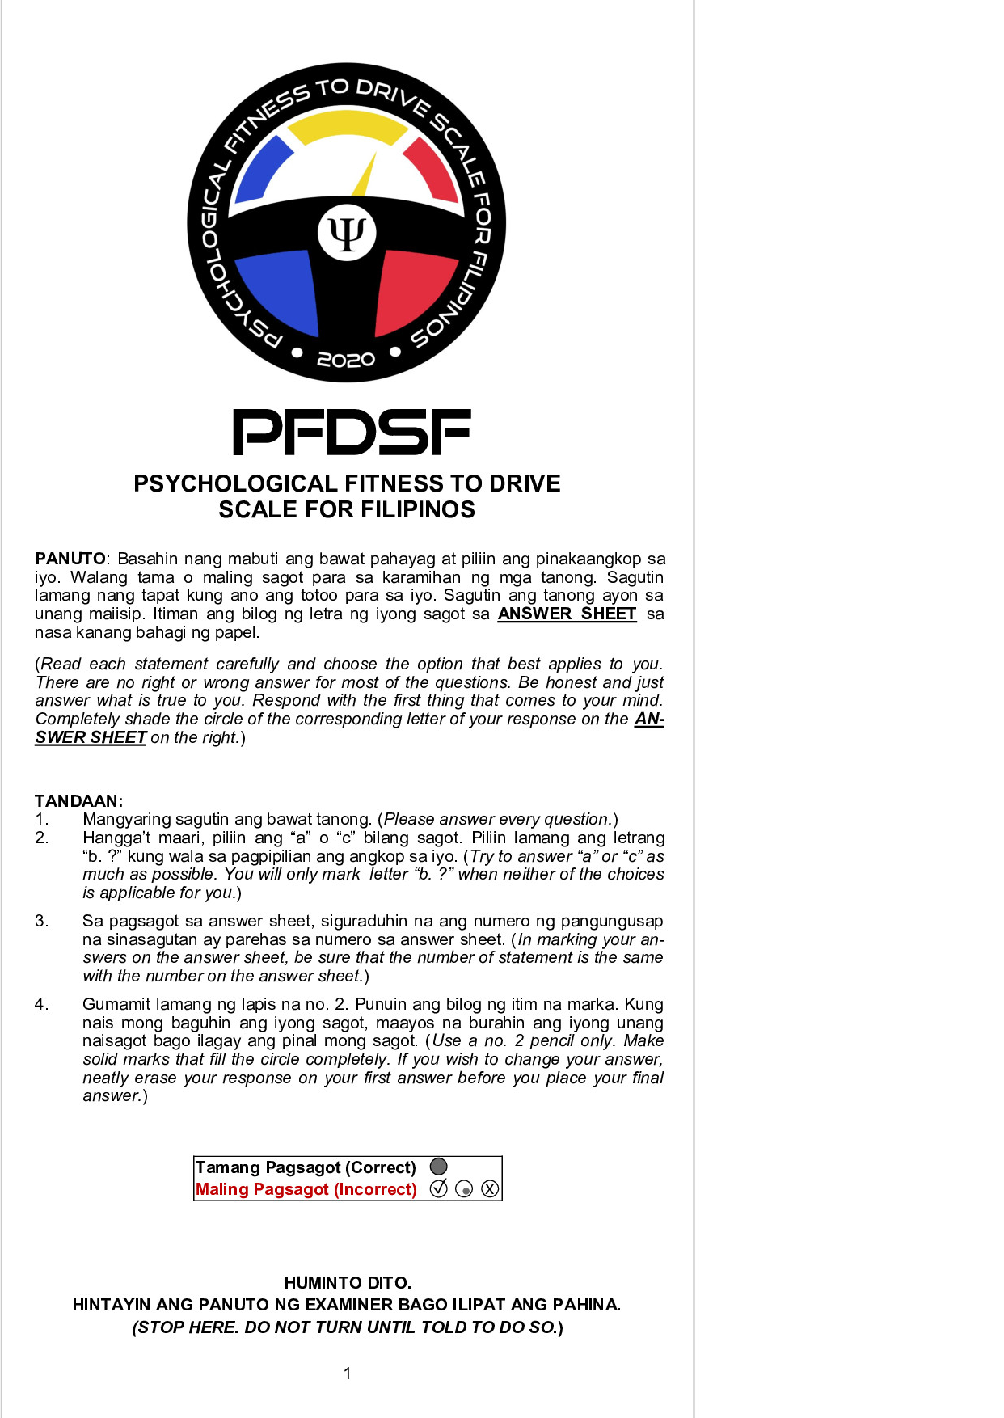
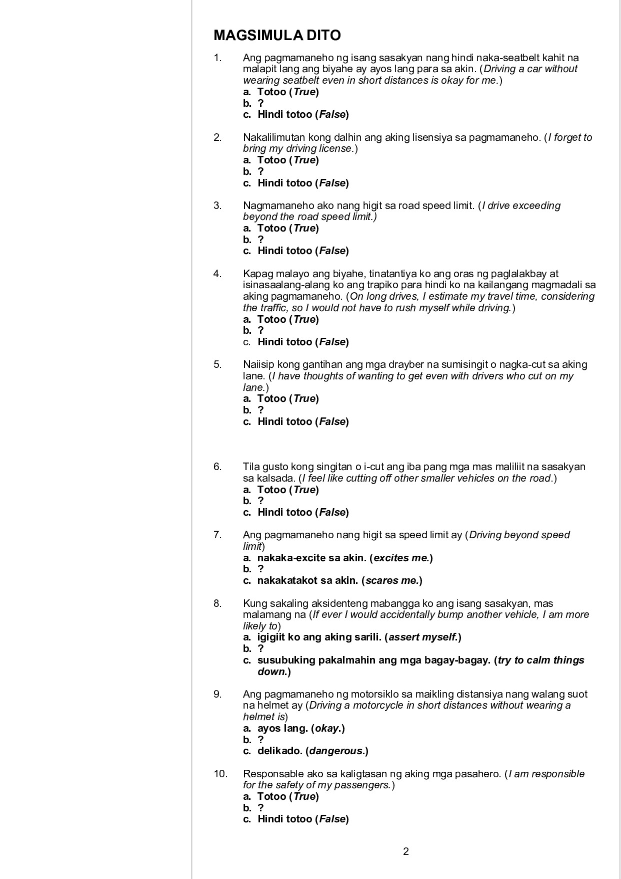

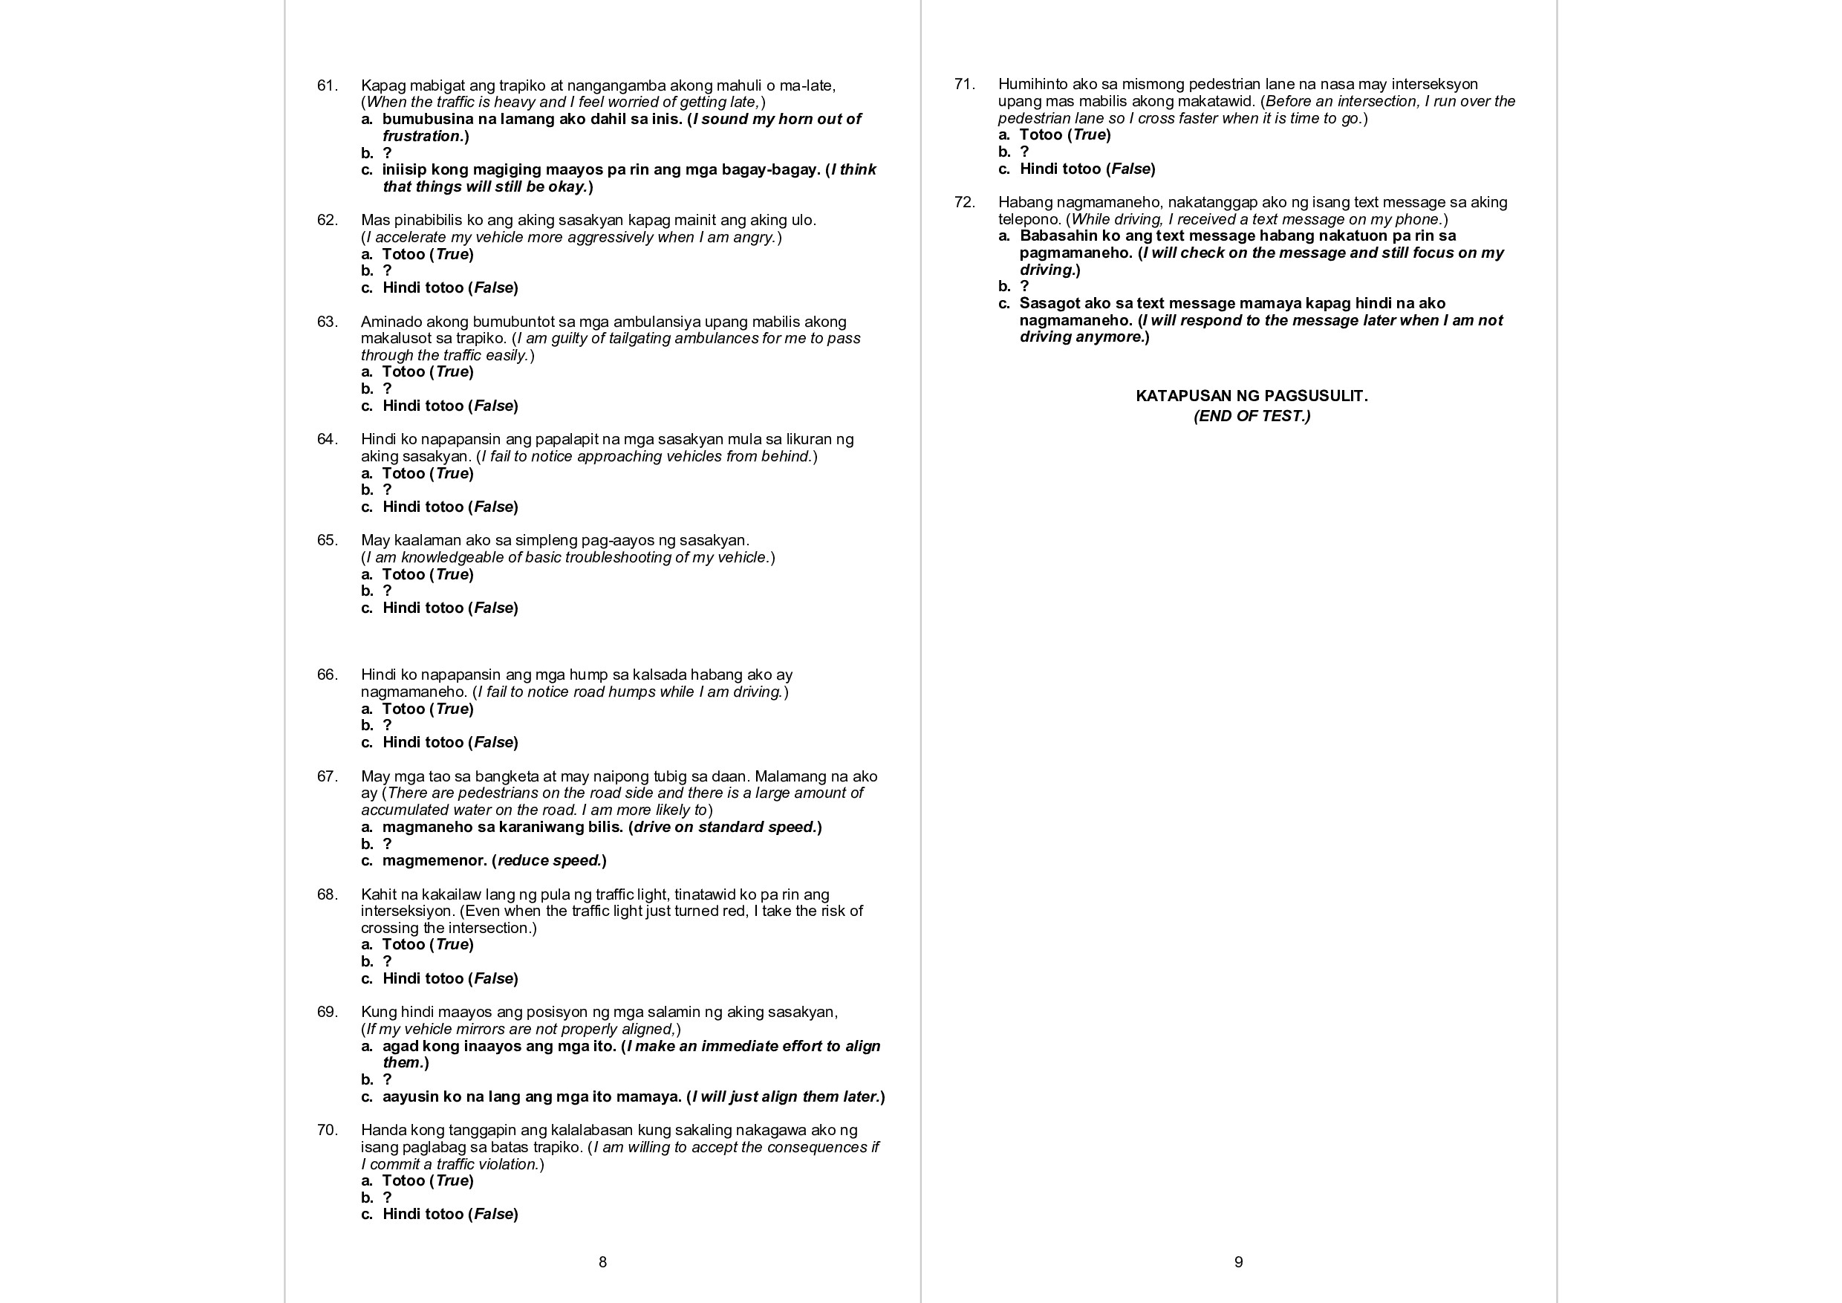
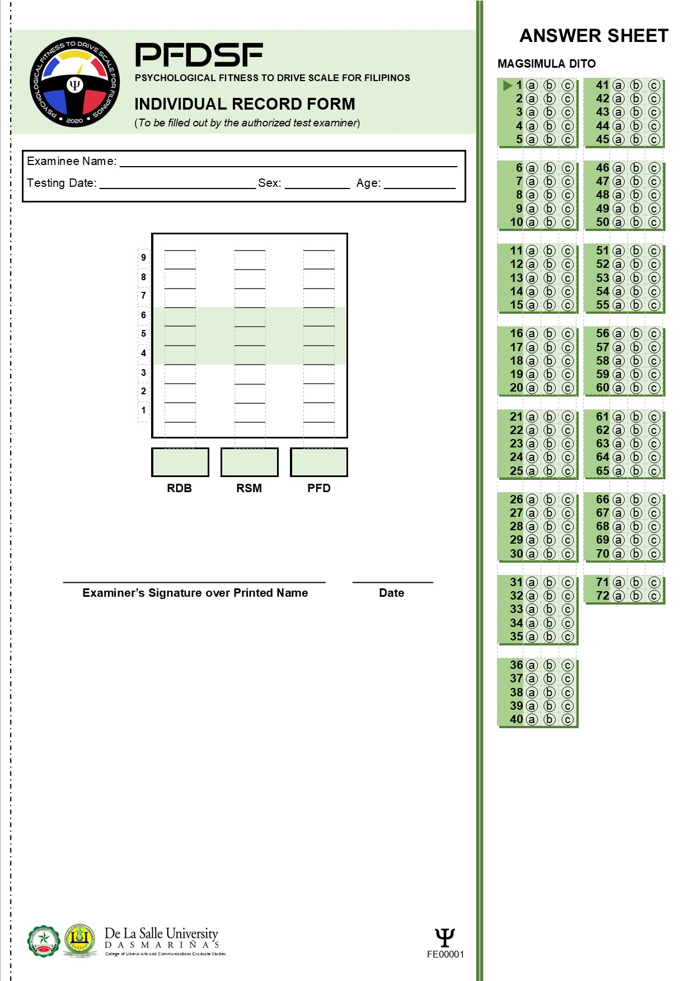

Appendix O: PFDSF Test Manual
__________________________________
Note: To get the details of the PFDSF, kindly contact Mr. Gideon Luke P. Ty, MAPsy, RPsy, RPm (at gideonlukety@gmail.com)

