Appendix G
Sample Tables and Figures

Table 1. The illustration of the coding process
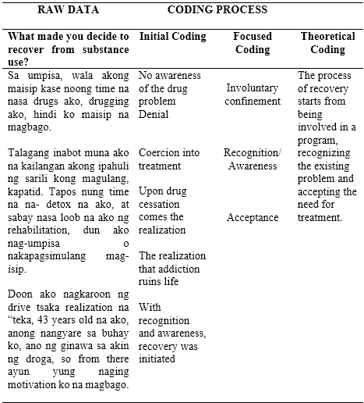

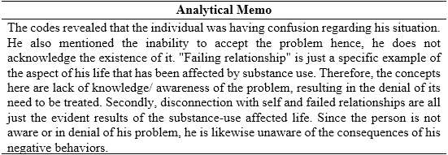
Table 2. Analytical Memo Writing during Initial Coding

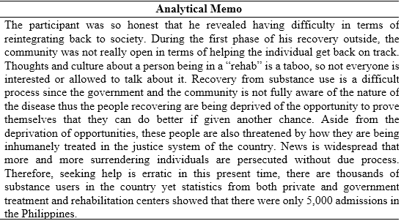
Table 3. Analytical Memo Writing after Interview

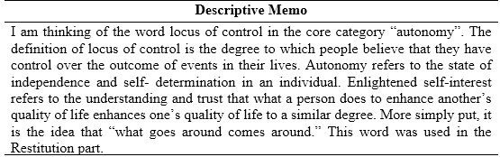
Table 4. Descriptive Memo Writing during Theoretical Coding

Figure 1. The incorporation of codes in the analytic process
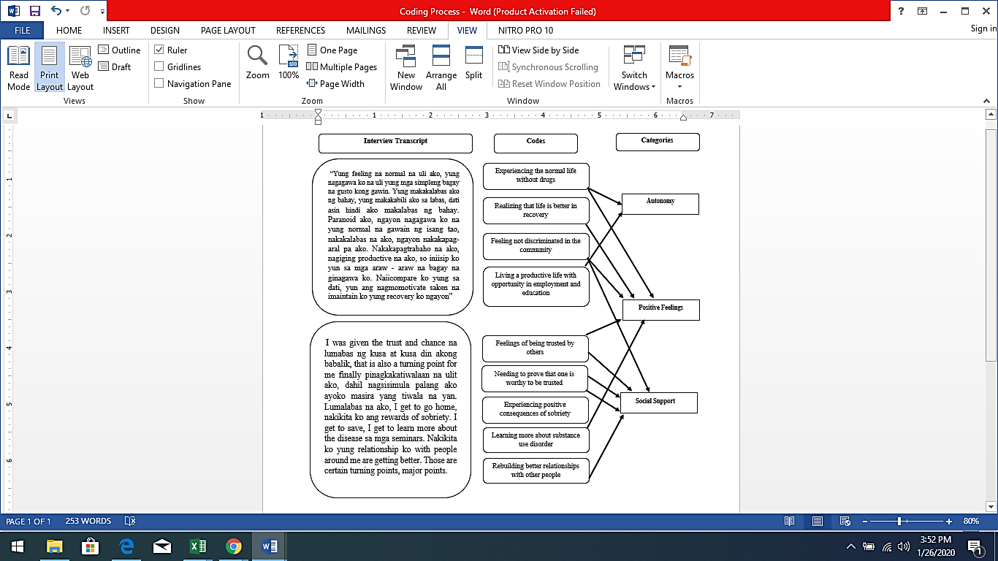

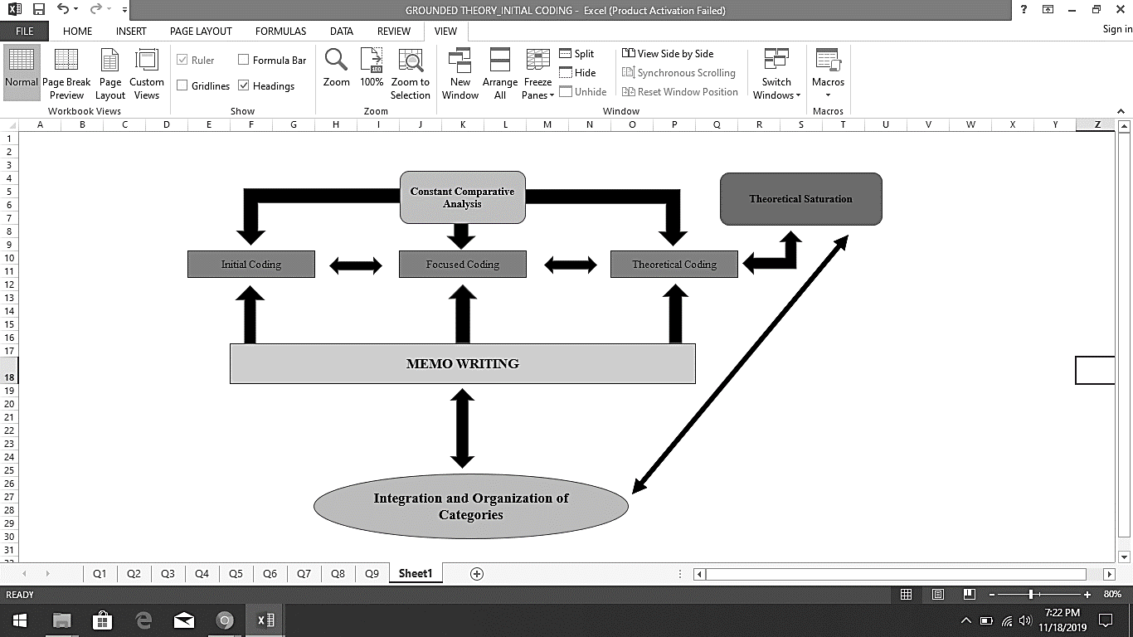
Figure 2. The data analytic procedures in developing the theoretical framework

