Lampiran 1. Daftar Sampel

No | Kode | Nama Perusahaan
1 | ADRO | Adaro Energy Tbk.
2 | ATPK | Bara Jaya International Tbk.
3 | BUMI | Bumi Resources Tbk.
4 | BYAN | Bayan Resources Tbk.
5 | DEWA | Darma Henwa Tbk.
6 | GTBO | Garda Tujuh Buana Tbk.
7 | ITMG | Indo Tambangraya Megah Tbk.
8 | KKGI | Resources Alam Indonesia Tbk.
9 | PKPK | Perdana Karya Perkasa Tbk.
10 | PTBA | Tambang Batubara Bukit Asam (Persero) Tbk.
11 | PTRO | Petrosea Tbk.
12 | ARTI | Ratu Prabu Energi Tbk.
13 | ELSA | Elnusa Tbk.
14 | ENRG | Energi Mega Persada Tbk.
15 | MEDC | Medco Energy International Tbk.
16 | RUIS | Radiant Utama Interinsco Tbk.
17 | ANTM | Aneka Tambang (Persero) Tbk.
18 | CITA | Cita Mineral Investindo Tbk.
19 | TINS | Timah (Persero) Tbk.
20 | CTTH | Citatah Tbk.
21 | MITI | Mitra Investindo Tbk

Lampiran 2. Hasil Pengujian Asumsi Klasik

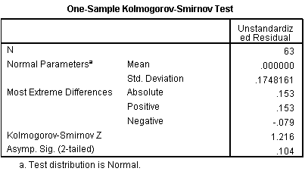

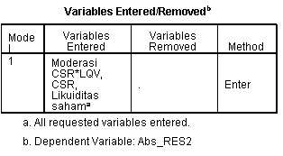

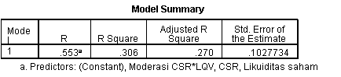

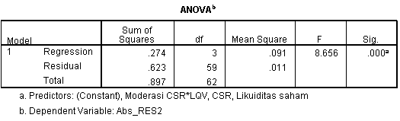

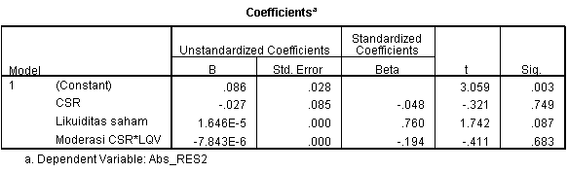

Lampiran 3. Statistik Deskriptif dan Hasil Pengolahan Regresi

