Increasing Knowledge About History of Hindu Empire in
Indonesia with Game “Indo Trivia”

Pieter Theodorus Handoko
Unika Soegijapranata
Jl. Pawiyatan Luhur Cell. IV No.1, Bedan Duwur, Kec. Gajahmungkur, Semarang, Indonesia
theoalpha9@gmail.com

Abstract— Most young people think that History is not important enough to learn and they are more likely to choose to play games. This study aims to develop the game "Indo Trivia" which is a game about the history of Indonesia, especially the history of the Hindu kingdom on the island of Java. In this game, there is a history of the Tarumanegara kingdoms, Hindu Mataram, Kediri,
Singasari, and Majapahit kingdoms. This thesis report contains about how to make games as a medium of learning about history, especially history during the Hindu kingdom as well as providing a quiz about the history of Indonesia. The game development method used is the waterfall. The game testing method by proposing a hypothesis that is tested using a questionnaire test tool. a questionnaire will be given if the respondent has finished playing the game "Indo Trivia". From the results of the study, it was found that the variables of convenience, usefulness, and pleasure correlated with the variable of desire to reuse.
Keywords— History, Hindu Kingdom

Game, Education, and Test

I. INTRODUCTION

According to the book, " Sejarah Untuk kelas XI Sekolah Mengngah Atas Program Ilmu Pengetahuan Sosial" by N. Supriatna states that history is a subject that instills knowledge and values about the process of change and development of Indonesian society and the world from the past to the present. But it's not that young people today want to know about the history of Indonesia. Most of them even think that history is just an incident in the past that has passed and
there is no need to study history, even history
lessons are poorly understood by students.

In fact, by knowing about the history that exists in Indonesia, young people know more deeply about the country where they live. They also become more aware of what happened in ancient times before this
country was formed and learn about it so that they do not repeat the same mistakes made
by their ancestors.

As happened in the Hindu kingdoms on the island of Java, Indonesia in the past. At that time it was full of greed, desire to dominate everything, and revenge, therefore the end of several kingdoms such as Kediri, Singasari, and Majapahit was the civil war, revenge,
and the desire to dominate. Some overthrew the existing king and took over which caused some disapproval, which led them to try to establish their kingdom. There are also those whose kingdoms have been torn apart due to disputes between the two parties that have
not been resolved until they have cooperated with foreign soldiers. But this is what makes history at this time (the period of the Hindu kingdom) interesting to study because most of its kingdoms are a continuation of the end

of the previous kingdom, for example, the end of Kediri which led to the establishment and the beginning of the Singasari kingdom.

Historical sources to learn this are various children who are still in school they can know from their teachers and for young people who are already in college they can ask the lecturers or search for themselves on
the internet because young people who are in
college tend to access the internet more easily and more often from when they were still in elementary, middle, and high school. But most young people today prefer to play games because they think playing games is more useful than learning about history. And the internet is often not used wisely and is used for mostly negative things, such as how to hack, look for cheats, even to things that smell like porn and other things.

Therefore, in this study, a game is made in the form of a 2D Platformer and a Trivia Quiz to test how well they understand the history of the Hindu kingdom in Indonesia and whether in this way they enjoy learning history or not. Not only testing but also encouraging young people today to start learning about the history of the Hindu
kingdoms in Indonesia and to be interested in
knowing more about the Hindu kingdoms of the past.

II. METHOD
2.1 Primary Data Source

Primary data sources are obtained from players who have finished trying the game "Indo Trivia" through the questionnaire method. The target respondents are elementary and high school students or children around the age of 6-16 years.
2.2 Secondary Data Source

Secondary data sources are obtained from books, journals, or articles whose contents are related to this game.
2.3 Game Development Method

Game development starts with making game designs. After the design is complete,
then give it to the supervisor. If the existing design has been approved, then start the process for game development.
The game development process will begin
with the search for appropriate assets for the game. Assets are taken from the unity asset store and several trusted websites. Some assets are also self-edited for the desired result. After the atmosphere in the game/1 stage/1 area has been completed, there will
be a coding process. To run the system in the game. After the game becomes a game, it
will be tested to find out if there are bugs/errors in it. After it is felt that there are
no bugs/errors, the game will be tested on respondents. Figure 2.1 below is a flowchart
for game development.

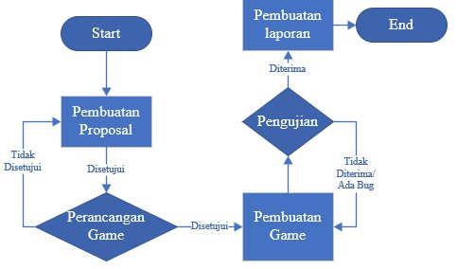Figure 2.1: flowchart game development

2.4 Game Testing Method
For the "Indo Trivia" game, 3 types of data testing will be carried out, namely
Validity, Reliability, and Correlation tests through these 3 types of tests, it will be
known whether the results of the questionnaire are valid and can be accounted
for or not. In this test, Variable EE (Effort Expectancy = ease), PE (Performance Expectancy = usefulness), and HM (Hedonic Motivation = pleasure) will be seen whether they have a strong influence on Variable BI (Behavioral Intention = desire to continue using) or not.

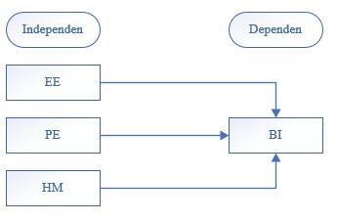Figure 2.2: Connection Between Variable

III. RESULTS AND DISCUSSION
Results and Discussion contain the results, their relation with theory, and their comparisons with previous related studies.
A. RESULT
• Game Design
Game Analysis and Goals
This "Indo Trivia" game is designed with the aim that players can find out more about the
brief history of several famous Hindu kingdoms on the island of Java and some of
the relics of these kingdoms. In this game, there are also various types of gameplay that
are designed so that players don't get bored with monotonous gameplay.
Genres, Platforms, and Target Audience
This game is a 2D platformer, Puzzle, and
Quiz genre. This "Indo Trivia" game was made for Android so that players can play it anywhere and anytime. The target player for this game is around the age of 6 years and over.
Character & Short Storyline
Figure 3.1.1 below is the main character in the game "Indo Trivia"
 Figure 3.1.1: Sprite Main Player
That character is a little genius who is curious
about the historical heritage in Indonesia. He was given the task by his teacher to collect the relics, arrange them and together with his
“Indo Trivia” is a game for Android with a 2d platformer, puzzle, and quiz genre. This game is a single-player game that is focused on learning about the historical heritage and history of the Hindu kingdoms in Indonesia. With more than 1 game type and legacy pictures
Plot
The history that is in each stage and the location of the kingdom that adjusts to its original position will make players know more about the Hindu kingdom in Indonesia. This “Indo Trivia” game was created using Unity Engine 2D version 2018.4. The game "Indo Trivia" itself has 5 Levels (Area) and each level (Area) has 3 stages that must be completed.
Area 1 is the area of the Tarumanegara
kingdom, Area 2 is the area of the Hindu Mataram kingdom, Area 3 is the area of the kingdom of Kediri, Area 4 is the area of the Singasari kingdom, Area 5 is the area of the Majapahit kingdom. The background in each area will adjust to the place that describes/is typical of the kingdom.
Stage 1 is collecting relics / collecting relics.
At this stage, the player must collect a predetermined number of relics to proceed to the next stage. In stage 2, which is arranging the puzzle, we have to arrange the puzzle so that it becomes the correct picture. In stage 3, Trivia Quiz, we will be asked some questions about the kingdom in the area we chose at the beginning and maybe questions about the kingdom related to the kingdom.
Here is the flowchart of the game "Indo
Trivia"
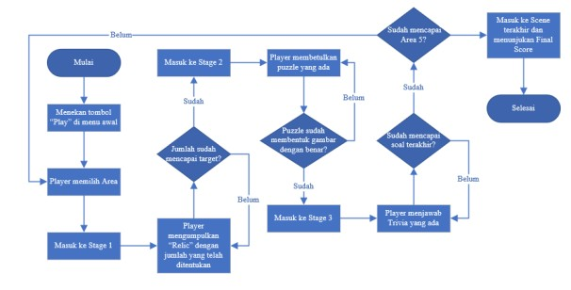
Figure 3.1.2: Flowchart of the game “Indo Trivia”
Game Result
teacher, study the relics.

Game Overview
• Game Creation

•

Area Select

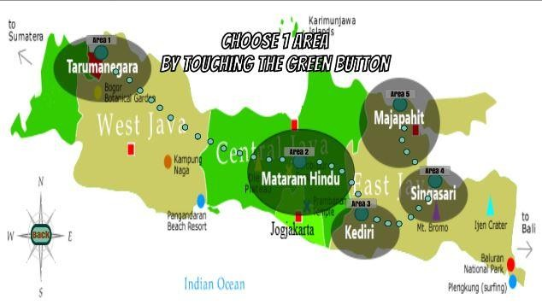

Figure 3.3:Area Selection

Figure 3.3 above is a scene when the player selects Area (Level). Completed levels will not be able to be played again. When the player has completed 1 area, the dark green circle for that area will close and become bright as a sign that the player has finished playing it and the area is no longer
playable. When the player completes stage 3 in area 5 (Majapahit area), then the player will be immediately taken to the game over screen.
Stage 1

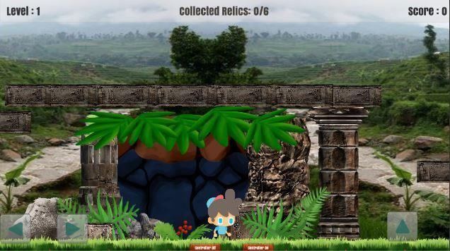

Figure 3.4 : Stage 1 area 1

Figure 3.4 is the display when a new player enters stage 1. In stage 1, the player must collect the relic with a predetermined amount. In Area 1 the player collects 6 relics, in Area 2 collects 8 relics, in Area 3
collects 10 relics, in Area 4 collects 12 relics, in Area collects 15 relics to be able to
proceed to the next stage. For each relic collected, the player will get 10 points and if the player collects the wrong/bad relic then the player's score will be deducted by 10.
Figure 3.7 is the background for areas 2, 3, 4, and 5.

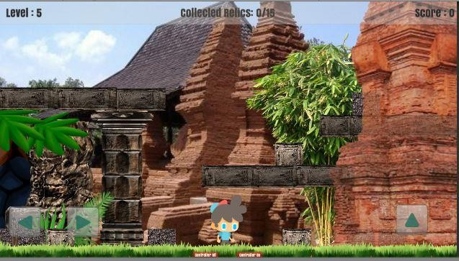

Figure 3.5: one of the backgrounds on stage 1

To pick up a relic, the player must swipe the screen to move it to the collection point to
get a score if the collected relic is correct/get a minus point if the relic taken is an incorrect relic.
Stage 2

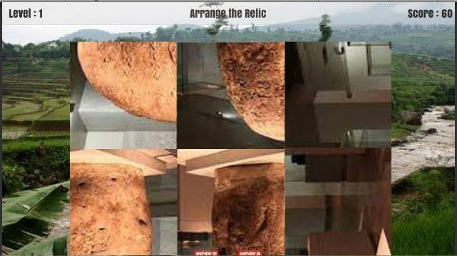

Figure 3.6: one example of a puzzle

In stage 2 players will be given a number of pictures with messy positions. the player must press the image to rotate the image 90o. when the picture is not messy, the name will come out from the picture then the player
can proceed to stage 3. In stage 2, for each piece of the picture, the player will be given
10 points. In Figure 3.16 it is a puzzle for areas 1 and 2, and in Figure 3.17 it is a puzzle image for areas 3, 4, and 5.

SISFORMA: Journal of Information Systems (e-Journal)Vol. … | No… |Th. ….. page ….
ISSN 2442-7888 (online) DOI 10.24167/Sisforma

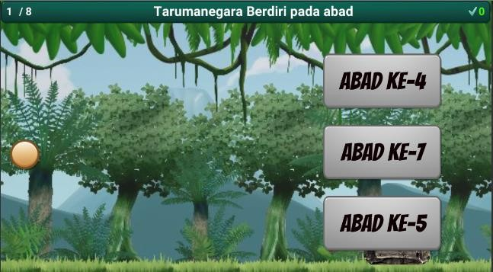Stage 3

Figure 3.7: Gameplay Stage 3
If all has been answered, a short history

panel will appear. This panel contains a brief history of the kingdoms in the area. From
this panel we can also know various kinds of historical relics from the kingdom.
After that the player will return to the "Area
Selection" with the green circle that was selected earlier will be closed. When the 5th

Figure 3.7 is the display when the player enters stage 3. In stage 3, the player will be given a question that appears at the top of the layer, the answer will come from the right side. Players can press the screen so that the player can go up then if the screen is not pressed then the player will go down by
itself. For each correct answer, the player will be awarded 10 points and for each wrong answer, the player will not get
additional points. At this stage there will be 8 questions that will appear.
The problem is about the kingdom in the area. When the answer has spawned, the answer will move from the right of the screen to the left of the screen. When the answer hits the player, the answer will stop to tell which answer is wrong and right. when the screen is touched again, the questions and answers will be replaced with new ones. if the correct answer is hit, the
points on the screen in the upper right corner will be added 1. When all 8 answers have been answered, the number of correct answers will add a score of 10 for each correct answer.

area is finished, the player will be taken to the “Game Over” screen and the score will be shown.
1. Respondent Education Level

Education  Level | Percentage
SD | 36 out of 69 respondents / 52.2%
SMP | 23 out of 69 respondents / 33.3%
SMA | 10 out of 69 respondents / 14.5%
Table 3.1: Percentage of Respondent’s Education

Level

2. Gender of Respondent

Gender | Percentage
Male | 52 out of 69 respondents / 75.4%
Female | 17 out of 69 respondents / 24.6%
Tabel 3.2: Percentage of Respondent’s Gender

B. DISCUSSION
1. Validity Test

Rotated Component Matrix
 | Component
 | 1 | 2 | 3
EE1  EE2  EE3  PE1  PE2  PE3  HM1  HM2  HM3  BI1  BI2  BI3 | -.017  -.032  .321  .092  .211  .209 | -.062  -.075  .104 | .936  .926  .794
EE1  EE2  EE3  PE1  PE2  PE3  HM1  HM2  HM3  BI1  BI2  BI3 | -.017  -.032  .321  .092  .211  .209 | .907  .893  .864 | .055  -.068  -.073  .129  -.115  -.032  .142  .250  .049
EE1  EE2  EE3  PE1  PE2  PE3  HM1  HM2  HM3  BI1  BI2  BI3 | .583  .735  .750  .849  .816  .808 | .564  .423  .452  .160  .101  .112 | .055  -.068  -.073  .129  -.115  -.032  .142  .250  .049

for or not. Table 3 below shows the results of the reliability test.
From table 3 below, we can see that all variables have a value above 0.8, so the
questionnaire can be accounted for. Variable
EE has Cronbach's Alpha 0.871 and Variable
BI has Cronbach's Alpha 0.874 then Internal Consistency is Good, and Variable PE has Cronbach's Alpha 0.907 and Variable HM has Cronbach's Alpha 0.904 then the Internal Consistency is Excellent.
Variable | Cronbach’s  Alpha | Internal  Consistency
EE | 0.871 | Good
PE | 0.907 | Excellent
HM | 0.904 | Excellent
BI | 0.874 | Good
Table 3: Reliability Test Result

Table 1: Validity Test Results Table 1 above shows the results of the validity test to determine whether the questionnaire is valid. For all variables that have a value above 0.5 then the variable is
valid. From the data above, we can see that
the EE variable has a high value in the component 3 column, namely 0.936, 0.926,
3. Correlation Test

.240
 | EE | PE | HM | BI
EE | 1 | -.029 | .087 | *
PE | -.029 | 1 | .575** | .357**
HM | .087 | .575** | 1 | .641**
BI | .240* | .357** | .641** | 1

and 0.794. The PE variable has a high value in the component 2 column, namely 0.907,
0.893, and 0.864. The HM variable has a high value in the component 1 column,
namely 0.583, 0.735, and 0.750. and the BI
variable has a high value in the component 1
column as well, namely 0.849, 0.816, and
0.808.
2. Reliability Test

Cronbach’s Alpha | Internal  Consistency
α > 0.9 | Excellent
0.9 > α > 0.8 | Good
0.8 > α > 0.7 | Acceptable
0.7 > α > 0.6 | Questionable
0.6 > α > 0.5 | Poor
0.5 > α | Unacceptable
Table 2: Range of Reliability Test Values Table 2 is a table to find out whether the values of existing variables can be accounted
* Correlation is significant at the 0.05 level (2-tailed).

** Correlation is significant at the 0.01 level (2-tailed).
Table 4: Correlation Test Result

From table 4 above, we can conclude that values that have * are values that correlate. For values that have a significant correlation
* at the level of 0.05 or 5%, while values that
have a significant correlation ** at the level of 0.01 or 1%. The value in table 4 above is the value of the Pearson correlation. Then
the value of the r table used is 0.2335 for the
5% level and 0.3035 for the 1% level, if the variable has a value greater than the r table value, then there is a correlation. Seen in the variable EE with BI has a value of 0.240 which is greater than 0.2335 so there is a correlation between EE and BI. The variable PE to BI has a value of 0.357 which is greater than 0.3035 so there is a correlation between PE and BI. For the HM variable with BI, it has a value of 0.641 which is

SISFORMA: Journal of Information Systems (e-Journal)Vol. … | No… |Th. ….. page ….
ISSN 2442-7888 (online) DOI 10.24167/Sisforma

greater than 0.3035 so there is a correlation between HM and BI.

IV. CONCLUSION
The conclusions of the game research "Indo
Trivia" are:
1. By designing the game "Indo Trivia" can
attract young people today to learn the history of the Hindu kingdom. Adding a brief history and some pictures of royal places and relics can help players to know more about the kingdom.
2. The application of the waterfall game
development method in making the game "Indo Trivia" is very effective. Because the game development method in this way can help developers to develop games in stages, so the development process doesn't fall apart or there is chaos in the middle of developing games. Although this method is quite old- fashioned and inflexible, it is still effective, because, before the development of the game, the process of reviewing and
designing the game to be made has been carried out. Therefore the game made will have a strong foundation.
3. From the results of the "Indo Trivia" game
testing and questionnaires given to respondents, it can be concluded that EE, PE, and HM which are correlated with BI can be interpreted as ease, usability and pleasure affect or have a relationship with the desire
to continue using

REFERENCES
[1] Supriatna, N. (2006). Sejarah untuk kelas XI Sekolah Mengngah Atas Program Ilmu Pengetahuan Sosial (Armasari Ika, Ed.). Grafindo Media Pratama. https://books.google.com.hk/books?hl=en&lr
=&id=nQCoI6JPTqwC&oi=fnd&pg=PR3&d q=apa+itu+sejarah+kerajaan+Hindu&ots=ay Kqb1efoD&sig=RRyahrhOcKjgEYHoR_Fy
48RAjHE&redir_esc=y#v=onepage&q=apa
%20itu%20sejarah%20kerajaan%20Hindu&

f=false

[2] Hafidah, E., Sumardi, & Suryana, Y. (2020). Pengembangan Media Puzzle tentang Sejarah Kerajaan Hindu Budha di Indonesia. Jurnal Pendidikan Ke-SD-An, 16(No 1), 1–
11. https://ejournal.upi.edu/index.php/MetodikDi daktik/article/view/26528/12530
[3] Winarno, E., & Zaki Ali. (2015). Membuat Game Android dengan Unity 3D. PT Elex Media Komputindo. https://books.google.co.id/books?id=04lKD wAAQBAJ&printsec=frontcover&dq=unity
+android&hl=en&sa=X&ved=2ahUKEwiL9 uax15XsAhWl63MBHa_AA9UQ6AEwBno ECAIQAg#v=onepage&q=unity%20android
&f=false
[4] Roy, A. (2016). Android Game Developer’s Handbook. Packt Publishing . https://books.google.co.id/books?id=6wjVD QAAQBAJ&pg=PA3&dq=game+android& hl=en&sa=X&ved=2ahUKEwjep7HhqZbsA hVWfisKHQosCecQ6AEwAXoECAMQAg
#v=onepage&q=game%20android&f=false

[5] Sa’idah, I. (2016). Pengembangan paket interaksi sosial untuk siswa sekolah menengah. Artikel. https://books.google.co.id/books?id=rBy_D wAAQBAJ&pg=PA1&dq=belajar+sambil+b ermain&hl=en&sa=X&ved=2ahUKEwjdxbz uuZbsAhXXT30KHWncCoc4ChDoATACe gQIBRAC#v=onepage&q=belajar%20sambi l%20bermain&f=false

